**NAME_____________________________ADMISSION NO.__________CLASS________**

**231**

**BIOLOGY (Theory)**

**AUGST/ 2022**

**2 $\frac{1}{2}$ Hours**

**KENYA CERTIFICATE OF SECONDARY EDUCATION**

**FORM TWO BIOLOGY PAPER**

**MARKING SCHEME**

**SECTION A**

1. (a) Biologically, what is a cell? (1 mk)

A cell is the basic structural and functional unit of a living organism;

b] Define the following term

1. Entomology (1 mk)

Study of insects;

1. Genetics (1 mk)

Study of inheritance and variation;

1. State the characteristics of life that is demonstrated when seeds produce heat during germination (1 mark)

Respiration;

1. State three structured differences between arteries and veins. (3 mks)

|  |  |
| --- | --- |
| Arteries | veins |
| narrow lumen | wide lumen |
| Thick muscular wall- | thin muscular wall |
| No valves except at the base of major arteries | have valves throughout their length; |

1. State **two** factors that denature enzymes. (2mks)

-high temperatures above optimum;

- Extreme pH/ strong acid/strong base/alkali;

1. Name **two** major branches of Biology. (2mks)

- Botany;

- Zoology

1. (a) Name the organelles that perform each of the following functions in a cell.
2. Synthesis of proteins (1mk)

Ribosomes;

1. Transport cell secretions (1mk)

Rough endoplasmic reticulum/ Rej. RER

Smooth endoplasmic reticulum; Rej. SER

1. Destroy old and worn out organelles or even the entire cell. (1mk)

Lysosomes;

1. Package and transport glycoproteins. (1mk)

Golgi apparatus/Golgi bodies;

(b) Using a light microscope, a student counted 55 cells across a field of view whose diameter was 6000μm. Calculate the average length of the cells. Show your working. (3 marks)

Cell diameter = $\frac{Diameteroffieldofviewinm}{Numberofcellsinfieldofview}$

= $\frac{6000m}{55}$; = 109μm;

(c) Why is it recommended to keep the stage of the microscope dry. (1 mark)

- To avoid refraction of light;

- To prevent wetting of slide;

(Mark any one = 1 Mark)

1. State the functions of the following apparatus.
   * 1. Bait trap (1mk)

Attracts organisms using food as a bait; and traps them.

* + 1. Pooter (1mk)

Sucks small organisms from bark of a tree;

1. In which two structural ways in which organelles chloroplast and mitochondria similar.(2mks)

* Both have a double membrane;
* Both have a fluid where chemical reactions occur;

1. State two functions of centrioles. (2mks)

* Formation of spindle fibres;
* Involved in cell division;

1. What is the effect of extreme temperatures on proteins? (2mks)

Low temperatures inactivate them;

High temperature above optimum denature them;

1. Study the reaction below and answer the questions that follow.

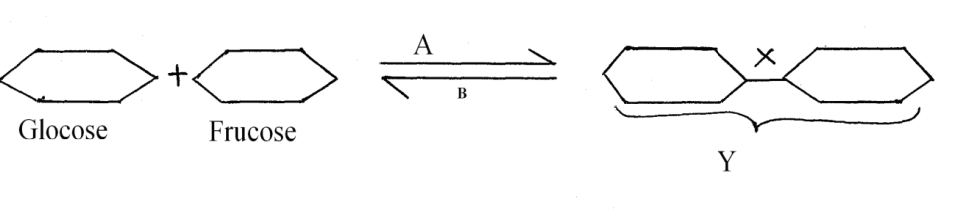

i) State the biological process that takes place represented by A ( 1mk)

Condensation

ii) What Biological process is represented by B (1mk)

Hydrolysis

iii) State the product Y (1mk)

Sucrose/ disaccharide

iv) State the bond represented by X (1mk)

Glycosidic bond

1. The diagram below show how food bolus moves along the human oesophagus and the intestines.

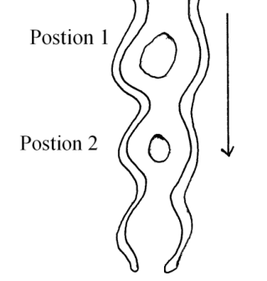

a) Identify the process illustrated above (1mk)

Peristalsis

b) Briefly state how the movement of the bolus from position 1 to position 2 is achieved. (2mks)

Wave like, Motion; brought about by alternate contraction and relaxation of circular and longitudinal muscles; of the wall of oesophagus and intestines.

1. State **two** reasons why the stomach wall cannot be digested by the proteolytic enzymes.(2 marks)

Has mucus ;

Enzymes released in an inactive form e.g. pepsinogen

1. (a) Define the term balanced diet. (2marks)

Is a diet that consists of all classes of food / carbohydrates, protein, lipids, water, mineral salts and vitamins; taken in their right proportions for a healthy body;

(b) State the importance of roughage in a diet. (1mark)

Roughage adds bulk to the food hence facilitating peristalsis / offer grip to prevent constipation;

15. State ONE role played by the following substance in digestion.

(i) Hydrochloric acid (2mks)

Provide optimum pH for enzyme activities;

kills micro-organisms in food;

activation of pepsinogen to pepsin;

(ii) Bile salts (2mks)

- Emulsification of fat;

- Neutralize acid chime **from** the stomach;

- Provide optimum pH (alkaline medium)

16. State the role of the following chemicals in a test for non-reducing sugar.

(i) Hydrochloric acid (1mk)

Hydrolyse non-reducing sugar to reducing sugar/ Hydrolyse dissacharides to

monossacharides;

(ii) Sodium hydrogen carbonate (1mk)

Neutralise the hydrochloric acid;

17. (a) Why is blood group AB described as universal recipient? (2mks)

AB Receives blood from all blood groups without agglutination; since it lacks antibodies;

(b) Suggest why blood does not clot in blood vessels of a healthy person. (lmk)

Blood in undamaged vessels contain anticlotting factor / heparin.

1. State three ways in which the vessels that link arterioles with venules are suited to carrying out their functions. (3marks)

- narrow lumen to increase pressure / resistance for nutrients to filter out;

- Thin walled / consists of a single layer of cells to shorten diffusion distance of substances;

- Numerous / many in number / form dense network to provide a large surface area for exchange of materials;

19. Below are diagrams of specialised cells in mammals

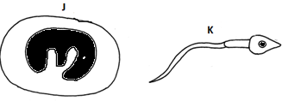

(a) Identify each of the cells (2mks)

(i) J. ...........................................................................................................

White blood cell/leucocyte;

(ii) K ...........................................................................................................

Sperm cell;

(b) Explain how cell specialization has enabled cell K to be effective in its functions (2mks)

- has a long tail fro propulsion;

- numerous mitochondria to provide energy for propulsion;

20. Some students set-up the experiment shown below to investigate a certain physiological process in plants. After one hour, they placed cobalt chloride paper on the leaf surface.

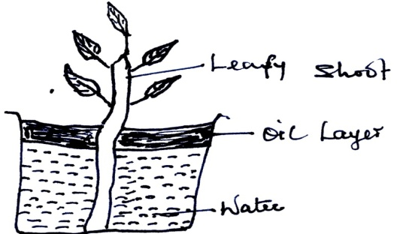

a) What process was being investigated? (1mk)

Transpiration

b) State the role of the oil layer in the experiment (1mk)

To prevent evaporation of water from the beaker

c) Suggest one precautionary measure that the students were supposed to observe during the preparation and setting up of the experiment (1mk)

The leaf shoot must be cut in water

d) Suggest changes observed on the cobalt chloride paper after one hour. (1mk)

It turned from blue to pink

21. Explain why water logged soil does not support plant growth. (3mks)

When soil is waterlogged the air spaces are occupied by water; this reduces the amount of oxygen in the soil, causing poor respiration hence poor uptake of minerals.

**Section B**

1. The diagram **below** shows part of plant tissue.

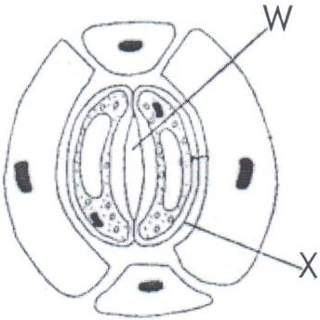

* + 1. Name the cell labelled**X** and part labelled**W**. (2mks)

X – Guard cell;

W – Stoma; rej. Stomata

* + 1. State **two** adaptations of cell labelled X to its functions. (2mks)

- Have chloroplast that photosynthesis making sugar necessary for opening and closing of stomata;

- Have thin outer wall and thick inner wall to which stretch differently to enable opening of stomata;

1. The number of stomata on the lower and upper surface of two leaves form plant X and Y were counted under the field of view of a light microscope. The results were show below.

|  |  |
| --- | --- |
| **Number of stomata** | |
| **Leaf** | **Upper surface** | **Lower surface** |
| **X** | 4 | 12 |
| **Y** | 20 | 23 |

1. Which of the leaves would be expected to have lower rate of transpiration (1mk)

leaf X

(b) Give a reason for your answer in [a] above (1mk)

X has fewer stomata;

Most stomata in the leaf X are concentrated on the lower surface;

1. An experiment was set up as show below.

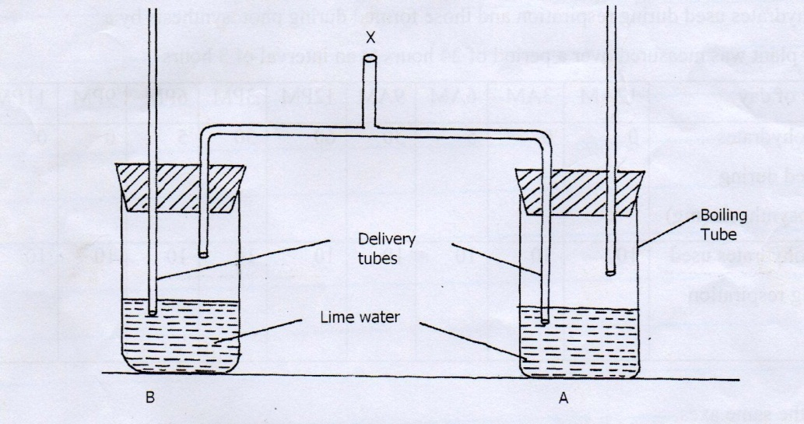

1. A student blew air in and out through point X. Using arrows indicate how air gets in and out of the set up (2mks)

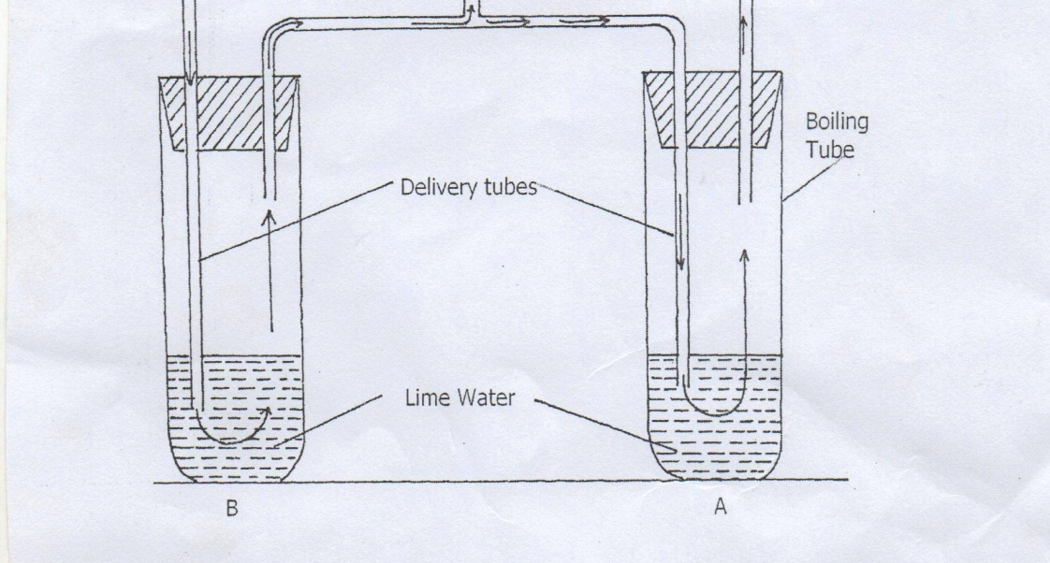

(b) (i) In which of the tube would lime water turn milky first. [1mk]

A

ii) Give a reason. [1mk]

Exhaled air has more carbon (IV) dioxide; inhaled air

25. (a) Name the type of circulatory system found in members of the class insecta (1mk)

Open circulatory system;

(b) Name the blood vessels that transport blood from:

(i) Small intestines to the liver (1mk)

Hepatic portal vein;

(ii) Lungs to the heart (1mk)

Pulmonary vein;

(c) The diagram below shows gaseous exchange in tissues

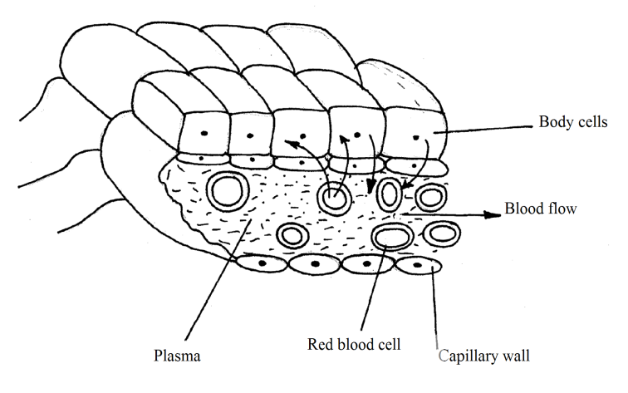

(i) Name the gas that diffuses

(I) To the body cells (1mk)

Oxygen

(II) From the body cells (1mk)

Carbon (iv) oxide; Rej CO2/carbondioxide.

(ii) Which compound dissociates to release the gas named in (a)(i) above (1mk)

Haemoglobin;

(d) What is tissue fluid (2mks)

Is the liquid part of blood ; from which blood proteins have been filtered out;

1. Describe the opening of the stomata using the potassium ion theory (10mks)

Chloroplasts in the guard cells in the presence of light produce ATP molecules;

The energy released drives potassium ions from the adjacent epidermal cells into the guard cells; while hydrogen ions are moved out; by diffusion; accumulation of potassium ions in the guard cells; raises their osmotic pressure; above that of adjacent epidermal cells; guard cells therefore gain water from the adjacent epidermal cells; by osmosis ;making them turgid and the stomata opens;

1. (a)name the respiratory surface in human beings. (1mk)

Alveolus;

1. Describe exhalation mechanism in human being. (9mks)

External intercostals muscles relax;

Internal intercostals muscles contract;

This causes the ribs to move downwards and inwards;

Diaphragm muscles relax; and form a dome shape;

These movements decreases the volume of the thoracic cavity; and increases pressure; as compared to atmospheric pressure;

Air is forced out of the lungs to the atmosphere;