**CHEMISTRY END TERM 2 2022 FORM 1 MARKING SCHEME**

1.The diagram below is a set up for the laboratory preparation of dry oxygen gas.

**Sodium peroxide**

**Liquid X**

**Liquid Y**

1. Name:
2. Liquid Y (1 Mark)

**Conc. Sulphuric acid**

1. Liquid X (1 Mark)

**water**

1. Write a word equation for the reaction that took place in the flask. (1mark)

**Water + sodium peroxide sodium hydroxide + oxygen gas**

1. State two uses of oxygen gas (2Mks)

-**respiratory aid in hospitals**

**-oxy-acetylene flame,oxy-hydrogen flame for welding and cutting of metals**

**-rocket fuel oxidiser**

**(any other correct use 1mk each)**

**2.**  Study the figure below and answer questions that follow.

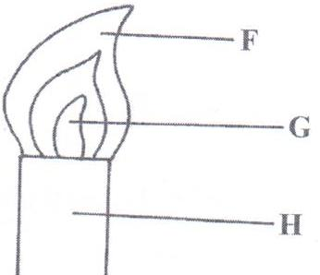

1. Name the type of flame shown and give a reason. (2mks)

**Flame- luminous, it is wavy**

(b)Name the parts labelled **F** and **G**. (2mks)

**F-bright yellow zone G- almost colourless zone**

( c)**S**tate the under which the above flame is produced? (1mk)

**-when the air hole is fully closed**

(d) State the three differences between the two flames of a Bunsen burner (3Mks)

|  |  |
| --- | --- |
| **LUMINOUS FLAME** | **NON LUMINOUS FLAME** |
| **Yellow in colour** | **Pale blue in colour** |
| **Produces soot** | **No soot produced** |
| **Four regions** | **Three regions** |

3. State the best method to separate the following mixtures (5Mks)

(a) components of crude oil -**fractional distillation**

(b) benzoic acid and sodium chloride-**sublimation**

(c) oil from sunflower seeds- **solvent extraction**

(d) iron filing and sulphor- u**se of magnet**

(e) coloured pigment from grass- **chromatography**

4. Draw and state one use of the following apparatus.(10mks)

(a) deflagrating spoon **–holding substances being burned**

1. Conical flask –**general laboratory experiments and measuring approximate volumes**

© round bottomed flask**-heating liquid substances**

1. Mortar and pestle –**crushing substances**
2. Evaporating dish -**evaporating liquids**

5.Mugure a form one student was stung by a wasp in the laboratory, the technician applied sodium hydroxide to her. Explain why was this done.(2mks)

**Wasp sting produces acidic liquid which was neutralised by the sodium hydroxide which is a base**

6. State three roles of chemistry as a subject to the society (3mks)

**-manufactures of food to control hunger**

**-manufacture of drugs to treat diseases**

**Manufacture of detergents**

7. Complete the table below(8mks)

|  |  |  |  |
| --- | --- | --- | --- |
| element | symbol | element | Symbol |
| sodium |  |  | Hg |
|  | K | copper |  |
| sulphur |  |  | C |
| iron |  | hydrogen |  |

8.(a) Define the term mixture (1mk)

-**two or more substances mixed together in which the individual components forming the mixture retain their properties**

(b) Name five types of mixtures (5Mks)

**-solid-solid -solid-gas**

**-liquid-liquid -liquid –gas**

**-solid- liquid gas-gas**

**-**

9.(a) Define the following terms (2mks)

(i) drug- **any substance natural or manufactured which when used alters the the body functions**

(i)drug abuse- **overdose/underdose or using drugs for purposes not intended**

(b) Name three commonly abused drugs (3mks)

**- bhang, alcohol, tobacco, khat (miraa), cocaine, heroin.**

(c) State two effects of drug abuse to the consumer (2mks)

**Liver cirrhosis, mental disorder, addiction, vascular disorders etc.**

10.During Olympics, urine sample of five short distance runners were taken and tested for the presence of two illegal steroids by paper chromatography. Methanol was used as the solvent. A chromatogram from the test appeared as shown below. Study the chromatogram and answer the questions that follow.

**KEY**

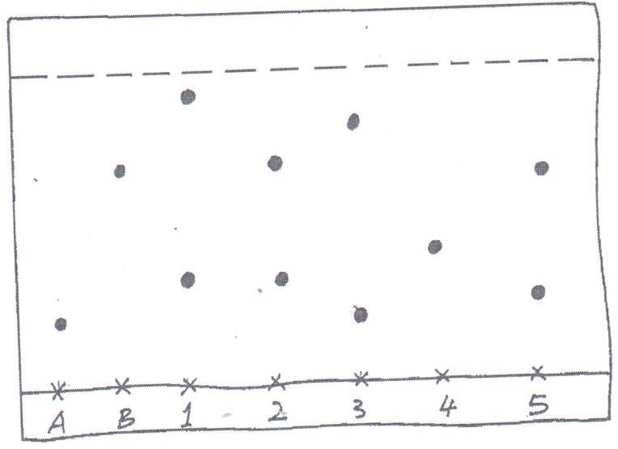 SPOT A – STEROID A

SPOT B – STEROID B

SPOT 1 – ATHLETE 1

SPOT 2 – ATHLETE 2

SPOT 3 – ATHLETE 3

SPOT 4 – ATHLETE 4

x x x x x x x

**A B 1 2 3 4 5**

* 1. Which of the two steroids is most likely to be more soluble in methanol? Give a reason. (1mk)

**B, has moved the furthest on the chromatogram**

* 1. Identify the athletes that tested positive for the illegal steroids. **2 and 3**  (2mks)
  2. On the diagram, indicate the solvent front. (1mk)

11. The diagram below shows parts of a Bunsen burner.

A

B

C

1. Name the parts labelled A , B (1 mark)

**A-Chimney/barrel**

**B- Air hole**

1. Give one use of the part labelled B (1 mark)

**Allows air into the chimney**

12. Hydrated copper (II) sulphate exists as blue crystals while anhydrous copper (II) sulphate is a white powder. Describe a laboratory experiment that can be used to show that the action of heat on hydrated copper (II) sulphate is a reversible reaction (3 marks)

**Heat blue hydrated copper(ii) sulphate in a test tube and it turns white . Allow the vapour produced to condense on the cooler parts of the test tube. Let the condensed liquid flow back to the anhydrous copper(ii) sulphate which turns blue from white.**

13.(a) Melting point of naphthalene is 800C. When camphor is added to a sample of naphthalene, the melting point changes to 79.80C. Explain (2mks)

**Camphor is an impurity and impurities lower the melting point.**

1. What is effect of adding magnesium sulphate to the boiling point of distilled water? (1mk)

**Being an impurity, it** raises **the boiling point of water.**

14.(a) A patient was given tablets with prescription 2 x 3 on the envelope. Clearly outline how the patient should take the tablets.

(1 mark)

**Take 2 tablets after every 8 hours. 🗸¹**

1. Two samples of equal volumes of water were put in 250cm³ beaker and heated for 10 minutes. Sample 1 registered a

higher temperature than sample 2.

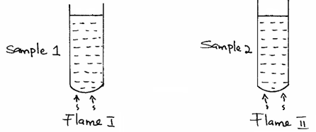

State the conditions under which flame I is produced in Bunsen burner. (1 mark)

**Produced when the air hole is open. 🗸¹**

15. The apparatus below was used to separate a mixture of liquid A and B.

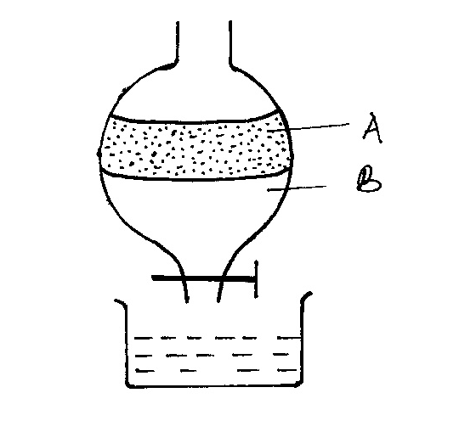

1. State two properties of the liquids that make it possible to separate them are using such apparatus. (2 marks)

* **Difference in densities. 🗸¹**
* **They are immiscible. 🗸¹**

16.The table below shows PH values of solutions **A**, **B**, **C** and **D**.

|  |  |
| --- | --- |
| Solution | PH |
| A | 3.0 |
| B | 13.0 |
| C | 8.5 |
| D | 7.0 |
| E | 5.5 |

(a) Identify a solution which is

(i) Strongly acidic. **A** (1 mark)

(ii) Strongly basic. **B**  (1mk)

1. Distilled water **D** (1mk)
2. Lemon juice **E** (1mk)

(b) Which of solutions would react with lead (II) oxide? Explain. (2 marks)

**A. being a strong acid, it will react basic lead(ii) oxide to form salt and water**

17.In an experiment a certain volume of air was passed repeatedly from syringe over heated zinc powder as shown in the diagram below.

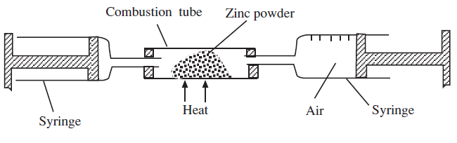

The experiment was repeated using excess magnesium powder. In which one of the two experiments was the change in volume of air greatest. Give reasons. (3mks)

**Using magnesium. Magnesium being more reactive than zinc reacts with both oxygen and nitrogen while zinc reacts only with oxygen from the air.**

18(a) what is the chemical name for rust. (1mk)

**-Hydrated iron(iii) oxide**

1. State the conditions necessary for rusting. (1mk)

**Water and oxygen**

(c) List three methods of preventing rusting. (3mks)

**Electroplating**

**Galvanizing**

**Painting, coating, tarring**

**Sacrificial protection**

19. Complete the word equations for the following reactions; (3mks)

(a) sodium carbonate + hydrochloric acid = **sodiumchloride+water+carbon(iv)oxide**

(b)Zinc + sulphuric acid = **zinc sulphate +hydrogen**

(c) potassium hydroxide + nitric acid = **potassium nitrate + water**

20. Define the following terms and give an example of each (8mks)

(a) An atom –**smallest particle of an element that can take part in a chemical change e.g oxygen.**

(b) Molecule –**smallest particle of an element or a compound that can exist independently e.g water, hydrogen gas, oxygen gas etc.**

(c) Element – **substance that that cannot be split into two or** **more simpler substaces by chemical means e.g sodium, iron , oxygen etc**

(d) Compound **– substance consisiting of two or more elements that are chemically combined e.g magnesium oxide, sodium chloride, water etc.**

21. Give three differences between permanent and temporary changes. (3mks)

|  |  |
| --- | --- |
| **TEMPORARY CHANGE** | **PERMANENT CHANGE** |
| **reversible** | **irreversible** |
| **No change in mass** | **Change in mass** |
| **No new substance formed** | **New substance formed** |

22.State two laboratory rules to observed when preparing a **poisonous** gas. (2mks)

-a**lways prepare the gas in a fume chamber or in the open**

**-wear gas masks**

**-avoid smelling the gases directly, instead waft the fumes.**