**312/1**

**GEOGRAPHY**

**FORM I**

**END OF TERM II EXAM (2022)**

**MARKING SCHEME**

1)a) Name two Greek words from which the term geography originated (2mks)

* **Geo**
* **Graphien**

b) What is environment? (2mks)

* **Environment refers to all the external conditions surrounding an organism which has influence over its behavior ( 2mks)**

c) List four main areas covered in human geography (4mks)

* **Farming**
* **Forestry**
* **Mining**
* **Tourism**
* **Settlement**
* **Transportation**
* **Trade**

**Industry (Any 4 x 1 = 4mks)**

d) Explain the relationship between geography and the following subjects

i) Biology (2mks)

* **Geography explains the distribution of organisms and factors influencing their distribution on the earth’s surface (2mks)**

ii) Agriculture (2mks)

* **Geography studies farming systems, their distribution and the factors affecting farming activities (2mks)**

2)a) Explain the meaning of the following terms

i) Weather (2mks)

* **Weather is the state of the atmosphere of a given place at a given time over a short period of time (2mks)**

ii) A weather station (2mks)

* **A weather station is a place where observation measuring and recording of weather elements is done (2mks)**

b)i) Your school want to establish a weather station, name the area within the compound where it can be sited (1mk)

* **School field (1mk) Any other relevant area**

ii) State four factors that the school would consider while establishing the weather station (4mks)

* **The site should be open and where there is free flow of air**
* **The site should present a wide view of the surrounding and the sky**
* **The site should be away from tall structures and trees**
* **The ground should be gentle**

**The site should be properly secured (Any 4 x 1 = 4mks)**

3)a) Apart from convectional rainfall, name two other types of rainfall. (2mks)

* **Orographic rainfall / relief**

**Cyclonic / Frontal rainfall ( 2 x 1 = 2mks)**

b)i) While using a well labeled diagram, describe how convectional rainfall is formed (9mks)

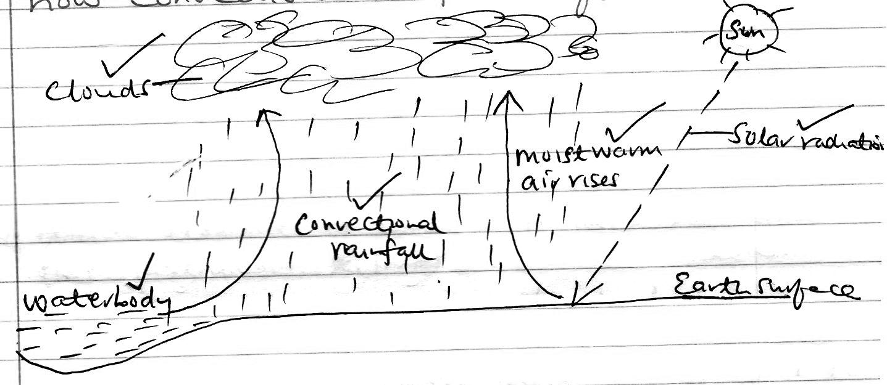

* **The earth surface / water body is heated causing evaporation**
* **Warm moist air rises, and it cools as it rises**
* **Condensation takes place forming tiny water droplets / clouds**

**The droplets merge and fall to the earth surface as convectional rainfall.**

**(Any 4 x 1 = 4mks)**

ii) State three characteristics of convectional rainfall (3mks)

* **It mainly occurs in the afternoon**
* **It is usually torrential and falls for a short period**
* **It is accompanied by thunder and lightning**
* **Mainly occurs around major water bodies**

**(Any 3x 1 = 3mks)**

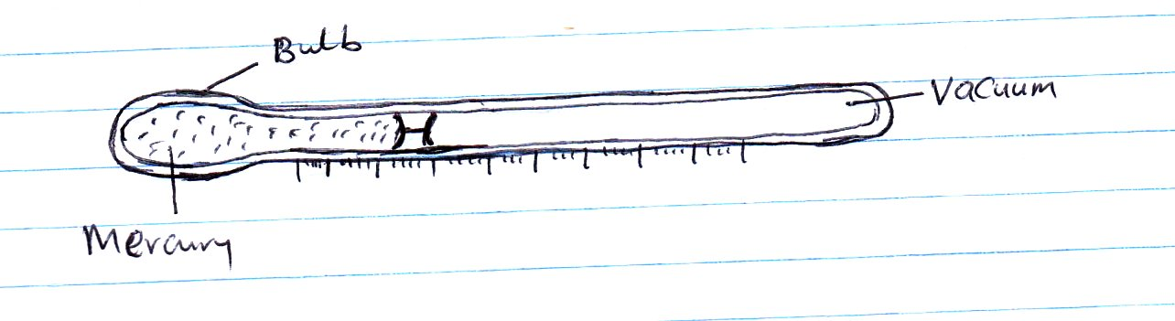4)a) Study the diagram below representing an instrument for measuring on element of weather. Use it to answer question i, and ii.

i) Which element of weather is measured using the above instrument? (1mk)

* **Temperature 1mk**

ii) Describe how the above instrument is used to measure the element given in 4 a(i) above (4mks)

* **When the temperature rises it causes mercury to expand**
* **Mercury rises through the glass tube pushing the metal index**
* **When temperature falls mercury contracts**
* **The maximum temperature is read from the scale at the lower end of the index**

**The thermometer metal index is re-set again at 00c. (Any 4 x 1 = 4mks)**

b) Apart from the above instrument, name three other instruments found in a Stevenson Screen (3mks)

* **Six’s thermometer – Minimum thermometer**
* **Hygrometer / dry or wet bulb thermometer (2 x 1 = 2mks)**

5) The table below shows rainfall and temperature figures for a station in Kenya. Use it to answer question i, ii,iii and iv.

|  |  |  |  |  |  |  |  |  |  |  |  |  |
| --- | --- | --- | --- | --- | --- | --- | --- | --- | --- | --- | --- | --- |
| **Month** | **J** | **F** | **M** | **A** | **M** | **J** | **J** | **A** | **S** | **O** | **N** | **D** |
| Temp 0c | 27 | 25 | 23 | 20 | 18 | 18 | 17 | 19 | 20 | 21 | 21 | 24 |
| Rainfall (Mm) | 53 | 50 | 55 | 251 | 242 | 230 | 180 | 109 | 90 | 51 | 85 | 100 |

i) Calculate the diurnal range of temperature for the station (2mks)

* **270c – 170c = 100c (2mks)**

ii) Calculate the average temperature for the station (2mks)

**27 + 25 + 23 + 20 + 18 + 18 + 17 + 19 + 20 +21 + 21 + 24**

**12**

**= 253 ≈ 21.10c / 210c (2mks)**

**12**

iii) Determine the total annual rainfall (2mks)

**53 + 50+ 55 + 251 + 242 + 230 + 180 + 109 + 90 +51 + 85 + 100**

**= 1496mm (2mks)**

iv) Which month recorded the highest amount of rainfall (1mk)

* **April (1mk)**

6) The diagram below shows, the external layers of the Earth’s atmosphere. Use to answer questions i, ii, and iii

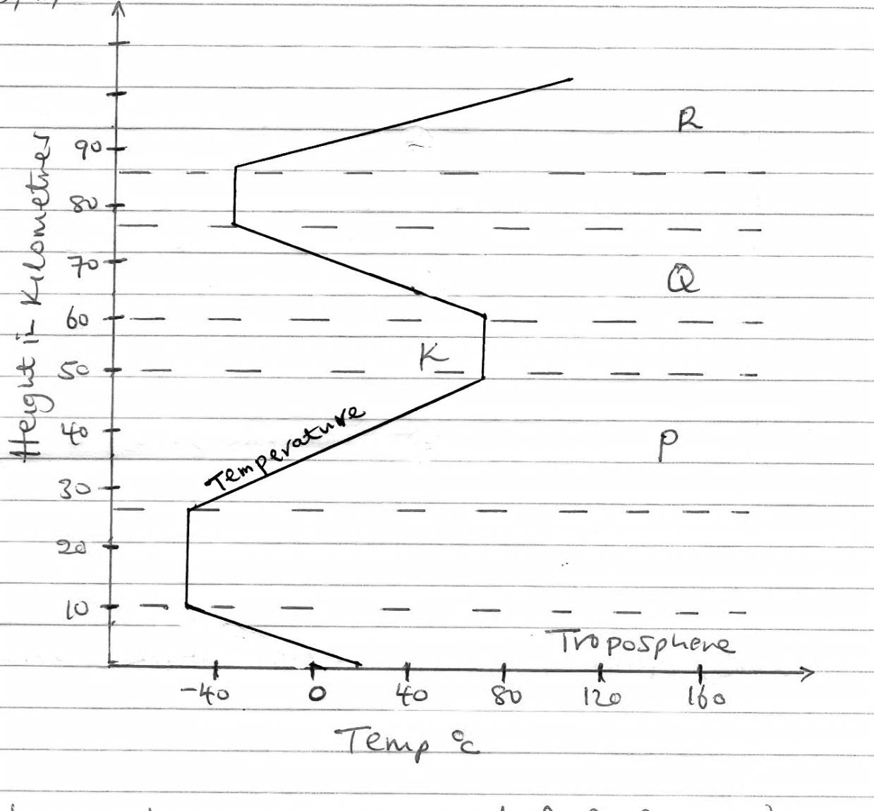

i) Name the parts marked P, Q, R (3mks)

* **R - Stratosphere**
* **Q - Mesosphere**

**R – Thermosphere (3 x 1 = 3mks)**

ii) Identify the discontinuity labeled K (1mk)

* **K – Stratopause (1mk)**

iii) Give the characteristics of the zone named Troposphere (3mks)

* **It contains the highest concentration of gases**
* **Most of the water vapour is concentrated here**
* **Temperature decreases with increase height**
* **The zone extend to approximately 15km above the earth surface**

**(4 x 1 = 4mks)**

7)a) Define the following terms

i) A picture (2mks)

* **Is a an image of a real object (2mks)**

ii)A plan (2mks)

* **Is a map of a very small area usually drawn to scale (2mks)**

iii) A map (2mks)

* **Is a representation of a part or the whole of the earth’s surface drawn on a flat surface and drawn to scale (2mks)**

b) List three main types of maps (3mks)

* **A sketch map**
* **A topographical map**

**An atlas map (3 x 1 = 3mks)**

c) Outline five marginal information That you may get on a map (5mks)

* **Map name**
* **Man series**
* **Sheet number**
* **Compass direction**
* **Scales**
* **Key**
* **Publisher**

**Copyright (Any 5x 1 = 5mks)**

d) Covert the following representative fraction into statement scale

i) 1/200,000 (2mks)

**200,000 x 1km = 2km**

**100,000**

**1cm to 2km (2mks)**

ii) 1/350,000 (2mks)

**350,000 x 1km = 3.5**

**100,000**

**1cm to 3.5 km (2mks)**

8)a) List three planets that do not have satellites (3mks)

* **Mercury**
* **Venus**

**Mars (3 x 1 = 3mks)**

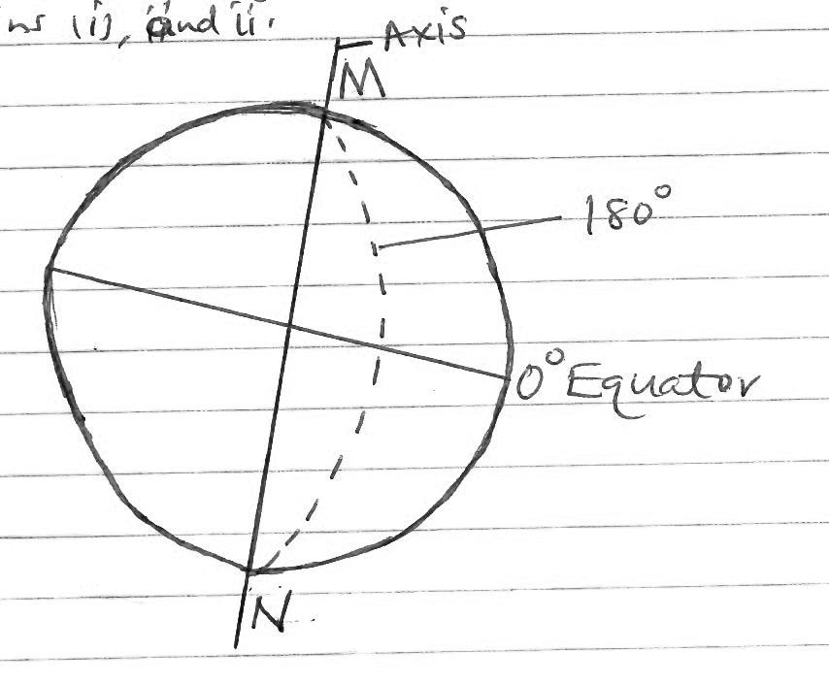b) Study the diagram of the earth below and we use it to answer questions i) and ii)

i) Name the parts marked M and N

* + **M - North pole**
  + **N – South pole (2mks)**

ii) What is the name of the line of longitude marked 1800? (1mk)

* **International dateline (1mk)**

iii) What happens to time when you cross this line mentioned in b(ii) above (2mks)

* **When you cross the line to the East you gain time / day while you cross it toward the West you lose time / day (2mks)**

c) What two times of the year is the sun overhead at the equator (2mks)

* **21st March**
* **23rd September ( 2mks)**

d) The time in Bangkok Thailand 1000E is 3:12p.m, what will be the time in Nairobi 370E? (3mks)

* **Time in Nairobi**

**Difference in degrees = 1000 – 370 = 63**

**Difference in time 630 x 4min = 252min = 4hrs 12 min**

**60**

**Time in Nairobi 3:12p.m – 4hr 12min = 11:00a.m ( 3mks)**

e) State four characteristics of planets (4mks)

* **Planets are spherical**
* **They revolve around the sun in anticlockwise direction**
* **Don’t have their own light but reflect it from the sun**
* **Only one of them support life**
* **Have their own force of gravity**
* **Each planet has its own orbit Scales**
* **Key**
* **Publisher**

**Copyright**

**(Any 5x 1 = 5mks)**

9)a) Define the term statistics (2mks)

* **Statistics refers to the numerical facts / figures collected systematically and arranged for a given purpose (2mks)**

b) Differentiate between discrete and continuous data (2mks)

* **Discrete data are statistics which are given in a whole numbers while continuous data are given in any value. (2mks)**

c) List four methods of data collection from the field (4mks)

* **Direct observation / observing**
* **Interviewing**
* **Administering questionnaires**
* **Taking measurements**
* **Carrying out experiments**

**(4 x 1 = 4mks)**