**312/1**

**GEOGRAPHY**

**FORM 2**

**END OF TERM II EXAM (2022)**

**MARKING SCHEME**

1. Identify the term that describe the following statement (4mks)

|  |  |  |
| --- | --- | --- |
|  | **Statement** | **Term** |
|  | Study of the rock materials | **Geology** |
|  | study of weather and climate | **Climatology** |
|  | study of soil | **Pedology** |
|  | study of population | **Demography** |

**( 4 x 1 = 4mks)**

1. Identify four ways a form two student would benefit from studying geography (4mks)

* **Geography is a career subject**
* **It help the learner to develop skills of observing, reading and analyzing and interpreting maps, diagrams and statistical graphs**
* **It enables the learner to understand different environmental influence**
* **Encourage international awareness and understanding**
* **Load to development career opportunity**
* **Help the learner to explain the origin of the earth**
* **Help the learner to appreciate important social values and Time Management**

**(Any 4 x 1 = 4mks)**

3) Classify the following clouds as either high, middle or low clouds (use a tick) (3mks)

|  |  |  |  |  |
| --- | --- | --- | --- | --- |
|  | **Types of clouds** | **High** | **Middle** | **Low** |
| i) | Cumulus |  |  | **√** |
| ii) | Cirros | **√** |  |  |
| iii) | Stratus |  |  | **√** |

**(3 x 1 = 3mks)**

4) Name four instruments kept in a Stevenson screen (4mks)

* **Maximum thermometer**
* **Minimum thermometer**
* **Six’s thermometer**
* **Hygrometer (Any 4 x 1 = 4mks)**

5)a) Differentiate between Magnetic North and True North (2mks)

* **Magnetic North is North according to the earth’s magnetic field while true is the position of the North Pole as shown on the globe (2mks)**

b) Identity four factors that should be considered when preparing a questionnaire (4mks)

* **Simplicity and clarity of the question**
* **Number of questions**
* **Logical order of the question**
* **Relevance of questions**
* **Nature of the question**
* **Objectivity of the question**

**(Any 4 x 1 = 4mks)**

6) State four methods of recording statistical Data (4mks)

* **Field sketching**
* **Mapping**
* **Tabulation**
* **Taking photography**
* **Labeling sample**
* **Filling questionnaire**
* **Tape recording (Any 4 x 1 = 4mks)**

7)a)i) Define the term map (2mks)

* **A map is a representation of a part of the earth or the whole of the earth on a flat surface like a sheet of paper as chalk board drawn to scale.( 2mks)**

ii) Give three characteristics of sketch map (3mks)

* **Should have a title**
* **Should have a key**
* **Should be enclosed in a frame**
* **Neat and clear**
* **Should have a compass direction**

**(Any 3x 1 = 3mks)**

b) Convert the following statement scale into representative fraction (RF scale)

i) 1 cm rep 1km (**2mks)**

**1 x 100,000 = 1 or 1:100,000**

**100,000**

ii) 1cm rep 200m (**2mks**)

**2 x 100,000 = 1 or 1:20,000**

**200,000**

iii) 1cm rep 0.05km (**2mks**)

**0.05 x 100,000 = 1 or 1:5000**

**5000**

c) Outline three methods used to measure distance on a curved line (3mks)

* **Using a piece of string**
* **Use a paper edge**

**Using a pair of divider**

**( 3 x 1 = 3mks)**

8)a)Name the two type of Earth Movement that occur within the earth’s crust (2mks)

* **Horizontal earth movement**

**Vertical earth movement (2 x 1 = 2mks)**

b) Explain four evidence put forward to proof continental draft theory (8mks)

* **Fitting of Western coast of Africa and S. America into a Jig saw**
* **Discovery of coal 400N and 550N which was formed by burying of tropical vegetation**
* **Considerable displacement of rocks along some faults e.g along the great glen fault of Scotland**
* **Red sea shores show evidence of having undergone lateral displacement an indication that was formed by movement of the earth crust.**

**Cape of Brunos Aires fold resemble one another by having East and West trend. (Any 4 x 2 = 8mks)**

c) Name one fold mountain in

i) Asia **- Himalatas**  **(1mk**)

ii) North America - **Appalation**  **(1mk**)

iii) South America - **Andes**  (**1mk)**

d)i) Apart from fold mountain name three other features resulting from folding (3mks)

* **Escarpments**
* **Synclinal valley**

**Depression (3 x 1 = 3mks)**

9) The diagram below represent feature produced by faulting. Use it to answer the questions that follows.

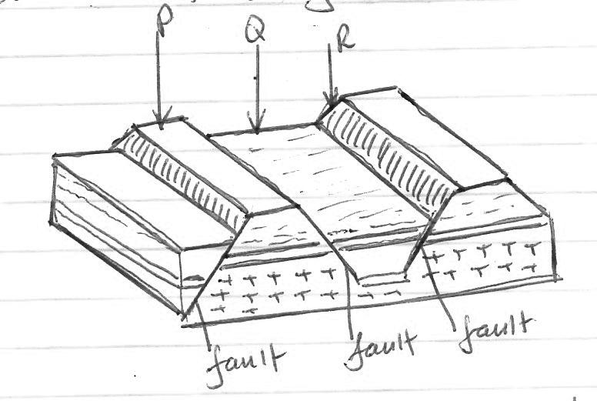

1. Name the features marks (3mks)

* **P - Horst block**
* **Q - Rift valley**

**R – Fault scarp**

**( 3x 1 = 3mks)**

1. Differentiates between a normal fault and a reverse fault (2mks)

* **In a normal fault part of the fault is exposed to form an escarpments while in reverse fault the plane is not exposed**
* **A normal fault occur due to compressional force**

**In anormal fault the up throw move away from down throw while reverse fault the upthrow move over down throw.**

**(Any 2 x 1 = 2mks)**

c) State four uses of rocks (4mks)

* **Rocks weather down to form soils which is suitable for agriculture**
* **Some rocks act as reservoir for water / oil / gas**
* **Rock provide materials for the building and construction industry**
* **Rocks are sources of minerals**
* **Some rocks act as tourist attraction**
* **Some rocks are used in sculpturing / carving industry to make ornaments**
* **Study of rock are sources of food e.g rock salt**
* **Some rocks are ornamentals**
* **Some rocks provide materials for manufacturing industires**

**(Any 4 x 1 = 4mks)**

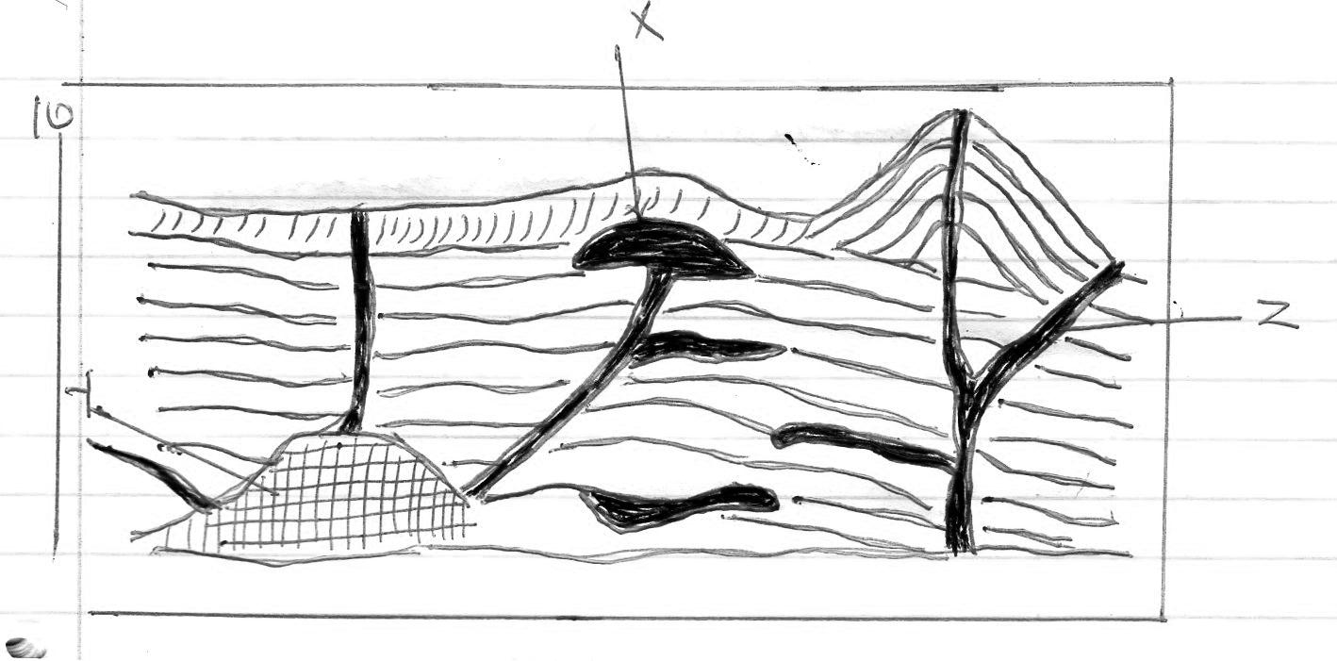

a)i) Name the features marked X, Y, and Z (3mks)

* + - **X - lacolith**
    - **Y – Batholith**
    - **Z - Dyke (3 x 1 = 3mks)**

ii) Explain how a parasitic cone is formed (4mks)

* **Pressure is reduced causing the magma form the interior of the earth to fail to reach the top of volcano**
* **The upper part of the main went of the volcano is blocked / pressure is reduced causing the magma from the interior of the earth to fail to reach the top of Volcano.**
* **Pressure build up as magma escape through the side vent**
* **The successive outputting of the magma through the side vent build alternative layer of ash and lava to phone con-lets for the side of composite volcano.**

**The cone let is a parasite cone.**

**( 4 x 1 = 4mks)**

b) Give six characteristics of a composite cone (6mks)

* **It has vertical vent or pipe**
* **It is composed of alternating layer of ash**
* **It is conical in shape / steep sided**
* **It has a side vent**
* **It has a cone-let / parasitic cone on the side**

**At the peak it may have a caldera / plug or crater (Any 6 x 1 = 6mks)**

c) Explain four ways in which volcanic mountain positively influence human activities (8mks)

* **Volcanic mountain are sources of rivers which provide water for domestic, industrial transport and irrigation**
* **They influence the formation of relief rainfall that encourages agricultural activities**
* **Volcanic soils are suitable for agriculture**
* **Volcanic mountain produce timber for construction and building activities**
* **The volcanic mountain form beautiful scenes that attract tourists**
* **Hot springs / geysers are used to general geothermal**
* **The crater lake are fishing / breeding ground for fish**
* **Volcanic rocks provide material for construction and building. (Any 4 x 2= 8mks)**

d) You intend to carry out a field study of a volcanic landscape

i) State four reasons why it is necessary to conduct a reconnaissance of the area of the   
 study (4mks)

* **To enable them draw up study objective / hypothesis**
* **To familiarize themselves with the area of study**
* **To enable them draw the route map**
* **To enable them prepare a work schedule / plan of activities**
* **To enable them identify / sort out relevant tools / equipment for the study**
* **To identify suitable methods of data collection**
* **To seek permission from the occupant of the site of study**
* **To enable them prepare financially (Any 4x 1 = 4mks)**

ii) During your field study state why you would need the following item.

i) Geological hammer (**2mks**)

* **To break up the rock**

ii) A polythene bag (**2mk**s)

* **For carrying rock samples**

11)a) Give four causes of earthquakes (4mks)

* **Collision of tectonic plate energy in the mantle**
* **Violent volcanic eruption**
* **Nuclear explosion**
* **Magma movement within the crust**
* **Gravitative pressure (Any 4 x 1 = 4mks)**

b) Name three types of earth quakes (3mks)

* **Primary / push waves – P – waves**
* **Secondary / shear waves – S – waves**
* **Longitudinal waves – E – waves**

**(3 x 1 = 3mks)**

c) State the five ways in which earth crust is affected by earthquake (5mks)

* **Earth quakes cause lateral vertical displacement of rocks**
* **They cause rising and lowering / uplifting and warping of parts of the sea floor**
* **They cause landslides / slumps**
* **They lead to faulting of the crust**

**They cause rising and lowering of land**

**(Any 5 x 1 = 5mks)**

12)a) What is a photograph? (2mks)

* **A photograph is an image of an object, person or scene in a form of a print or slide recorded by a camera on a film and later transfers onto a specially prepared paper. (2mks)**

b) List three types of ground photographs (3mks)

* **Ground close up**
* **Ground oblique**
* **Ground general view (3 x 1= 3 mks)**

c) Name three ways in which a photograph can be subdivided horizontally (3mks)

* **Foreground**
* **Middle ground**

**Back ground (3 x 1 = 3mks)**