**MATHEMATICS FORM TWO**

**MARKING SCHEME**

|  |  |  |  |
| --- | --- | --- | --- |
| **NO** | **WORKING** | **MARKS** | **REMARKS** |
| 1 | Numerator $=-18+1 = -17$ Denominator $= 8-30 =-22$ $=\frac{-17 }{-22} =\frac{17}{22}$ | M1  M1  A1 | Numerator  Denominator |
| 2 | 4x2 = 3 (4x - 3)  4x2 = 12x – 9  4x2 = 12x + 9 = 0  (2x - 3) (2x - 3) = 0  x = 1.5 | M1  M1  A1 |  |
| 3 | $$14÷\left(\frac{1}{3}×\frac{21}{4}\right)-\left(\frac{15}{4}×\frac{4}{3}\right)$$ $$=14÷\frac{7}{4}-5$$ $$=14×\frac{4}{7}-5$$ $$=8-3⇒3$$ | M 1  M 1  A 1 |  |
| 4 | Let x be sides of the square $$x^{2}+x^{2}=8^{2}$$ $${2x}^{2}=64$$ $$x^{2}=32$$ $$x=5.657$$ 5.7 (1dp) | M1  M1  A1 |  |
| 5 | $BO=OD=\sqrt{{15}^{2}-{12}^{2}}$ = $\sqrt{81}$ =9  Area = $(½ × 9 × 12 ×2)$ + $(\frac{1}{2}×9 ×18 × 2)$ = 108 + 162  = 270 $cm^{2}$ | B1  M1  A1 |  |
| 6 | |  |  | | --- | --- | | **No** | **Log** | | 4.684 | 0.6706 | | 2.497 | 0.3975 + | |  | 1.0681 | |  |  | |  |  | |  |  |   0.8496 | M 1  M 1  M 1  A 1 | All correct logs  Correct addition of logs  Correct division  Accurate answer |
| 7 | $$2y-4x=1$$ $$y=2x+\frac{1}{2}$$ M1 =2  M2 =2 $$2=\frac{y+2}{x-3}$$ $$y=-2x-8$$ | B1  M1  A1 |  |
| 8 | $$Area=\frac{1}{2}×13.4×5\sin{{57.7}^{0}}$$ $$\frac{1}{2}×13.4×5×0.8453$$ $$28.32{cm}^{2}$$ | **m1**  **m1**  **a1** |  |
| 9 | C:\Users\USER\AppData\Local\Microsoft\Windows\Temporary Internet Files\Content.Word\IMG_20190622_010653.jpg | B 1  B 1  B 1 | Complete diagram $$∠ABC$$ Lines AB and BC |
| 10 | $$\frac{3\left(2x+1\right)-4(2x-1)}{12}$$ $$\frac{6x+3-8x+4}{12}$$ $$\frac{-2x+7}{12}$$ | M1  M1  A1 |  |
| 11 | $$\frac{22.5}{360}×2π×14$$ $$\frac{1}{16}×44×2$$ = 5.5cm | M1  M1  A1 |  |
| 12 | $\operatorname{Tan}{A=}\frac{12}{5}$ and $\operatorname{Sin}{A=\frac{12}{13}}$ $$2\left(\frac{12}{5}\right)+3\left(\frac{12}{13}\right)$$ $$=\frac{24}{5}+\frac{36}{13}=\frac{312+180}{65}$$ $$=7\frac{37}{65}$$ | M 1  M 1  A 1 |  |
| 13 | $$\frac{750}{120}=\frac{\sqrt{25}}{4}=\frac{5}{2}$$ $${\left(\frac{5}{2}\right)}^{3}=\frac{125}{8}$$ $$\frac{125}{8}×400$$ $$=6250{cm}^{3}$$ | B1  B1  M1  A1 |  |
| 14 |  | B1  B1  B1 | For North line at $60°$ may be simplified  ✓location of R  ✓for 700km ± 10km |
| 15 | Factorise numerator $${2t}^{2}-3pt-2p^{2}=\left(2t+p\right)\left(t-2p\right)$$ Factorise denominator $$4t^{2}-p^{2}=\left(2t-p\right)\left(2t+p\right)$$ Thus $$\frac{\left(2t+p\right)\left(t-2p\right)}{\left(2t+p\right)\left(2t-p\right)}⇒\frac{t-2p}{2t-p}$$ | M 1  M 1  A 1 |  |
| 16 | 360-60 = ${300}^{0}$ $$A= \frac{300}{360}×\frac{22}{7}×2.1×2.1$$ 11.55 ${cm}^{2}$ | M1  M1  A1 |  |
| 17 | (a) Total sales = sh.360 ×500  = sh.180,000  Commission = sh(180,000 – 100,000)×2/3  =sh.1600  Total earnings = sh.(12,000 + 1600)  =13600   1. (i) New salary=sh.(12000 + 2000×10/100)   =sh. 13200  Commission paid  = sh(17,600– 13,200)  =sh.4400  Commission is paid on sh.4400 × 100/2  = 220,000  Total sales = sh.220,000 + 100,000  =320,000/=      =640 | M1  M1  A1  M1  M1  M1  A1  B1  M1  A1 | Follow thro |

18.

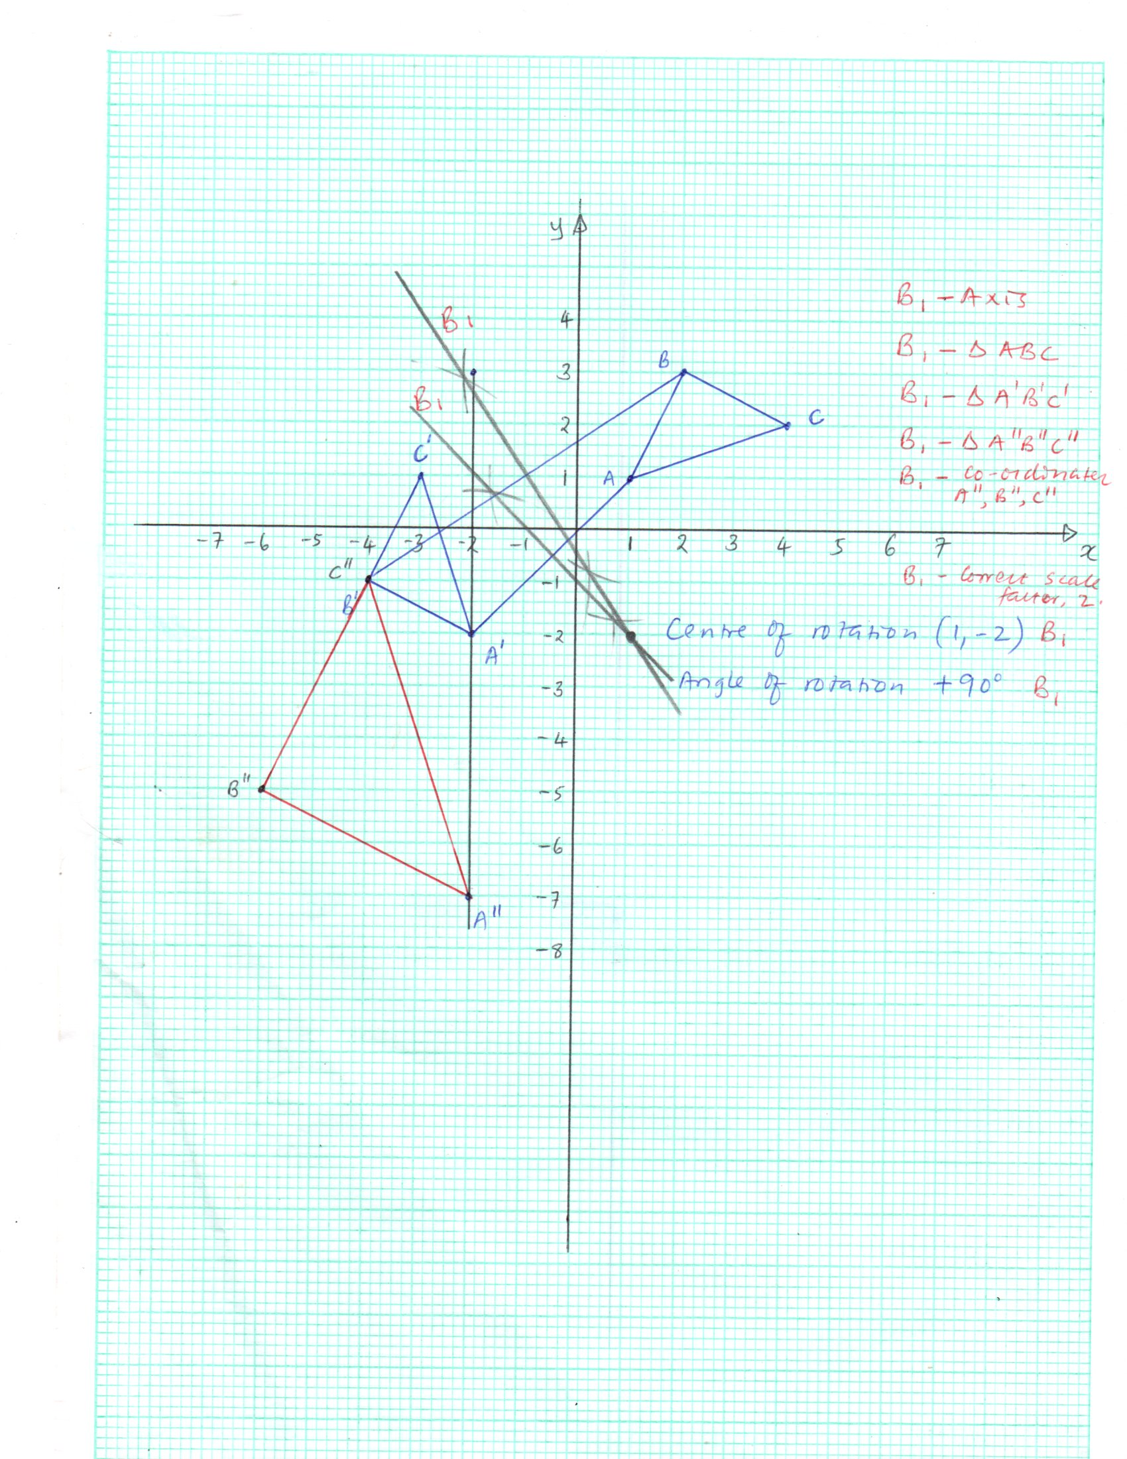

|  |  |  |  |
| --- | --- | --- | --- |
| 19 | 1. 385     b )    1 000 000kg/   1. Vol of cylinder = 385 ${cm}^{3}$  Vol of cuboids $4×x^{2}×10$ $$\frac{40}{40}x^{2}=\frac{385}{40}{cm}^{3}$$ $$b^{2}=9.625$$ b = $\sqrt{9.625}$ = 3.102 | M1  M1 A1  M1  A1  M1  M1  M1  M1  A1 |  |
| 20 | 1. =     D C  10.5 h 10.5  80  A T x B    Area of AXYBCD     1. Area of the shaded part   = 396.58-154  = 88.58 cm2 | M1  A1  B1  B1  M1  A1  M1  A1  M1  A1 |  |
| 21 | 1. i. V      1. Volume of marble (sphere) = 2. Surface area = | M 1  A 1  M 1  A 1  M 1  M 1  A 1  M 1  A 1 |  |