**PYSICS FORM 1**

**END TERM 2 YEAR 2022**

**MARKING SCHEME**

**SECTION A (40 MARKS)**

1. a). Name three branches of physics (3mks)

Mechanics, electricity and magnetism, thermodynamics geometrical optics, waves and Atomics physics.

b). Explain how biology is related to physics. (2mks)

Knowledge of lenses (learned in physics has helped in the making of the microscope which has assisted in the study of the cell, the Basic unit of the basic unit of life.

c). Kamau a form one student visited the lab to conduct an experiment in electricity, state two observation he is to observe before doing the connections. (2mks)

i) Electrical appliances he used were not faulty

ii) Electrical appliances he used were not wet.

2. The table below shows the basic physical quantities in physics . fill in the blank spaces. (3mks)

|  |  |  |
| --- | --- | --- |
| Basic physical quantity | SI unit | Symbol of unit |
| length | Metre | m |
| Electric current | Ampere | A |
| Intensity | Candela | Cd |

1. Define force and state its SI unit (2mks)

Force is a push or pull expressed in newton’s

1. Name two forces acting on a cork floating on water. (2mks)

Weight upthrust and surface tension

1. Two identical spring balances A and B each weighing 0.8N are arranged as shown below.

What are the readings of A and B? (2mks)

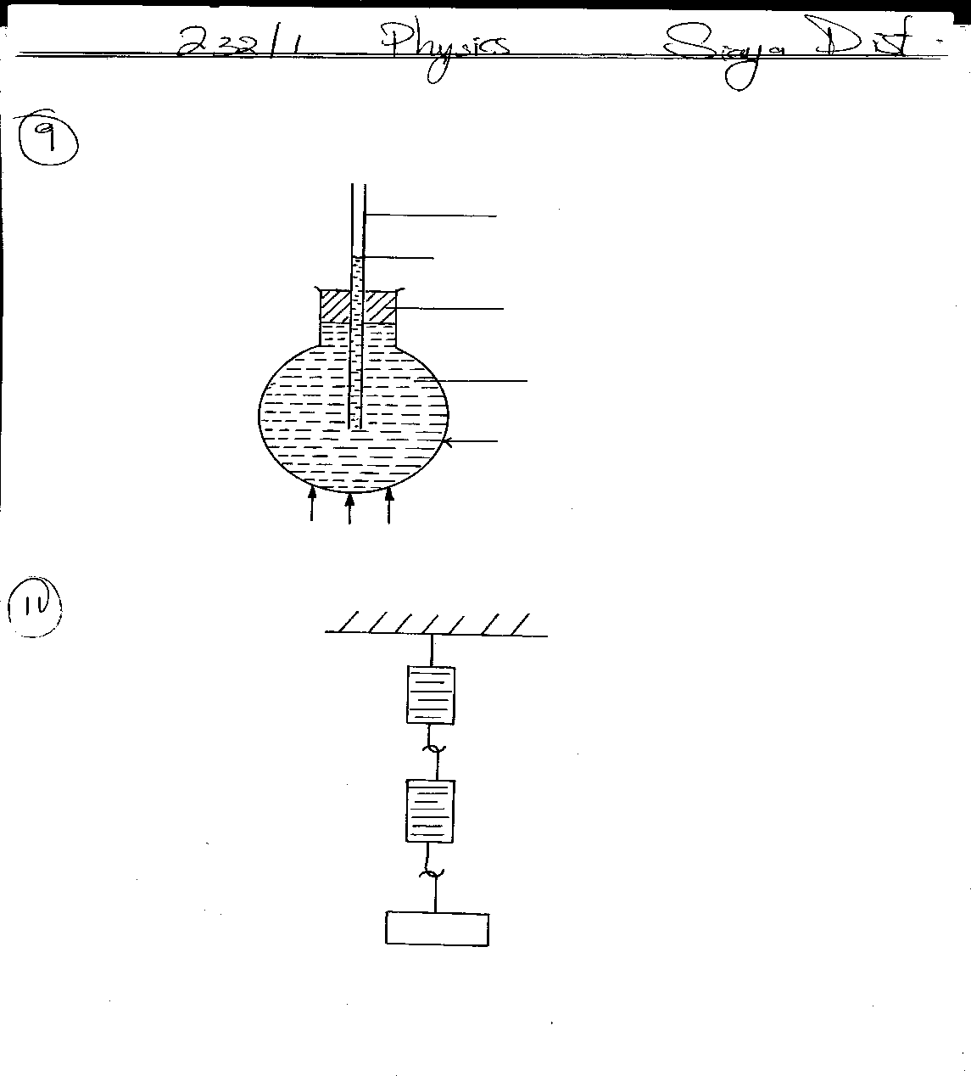

**A**

**B**

**30N**

Readings of A = 30 + 0.8 = 30.8N

Readings of B = 30N

1. a) The diagram below shows water drops being placed slowly on two surfaces.

clean glass waxed surface

Draw the two surfaces with water drops on them. (2mks)

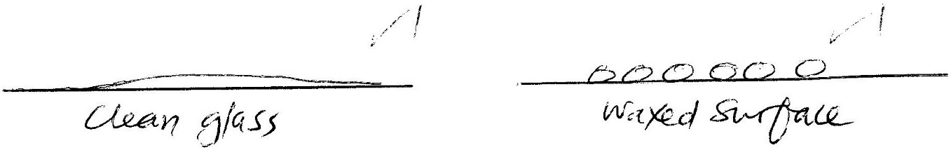

b) Explain the appearance of the drop on the two surfaces. (2mks)

* On clean glass adhesive forces are stronger than cohesive forces.
* On waxed surface cohesive forces are stronger than adhesive forces

1. a) State three differences between mass and weight. (3mks)

|  |  |
| --- | --- |
| Mass | Weight |
| 1. Quantity of matter in a body 2. Measured in kilograms 3. Same everywhere 4. Measured using a beary balance 5. Has magnitude only | Pull of gravity on a body  Measured in newtons  Changes from place to place  Measured using a spring balance  Has both magnitude and direction |

b) A mass of 7.5kg has weight of 30N on a certain planet. Calculate the acceleration due to gravity on this planet. (2mks)

W = mg

30 = 7.5 x g

g = 30/7.5 = 4N/Kg

1. A) What is matter. (1mk)

Matter is anything that occupies space and has mass.

**b)** Name two pieces of evidence which shows that particles of matter moves. (2mks)

1) Diffusion e.g. spreading of ammonia gas

2) In the smoke cell experiment Bright specks are observed to move in continuous random motion.

1. List down three states of matter. (3mks)

Solid, liquid and gas

1. With an aid of diagram describe an experiment that you would use to show that matter is made up of tiny particles. (3mks)

* Using beakers potassium permanganate crystals and water, dissolve some crystals using half full beaker of water until the solution is purple in colour.
* transfer half of the solution into another beaker and fill it with water to dilute the solution.
* continue the process with other beakers, comparing the colour through each dilution.
* Conclusion: As water increases, particles of potassium permanganate are spread further making the colour less and less deep.
* This shows that solid kmno3 is made up of tiny particles.

1. a) When the stopper is removed from a bottle containing liquid ammonia, the ammonia can be smelled in all parts of the room after a short while. Explain this observation. (2mks)

Diffusion; the particles of the gas spread from the bottle (high concentration) to all other areas (of low concentration)

b) State two factors that affect the rate of diffusion in gases. (2mks)

1) density of the gas

2) temperature

1. A) explain the meaning of the term electrostatic. (1mk)

Electrostatic is the study of static charges.

b) state the basic law of electrostatic. (1mk)

Like charges repel and unlike charges attract each other.

**SECTION B (60 MARKS)**

1. a) Draw a well labeled diagram of a clinical thermometer. (3mks)

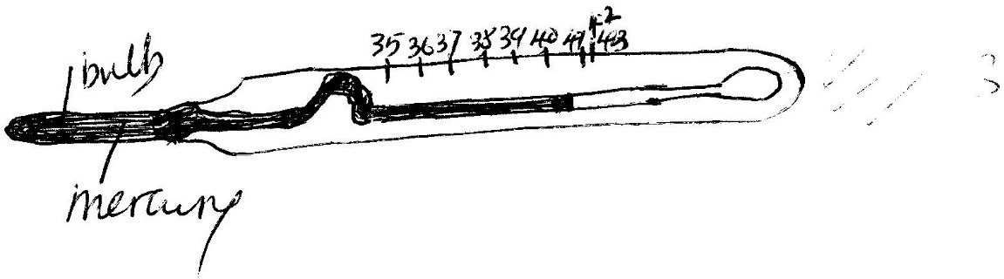

B) Give a reason why clinical thermometer cannot be sterilized using boiling water. (1mk)

boiling water is at 100oC and clinical thermometer measures upto 43oC; hence sterilizing the thermometer with boiling water will make the mercury expand and break it.

c). State two features of liquid in glass thermometer that makes it sensitive. (2mks)

- thin wall

- capillary bore

d) . Give three reasons why water is not suitable as thermometric liquid. (3mks)

1) Anomalous expansion (between 0oC & 4oC)

2) colourless

3) wet glass

4) low cooling point

5) high freezing point

e). convert the following into units in the brackets.

I) 200c (K) (2mks)

20 = 273 = 293

II) 180K (0c) (2mks)

180 – 273 = - 93oC

1. A). Define the term pressure and state its SI unit. (2mks)

Pressure is force acting perpendicularly per unit area expressed in Newtons per square meter.

b). what property of mercury makes it suitable for use in a barometer? (1mk)

high density

c). In an experiment to demonstrate atmospheric pressure, a plastic bottle was partially filled with hot water and the bottle is tightly corked. After sometime the bottle started to get deformed.

i) state the purpose of the hot water. (1mk)

To drive air out.

ii). Explain why the bottle got deformed. (2mks)

due to higher pressure outside the bottle compared to lower pressure inside the bottle, air tried to enter the bottle deforming the bottle.

d). The diagram below shows a mercury barometer.

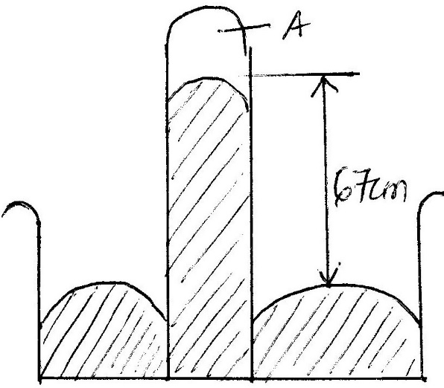

1. Name the part labeled A (1mk)

vacuum

ii) Calculate the atmospheric pressure of the place in;

I). mmHg (1mk

670mmHg

II). Pascals given the density of mercury is 13600Kg/m3 (3mks)

pressure = $l$ gh 1mk

= 13600 x 10 x $\frac{67}{100}$ 1mk

91120 Pascals

d). State ***two*** advantages of a force pump over lift pump. (2 marks)

1) It enables a continuous flow of water 1mk

2) The height to which water can be raised by the force pump does not depend on atmospheric pressure.

1. A) Define volume and state its SI unit (2mks)

VOLUME is the amount of space occupied by matter, expressed in cubic metres.

b). the figure below shows a measuring cylinder which contains water initially at level A. when a solid of mass 10g is immersed in water the level raises to B.

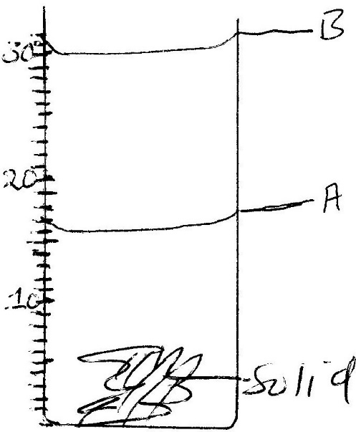

Determine;

1. the volume of the solid. (2mks)

Volume of the solid = 30 – 16 1mk

= 14 cm 3

1. the density of the solid (3mks)

density = $\frac{mass}{volume}$ 1mk

= $\frac{10 g}{14 cm3}$ 1mk

= 0.7143 g/cm 3 1mk

c) In an experiment to estimate the height of a tree in a school compound, a form one student recorded the following data;

Length of the shadow of the tree =900cm

Length of shadow of the rod = 300cm.

Height of the rod = 150cm

Determine the height of the tree in SI unit. (3mks)

= 1mk

= 1mk

2H = 900

H = 450 cm

= 45 m 1mk

d)The diameter of a hydrogen atom is 0.00000008cm. express this diameter in SI unit in standard form. (2mks)

diameter = 0.00000008cm

= $\frac{0.00000008m}{100}$ 1mk

= 0.0000000008m

= 8.0 x 10 -10 m 1mk

1. A) State two laws of reflection light. (2mks)

Law 1: The angle of incidence i, is equal the angle of reflection r. 1mk

Law 2: The incident ray, the reflected ray and the normal at the point of incidence all lie on the same plane. (1mk)

b) The diagram below shows a ray of light incident on a plane mirror.

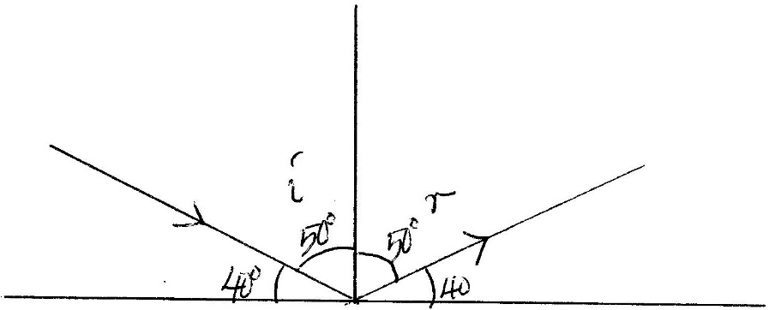

Find the angle of reflection. (2mks)

I = 90 – 40 = 50o 1mk

R = i = 50o

R = 50o 1ml

c). A student placed two plane mirrors at an angle X to each other and counted seven images of an object placed between the mirrors determine the angles between mirrors. (3mks)

No. of images =

7 =

8 =

X = = 45o 1mk

d) A pinhole camera camera forms an image of a flagpost 30m infront of the pinhole. If the height of the image is 10 cm and the screen is 20cm behind the pinhole, determine the height of the flagpost. (3mk)

$\frac{10}{H}$ = $\frac{30}{3000}$ 1mk

20 H = 10 x 3000

H = $\frac{10 x 3000}{20}$

H = 1500 cm

= 15 m

e) State two differences between the image formed by plane mirror and pinhole camera. (2mks)

|  |  |
| --- | --- |
| Plane mirror image | Pin hole camera image |
| 1. image is upright 2. image is virtual 3. image cannot be formed on a photographic plate | Image is inverted  Image is real  Image can be formed on photographic plate |

1. A) State three factors that affect heat conductivity in solid. (3mks)

1) Length of conductor 1mk

2) Cross-section area (thickness) 1mk

3) Temperature difference between ends of conductor

4) Nature of the material 1mk

b) Two copper rods A and B of the same length are attached with candle wax to either end and placed on a wooden blocks equidistant from the source of heat as shown below.

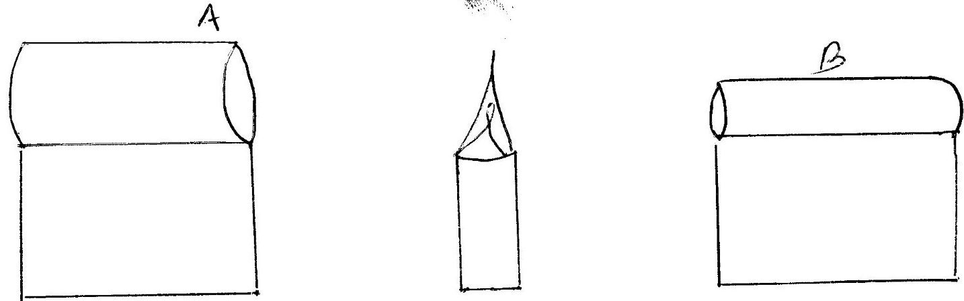

1. Which wax will melt first. (1mk)

Wax on rod A

1. give a reason for your answer in (i) above. (1mk)

rod A has a larger cross-sectional area (thickness) 1mk

1. Figure 8 shows a cross section of a vacuum flask

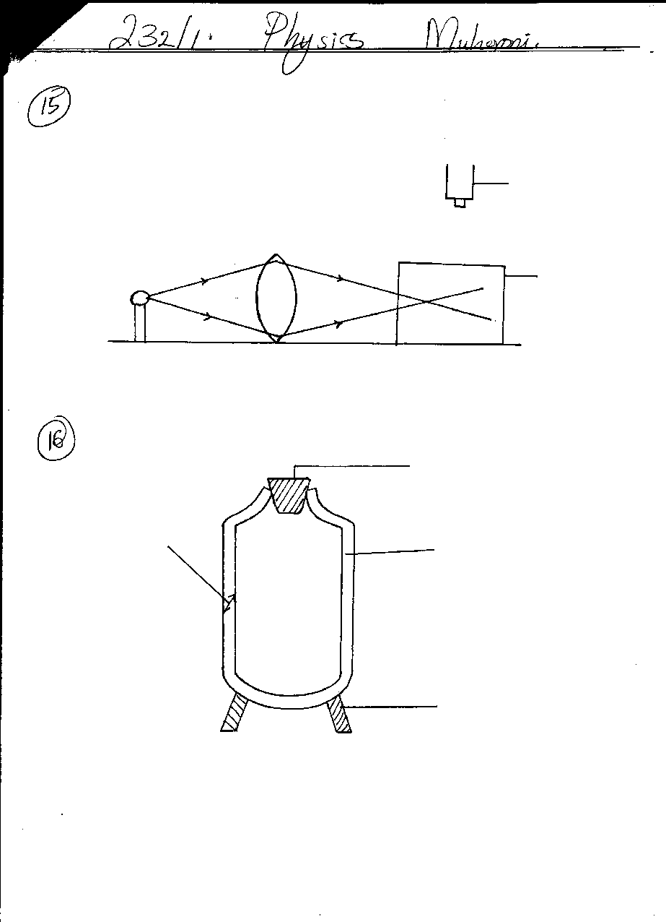

**Fig.8**

**B**

**A**

**Cork**

**Support**

(a) (i) Name the parts labelled **A** and **B (2mks)**

**A** ………Vacuum………………………..

**B** …Silvered wall………………..

(ii) Explain how the heat losses are minimized when hot liquid is poured into the flask (3mks)

1) Vacuum as an excellent insulator minimises heat transfer by conduction and convection.

1mk

2) Silver coating reduces heat transfer by radiation since silvery walls is a poor emitter and poor absorber of heat. 1mk

3) The wall-fitting cork reduces heat loss by evaporation. 1mk