**PHYSICS FORM 2**

**END TERM 2 YEAR 2022**

**MARKING SCHEME**

**SECTION A (50MARKS)**

1. 50 drops of a liquid were released from a burette which was originally reading 22cm3 to give a new reading of 56cm3. Calculate the volume of each drop. (2mks)

Vol. of 50 drops = (56 – 22)

= 34 cm3

Vol of 1 drop =

= 0. 68 cm3

1. (a) State two factors that affect surface tension. (2mks)

i) Temperature

ii) Impurities

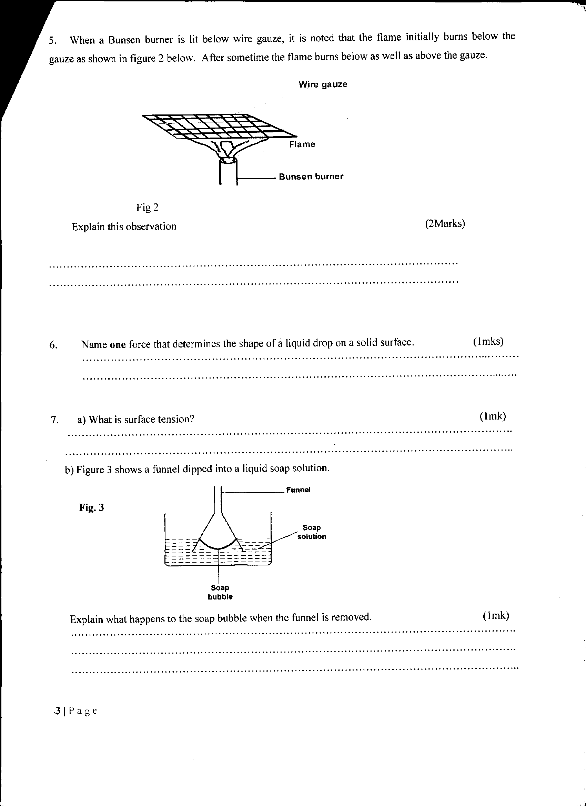(b) Figure 3 below shows a funnel dipped into a liquid soap solution.

**Fig 3**

Explain what happens to the soap bubble when the funnel is removed. (1mk)

* The soap bubble recedds inwards.

* This is due to surfaces tension. (The soap bubble behaves as if its surface is lights stretched)

1. State **one** defect **of** a simple cell and how it can be minimized. (2mrks)

Porlisation

* Addition of potassium dichromate which reacts with hydrogen to form water.

* Local Action

* Use sure zinc or amalgamate (coat) zinc with mercury.

1. State the property of light associated with formation of shadows (1mk)

Rectilinear propagation of light.

1. (i) State the basic law of electrostatics. (1mk)

Like charges repel with unlike charges attract.

ii) A) List down four uses of electroscope. (4mk)

i) To detect the presence of charges on a body

ii) To test the quantity of charge on a charged body.

iii) To rest the insulations properties of a material.

(iii) In testing for the sign of charge on a body, state and explain the behaviour of a

positively charged electroscope when negatively charged body is brought closer to the cap of the electroscope. (2mks)

The divergence of the leaf decreases,

1. A) Define electric current. (1mk)

Rate of flow of charges or change per unit time

b) A current of 0.25A is flowing through a lamp. Find the time it will takes for 75C of charge to pass through the lamp. (3mks)

I = 0.25A t = $\frac{Q}{I}$ t = (300 (s)

Q = 75C

t = ? t = $\frac{75}{0.25}$

1. A) State the principle of transmission of pressure. (1mk)

Pressure applied at one point of an enclosed liquid is transmitted equally all other part of the enclosed liquid,

b) In the figure below piston A has area of 12.25cm2 while piston B has an area of 196cm2. If a force of 11N is exerted on piston A, calculate the force exerted on piston B. (3mks)

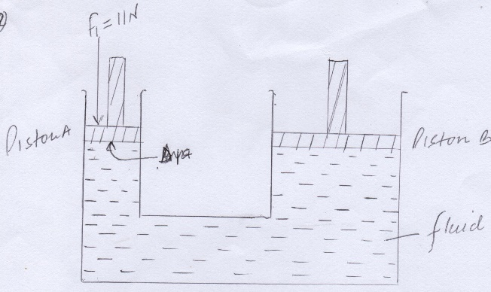

A1 = 12.25 cm2

A2 = 196 cm 2

F1 - ?

F2 = ?

$\frac{F1}{A1 }$ = $\frac{F2}{A2}$ F2 = $\frac{11}{12.25}$ x 196

$\frac{11}{12.25}$ = $\frac{F2}{196}$ F2 = 176 N

1. A) The figure below show a microscope M focused on smoke particles inside a glass container.

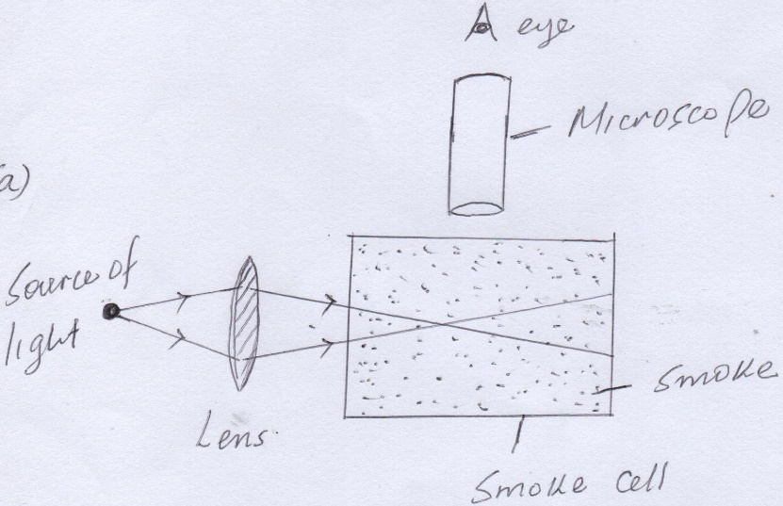

1. Explain what is observed. (2mks)

Bright specks are seen in continuous Random motions.

The bright specs are smoke particles and they move in continuous random motion due to uneven bombardment by invisible air particles

1. What change is observed to the movement of smoke particles when temperature is increased. (1mk)

The rate of random movement of particles increases.

1. State three differences between alcohol and mercury as thermometric liquid (3mks)

|  |  |
| --- | --- |
| Alcohol | Mercury |
| * Low boiling point (780c) * Low melting point (-1150c) * Poor thermal conductor * Slightly irregular expansion * Wets glass * Not easily visible in glass (needs coloring) | * High boiling point (3570c) * Higher melting point (-390c) * Good thermal conductor * Regular extension * Does not wet glass * Opaque and silvery (visible in glass) |

1. A) Differentiate between scalar and vector quantity. Give one example of each. (4mks)

Scalar quantity – has only magnitude and no direction

Vector quantity – has both magnitude and direction

Examples:

Scalar quantity – Mass, area, volume density, energy, time, pressure, temperature, length

Vector quantity – force, velocity, displacement, acceleration, momentum.

b)Two forces 6N and 8N acts on a body at right angle . draw the two forces acting on the body and find the resultant force diagrammatically. (4mks)

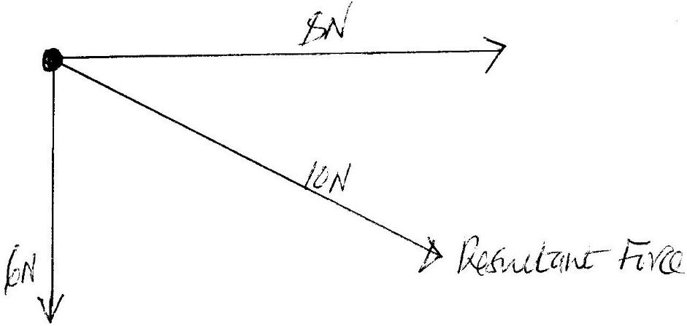

1. In a vacuum flask the walls enclosing the vacuum are silvered on the inside. State the reason for this. (1mk)

To reduce heat transmission by radiation.

1. Explain how physics is related to the following subject.
2. Mathematics (1mk)

Many concepts in physics are expressed mathematically

1. History (1mk)

Carbon dating, serves as a tool to the historians I establishing fossil ages.

Magnetic properties of iodestone was made use by explorers to determine direction

1. The diagram below shows three glass tubes A, B and C of different diameters dipped in water. The level of water in A is indicated.

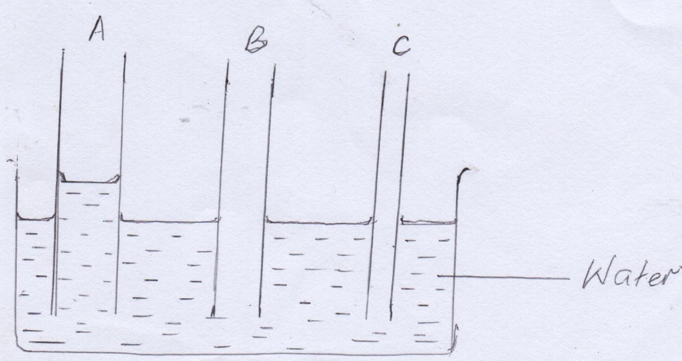

1. Mark the appropriate levels of water in B and C. (2mks)

B higher than A but lower than C

1. Explain your observations. (2mks)

This is due to capillarity

Capilarity is more in narrow tubes than in wide tubes. In narrow tube adhesion forces are greater for water.

1. The diagram below shows a plane mirror, an eye and an object.

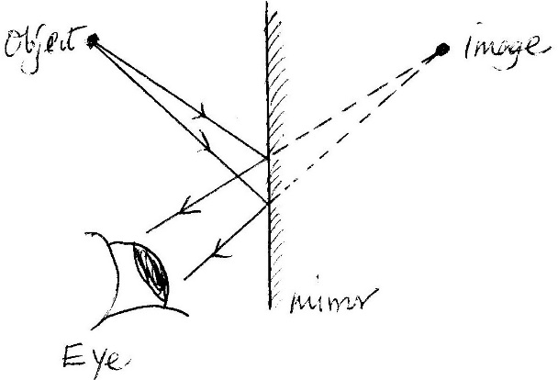

complete the ray diagram to show the position of the image. (3mks)

1. A form one student conducted experiment in the laboratory.

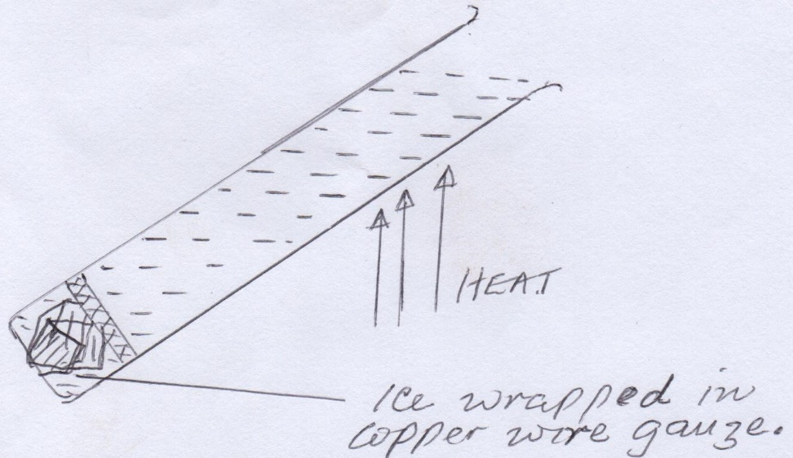

water was heated as shown until it started boiling at the top.

1. What is the purpose of the wire gauge. (1mk)

* To hold the ice block at the bottom to the tube

1. What was observed on the ice. (1mk)

* The ice did not melt

1. What was the aim of the experiment. (1mk)

* Show that water is a poor conductor of heat.

1. A uniform mixture consists of 30cm3 of water and 40cm3 of ethanol. If the densities of water and ethanol are 1g/cm3 and 0.85g/cm3respectively. Determine the density of the mixture. (4mks)

Mass of water = (30cm3 x 1g/cm3 )= 30 g

Mass of ethanol = 40 x 0.85 = 34 g

Total mass of the mixture = 64g

Total volume of the mixture = 30 + 40

= 70 cm3

Density of the mixture = 64/70

= 0.9143 g/cm3

**SECTION B (50 MARKS)**

1. State the basic law of magnetism. (1 mark)

Like poles repel unlike poles attract

1. The figure **below** shows how magnets are stored in pairs with keepers at the ends.

S

N

A

B

Bar magnets

Keeper

Keeper

Identify pole A …North pole…. and B…North pole…….. (2 marks)

c) Explain why soft iron keepers are suitable for storing magnets (2mks)

* They are easily magnetized
* More permeable to magnetism

d) Figure below shows a current carrying conductor. Indicate the direction of current in the conductor hence the magnetic filed pattern. (2mks)

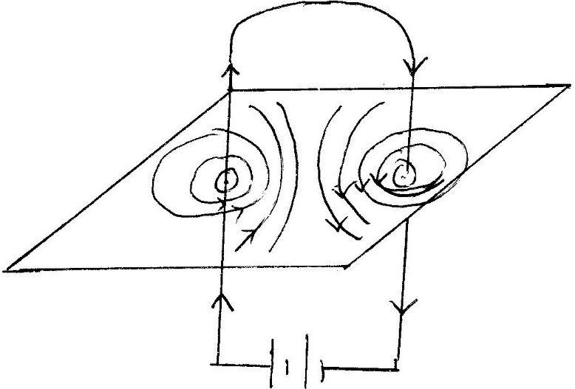

1. Figure below shows a conductor carrying current placed in the magnetic field of two magnets. Complete the diagram by showing the field pattern and the direction of force F that acts on the conductor (2mks)

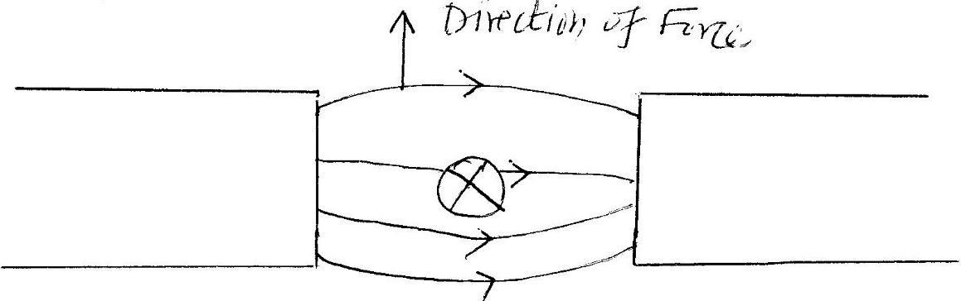

1. State 3 factors that affect the strength of electromagnet. (3mks)

* Number of turns in the coil
* Amount of current flowing in the coil
* Type of the material making the core

1. (a) (i) Define the term centre of gravity of a body. (1mk)

Point of application of the resultant force due to earth’s attraction on the body.

(ii) Locate the C.o.g. of the cylinder shown below. (1mk)

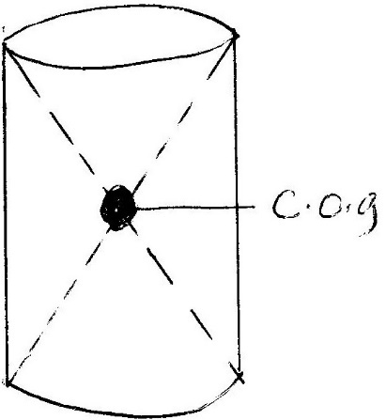

1. State two factors affecting stability of the body. (2mks)

* Position of the center of gravity
* The base area of the body

1. The figure below shows a boy and a girl on playground seesaw. The seesaw has a mass of 30kg and is pivoted at its centre. Their mother has to hold the girl’s end in order to keep the seesaw level. The boy’s mass is 50kg and the girl’s mass is 30kg. All the distances are shown on the diagram.

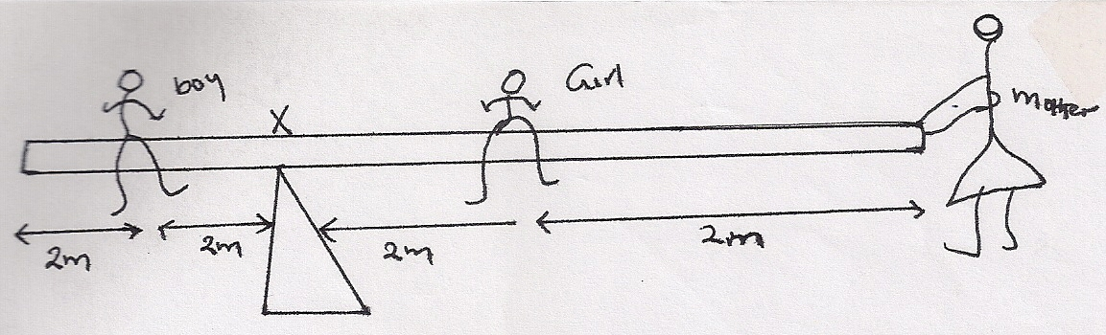

Calculate:

1. The turning effect of the boy’s weight about point x. (1mk)

Moment of a force = F x perpendicular distance

= 50 x 2

= 100Nm

1. The turning effect of the girl’s weight about x. (1mk)

Moment = F x perpendicular distance

= 30 x 2

= 60Nm

1. The force their mother must apply on the end of the seesaw in order to keep it level. (2mks)

(F x 4) + (30 x 2) = 100Nm

4F = 40

F = 10N

1. The total downward force in the central support of the seesaw. (2mks)

Total downward force = 10N + 300N + 500N

= 510N

1. A)State Hookes law. (1mk)

For an elastic material, the extension produced is directly proportional to the force applied provided the elastic limit is not exceeded.

b) i) A rubber chord of elastic constant 200N/m support an object of mass 400g. the object is then pulled down by an extra force of 1.6N. calculate the total extension of the rubber (3mks)

F = ke

e = F/k

Total force (F) = 1.6 + 0.4 = 2N

= 2N/200N/m

e = 0.01m

1. Two springs of elastic constant 400N/m are arranged in series and a load of 500g is suspended from the combination at the lower end. Find the extension of the combination. (3mks)

F = ½ Ke

F = 5N

K = 400N/m

e = $\frac{5 x 2}{400}$

e = 0.025 m

1. Sketch a graph of force against extension for material that obeys Hookes law. (2mks).

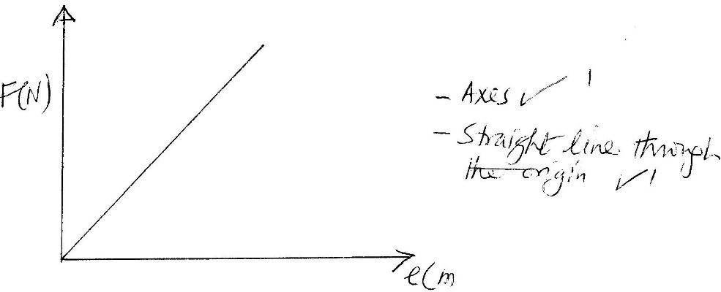

1. Ai) Distinguish between concave and convex mirrors. (2mks)

Concave – Converges light after reflection

Convex – Diverges light after reflection

1. State one application of each of the following.
2. Convex mirror (1mk)

* Driving side mirror
* Supermarket mirror

1. Parabolic mirror (1mk)

* Solar heat reflections
* Torch reflection
* Head – light reflector

b) An object O is placed infront of a concave mirror as shown in the figure below.

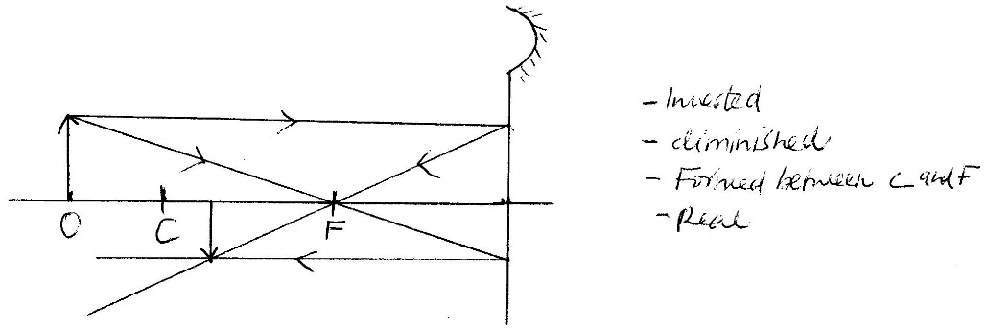

1. Complete the diagram to show the position of the image. (3mks)
2. State two properties of the image formed. (2mks)

* Inverted
* Diminished
* Formed between c and f
* Real

1. An object is placed 30cm from a concave mirror of focal length 20cm. calculate the position of the image. (3mks)

1/f = 1/v + 1/u

1/20 = 1/v + 1/30

1/v = 1/20 – 1/30

= $\frac{3-2}{60}$

= 1/60

V = 60

Position of the image is 60cm in front of the mirror

1. In an experiment to estimate the size of an oil molecule, an oil drop of diameter 0.05cm spreads

over water to form a circular path whose diameter is 15cm.

Determine :

(i) Volume of the drop. (2mrks)

Volume of the drop = 4/3 π r3

= 4/3 x 22/7 x (0.05/2)3

= 6.545 x 10-5 cm3

(ii) Area of the patch (2mrks)

Area of the patch = πr2

= 22/7 x (0.15/2)2

= 1.178 x 10-2cm2

(iii) Size of the oil molecule (2mrks)

Size/thickness of the molecule = $\frac{Volume of drop}{Area of patch}$

= $\frac{6.545 x {10}^{-5}}{1.178 x {10}^{-2}}$

= 5.556 x 10-3 cm