**NAME: ……………………………………………………………ADM. NO: .......…CLASS:…**

**AGRICULTURE**

**END YEAR EXAM, FORM TWO**

**NOV 2022**

1. State four symptoms of liver fluke attack in sheep. (2mks)
2. State four control measures of beef tape worm. (2mks)
3. State four ways of controlling lice in poultry. (2mks)
4. State four signs of infestations by external parasites in goats. (2mks)
5. State four characteristics of roughage in livestock feeds. (2mks)
6. State two functions of the crop in digestive system. (2mks)
7. State four factors that affect the digestibility of a feed in dairy animals. (2mks)
8. State four functions of vitamins. (2mks)
9. Prepare 100kg of pig ration containing 20% D.C.P using cereal balancer 10% D.C.P and cotton seed cake 30% D.C.P show your working. (4mks)
10. Define the term Health in livestock. (1mk)

b. State four physiological parameters that can be used as indicators of ill health in livestock. (2mks)

1. What are infectious diseases in livestock? (1mk)

b. Name the causes of infectious diseases in livestock. (1 ½ mks)

c. Explain two different ways through which good nutrition can help to control diseases in livestock. (2mks)

d. Define the term Quarantine. (1mk)

1. b. Identify the cabbage pest shown below. (1mk)

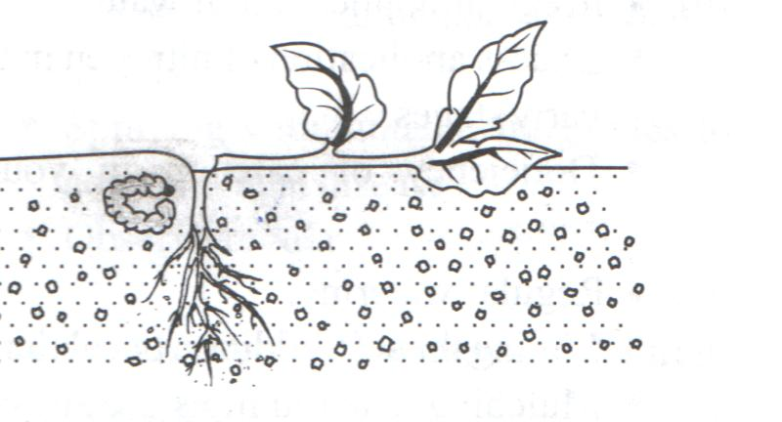

b. Suggest three possible control measures for the pest. (3mks)

c. Name two diseases of cabbage crop. (1mk)

1. State four factors considered when selecting a site for a tomato nursery bed. (2mks)
2. State three advantages of single stem pruning over multiple stem pruning. (1 ½ mks)
3. State four qualities of an ideal grain store. (2mks)
4. State four factors that determine the harvesting stage of a crop. (2mks)
5. Give the importance of carrying out the following in a nursery bed.
6. Pricking out (1mk)
7. Hardening off (1mk)
8. Study the illustration in the diagram below and answer the questions that follow. (1mk)

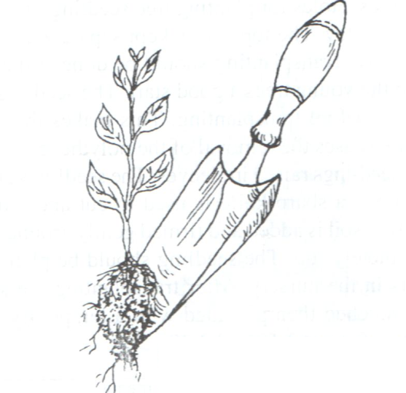

1. Identify the practice being illustrated. (1mk)
2. State three activities that should be carried out for successful results in the practice shown above. (3mks)
3. At what stage should the practice be carried out in vegetable seedlings.(1mk)
4. State four advantages of row planting. (2mks)
5. State four factors considered in timely planting. (2mks)
6. State four aspects of rainfall that influence agriculture. (2mks)
7. State four effects of applying excessive nitrogen in crop production. (2mks)
8. State two causes of hard pans. (2mks)
9. Name three tertiary operations carried out in land preparation.(1 ½ mks)
10. Name three types of pumps used by farmers. (1 ½ mks)
11. Give four reasons for treating water before use. (2mks)
12. State four factors that affect the quality of farm yard manure. (2mks)
13. Name four breeds of dairy goats. (2mks)
14. Give two types of labour records. (2mks)
15. Define agricultural economics. (1mk)