**NAME:…………………………………………………………… ADM. NO………………**

**SCHOOL:……………………………………………………SIGNATURE……………………DATE…………….……………………**

**443**

**AGRICULTURE**

**(Theory)**

**TIME: 2 HOURS**

November 2022 Examinations

**FORM 1**

**INSTRUCTIONS TO CANDIDATES**

* Write your name and Adm. number in the spaces provided.
* Answer ALL the questions in the spaces provided,

**FOR EXAMINERS USE ONLY**

|  |  |  |
| --- | --- | --- |
| Question | Maximum score | Candidates score |
| 1-22 | 100 |  |

***This paper consists of 8 printed pages. Candidates should check the question paper to ensure that all the pages are printed as indicated and no questions are missing.***

**1.**  Give **four** reasons as to why Agriculture is regarded as an art. **(4 marks)**

**………………………………………………………………………………………………………………………………………………………………………………………………………………………………………………………………………………………………………………………………………………………………………………………………………………………………………………………………………………………………………………………………………………………………………………………………………………………………………………………………………………………………**

**2.** Give the meaning of the terms. **(2 marks)**

Olericulture

**………………………………………………………………………………………………………………………………………………………………………………………………………………………………………………………………………………………………………………………………………………**

Pomology

**………………………………………………………………………………………………………………………………………………………………………………………………………………………………………………………………………………………………………………………………………………**

**3.** List **four** branches of livestock farming.  **(2 marks) ……………………………………………………………………………………………………………………………………………………………………………………………………………………………………………………………………………………………………………………………….**

**4.** What is agroforestry? **(1 mark)**

**………………………………………………………………………………………………………………………………………………………………………………………………………………………………………………………………………………………………………………………………………………**

**5. a)** Name **two** intensive farming systems in crops and in livestock farming. **(1 mark)**

Crops

**………………………………………………………………………………………………………………………………………………………………………………………………………………………………………………………………………………………………………………………………………………**

livestock. **(1 mark)**

**………………………………………………………………………………………………………………………………………………………………………………………………………………………………………………………………………………………………………………………………………………**

**b)** State **four** characteristics of extensive farming.  **(4 marks)**

**………………………………………………………………………………………………………………………………………………………………………………………………………………………………………………………………………………………………………………………………………………**

**………………………………………………………………………………………………………………………………………………………………………………………………………………………………………………………………………………………………………………………………………………**

**6.** Name a system of farming which is characterized by use of large tracks of land and production of

one crop. **(1 mark)**

**………………………………………………………………………………………………………………………………………………………………………………………………………………………………………………………………………………………………………………………………………………**

**7.** State **two** limitations of mixed farming. **(2 marks)**

**………………………………………………………………………………………………………………………………………………………………………………………………………………………………………………………………………………………………………………………………………………**

**8.** List **three** characteristics of shifting cultivation. **(3 marks)**

**………………………………………………………………………………………………………………………………………………………………………………………………………………………………………………………………………………………………………………………………………………**

**9.** State **four** as to why agriculture is important in Kenya. **(4 marks)**

**………………………………………………………………………………………………………………………………………………………………………………………………………………………………………………………………………………………………………………………………………………**

**10. a)** What are the advantages of organic farming in regard to environmental conservation. Give three.

**(3 marks)**

**………………………………………………………………………………………………………………………………………………………………………………………………………………………………………………………………………………………………………………………………………………**

**………………………………………………………………………………………………………………………………………………………………………………………………………………………………………………………………………………………………………………………………………………**

**b)** State **four** activities that may be undertaken to achieve organic farming. **(4 marks)**

**………………………………………………………………………………………………………………………………………………………………………………………………………………………………………………………………………………………………………………………………………………………………………………………………………………………………………………………………………………………………………………………………………………………………………………………………………………………………………………………………………………………………**

**11.** Name **four** factors that influence agricultural production. **(2 marks)**

**………………………………………………………………………………………………………………………………………………………………………………………………………………………………………………………………………………………………………………………………………………………………………………………………………………………………………………………………**

**12.** Give **two** reasons why the healthy wellbeing of a farmer is important in Agricultural production

**(2 marks)**

**………………………………………………………………………………………………………………………………………………………………………………………………………………………………………………………………………………………………………………………………………………**

**13.** Give **three** policies that the has to impose in order to regulate agricultural production. **(3 marks)**

**………………………………………………………………………………………………………………………………………………………………………………………………………………………………………………………………………………………………………………………………………………………………………………………………………………………………………………………………………………………………………………………………………………………………………………………………………………………………………………………………………………………………**

**………………………………………………………………………………………………………………………………………………………………………………………………………………………………**

**14.** Name **four** biotic factors that have negative effects on agricultural production. **(3 marks)**

**………………………………………………………………………………………………………………………………………………………………………………………………………………………………………………………………………………………………………………………………………………**

**………………………………………………………………………………………………………………………………………………………………………………………………………………………………………………………………………………………………………………………………………………**

**15.** State **four** climatic factors that influence Agricultural production. **(4 marks)**

**………………………………………………………………………………………………………………………………………………………………………………………………………………………………………………………………………………………………………………………………………………………………………………………………………………………………………………………………………………………………………………………………………………………………………………………………………………………………………………………………………………………………**

**16.** State **three** effects of low temperature on crop production. **(3 marks)**

**………………………………………………………………………………………………………………………………………………………………………………………………………………………………………………………………………………………………………………………………………………**

**………………………………………………………………………………………………………………………………………………………………………………………………………………………………………………………………………………………………………………………………………………**

**17.** **a)** Identify any **two** methods of increasing light intensity in crop production. **(2 marks)**

**………………………………………………………………………………………………………………………………………………………………………………………………………………………………………………………………………………………………………………………………………………**

**b)** Give the meaning of the following terms as used in light duration. **(2 marks)**

**i)** short day

**………………………………………………………………………………………………………………………………………………………………………………………………………………………………………………………………………………………………………………………………………………**

**ii)** day neutral

**………………………………………………………………………………………………………………………………………………………………………………………………………………………………………………………………………………………………………………………………………………**

**18.** Give **three** soil forming processes. **(3 marks)**

**………………………………………………………………………………………………………………………………………………………………………………………………………………………………………………………………………………………………………………………………………………**

**………………………………………………………………………………………………………………………………………………………………………………………………………………………………………………………………………………………………………………………………………………**

**19**  Name the soil horizons which; has ; **(3 marks)**

1. high amounts of nutrients-

**………………………………………………………………………………………………………………………………………………………………………………………………………………………………………………………………………………………………………………………………………………**

1. contains a hard pan-

**………………………………………………………………………………………………………………………………………………………………………………………………………………………………………………………………………………………………………………………………………………**

**20.** List **three** soil composition **(3 marks)**

**………………………………………………………………………………………………………………………………………………………………………………………………………………………………………………………………………………………………………………………………………………………………………………………………………………………………………………………………………………………………………………………………………………………………………………………………………………………………………………………………………………………………**

**21.** The diagram below shows an experiment set up using soil type G &, H and J and observations made after 24 hours. Study the diagram an answer the questions that follow.

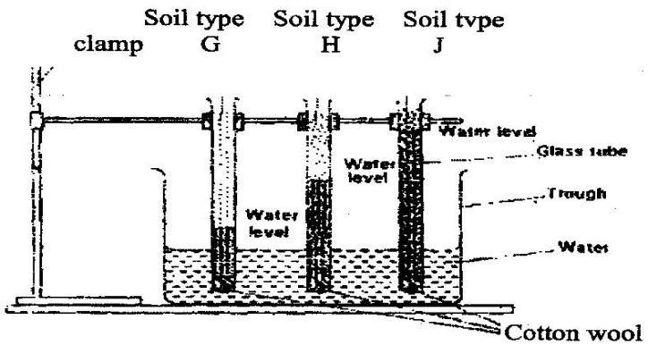

1. What is the experiment represented above designed to study? **(1 mark)**

**……………………………………………………………………………………………………………………………………………………………………………………………………………………**

1. Name the **three** soil types G & H and J. **(3 marks)**

G-

H –

J -

**c)** What is the characteristic texture of soil types G and J? **(1 mark)**

G-

J-

**d)** State **two** ways a farmer would improve the structure of soil type G.  **(4 marks)**

**………………………………………………………………………………………………………………………………………………………………………………………………………………………………………………………………………………………………………………………………………………**

**………………………………………………………………………………………………………………………………………………………………………………………………………………………………………………………………………………………………………………………………………………**

**22.** The table below shows different types of soil structure. Study and answer the questions that follow.

|  |  |  |
| --- | --- | --- |
|  | Soil structure | Where found |
| E | Blocky |  |
| F |  | Top horizons of soils in the forests |
| G | Platy |  |
| H |  | Top horizons of cultivated soils |