**NAME…………………………………………….ADMISSION NUMBER………………………**

**443/1**

**AGRICULTURE**

**TIME:2 HOURS**

**AGRICULTURE**

**PAPER ONE**

**NOVEMBER 2022 EXAMINATION**

**TIME 2HOURS**

**INSTRUCTIONS TO CANDIDATES.**

* *Write your name and admission number in the spaces provided.*
* *Answer all questions in the spaces provided.*
* *This question paper consists of three sections A, B and C.*
* *Answer all the questions in sections A and B any two questions from section C.*
* *Answers should be written in the spaces provided.*
* *The paper consists of 11 printed pages*

**For Examiner’s use only**

|  |  |  |  |
| --- | --- | --- | --- |
| **Section** | **Question** | **Maximum score** | **Candidate’s score** |
| **A** | 1-15 | 30 |  |
| **B** | 16-20 | 20 |  |
| **C** | 21 | 20 |  |
| 22 | 20 |  |
| 23 | 20 |  |
| **Total** |  | 90 |  |

*Candidates should check the question paper to ascertain that all the pages are printed as indicate and no questions are missing.*

**SECTION A**

1. State four advantages of shifting cultivation. 2mks

……………………………………………………………………………………………………………………………………………………………………………………………………………………………………………………………………………………………………………………………………………………………………………………………………………………………………………………………………………………………………………

1. Give four characteristics of Horizon A in a soil profile 2mks

……………………………………………………………………………………………………………………………………………………………………………………………………………………………………………………………………………………………………………………………………………………………………………………………………………………………………………………………………………………………………………

1. Differentiate between soils formed in ʿsitu’ and soil formed in deposition. 1mk

……………………………………………………………………………………………………………………………………………………………………………………………………………………………………………………………………………………………………………………………………………………………………………………………………………………………………………………………………………………………………………

1. State three factors which determine the depth of ploughing during land preparation. 1½mks

……………………………………………………………………………………………………………………………………………………………………………………………………………………………………………………………………………………………………………………………………………………………………………………………………………………………………………………………………………………………………………

1. What is secondary cultivation. ½mk

……………………………………………………………………………………………………………………………………………………………………………………………………………………………………………………………………………………………………………………………………………………………………………………………………………………………………………………………………………………………………………

1. State four types of water pumps. 2mks

……………………………………………………………………………………………………………………………………………………………………………………………………………………………………………………………………………………………………………………………………………………………………………………………………………………………………………………………………………………………………………

1. Give four reasons as to why green manure is not commonly used by farmers 2mks

……………………………………………………………………………………………………………………………………………………………………………………………………………………………………………………………………………………………………………………………………………………………………………………………………………………………………………………………………………………………………………

1. State four importance of keeping proper and up to date farm records. 2mks

……………………………………………………………………………………………………………………………………………………………………………………………………………………………………………………………………………………………………………………………………………………………………………………………………………………………………………………………………………………………………………

1. State four characteristics of Nitrogenous fertilizers. 2mks

……………………………………………………………………………………………………………………………………………………………………………………………………………………………………………………………………………………………………………………………………………………………………………………………………………………………………………………………………………………………………………

1. Give four advantages of using seeds as planting materials. 2mks

……………………………………………………………………………………………………………………………………………………………………………………………………………………………………………………………………………………………………………………………………………………………………………………………………………………………………………………………………………………………………………

1. State four advantages of budding in crop production. 2mks

……………………………………………………………………………………………………………………………………………………………………………………………………………………………………………………………………………………………………………………………………………………………………………………………………………………………………………………………………………………………………………

1. Outline four advantages of organic mulching in farming. 2mks

……………………………………………………………………………………………………………………………………………………………………………………………………………………………………………………………………………………………………………………………………………………………………………………………………………………………………………………………………………………………………………

1. Why is it not advisable to use organic manure when growing carrots .Give two reasons.1mk

……………………………………………………………………………………………………………………………………………………………………………………………………………………………………………………………………………………………………………………………………………………………………………………………………………………………………………………………………………………………………………

1. a)Give four ways of acquiring land. 2mks

……………………………………………………………………………………………………………………………………………………………………………………………………

b)Outline four general objectives of the million acreschems.4mks

……………………………………………………………………………………………………………………………………………………………………………………………………

1. State four types of soil erosion. 2mks

……………………………………………………………………………………………………………………………………………………………………………………………………………………………………………………………………………………………………………………………………………………………………………………………………………………………………………………………………………………………………………

SECTION B(20mks)Attempt all questions in this section

1. The diagram below shows one way of harvesting water.Study the diagram and answer the questions which follows.



1. Identify the method of harvesting water above ½mk

…………………………………………………………………………………………..

1. Name the parts labeled . 2mks

J………………………………………………………………..

K……………………………………………………………..

L………………………………………………………………….

M………………………………………………………………..

1. Give one reason as to why the part M should be covered. ½mk

………………………………………………………………………………………………

1. State one maintenance practice labeled that must be carried out on the part labeled M.1mk

………………………………………………………………………………………………

1. Study the diagram below carefully and answer the questions that follow.



1. Identify the structure shown above1/2 mk

………………………………………………………………………………………………

1. Name the parts labeled .2mks

O…………………………………………………………………….

P……………………………………………………………………..

Q……………………………………………………………………

R……………………………………………………………………..

1. Give a reason as to why each of the following are used when constructing the structure above.1mk
2. Q……………………………………………………………….
3. R………………………………………………………………………
4. What is the use of the stick in the structure1/2mk

………………………………………………………………………………………..

1. A farmer applied 200kg of CAN (20%N) per hectare in his five hectares of maize crop. Calculate the amount of Nitrogen the farmer applied on his crop .Show your working.4mks
2. Study the diagram below and answer the questions below.

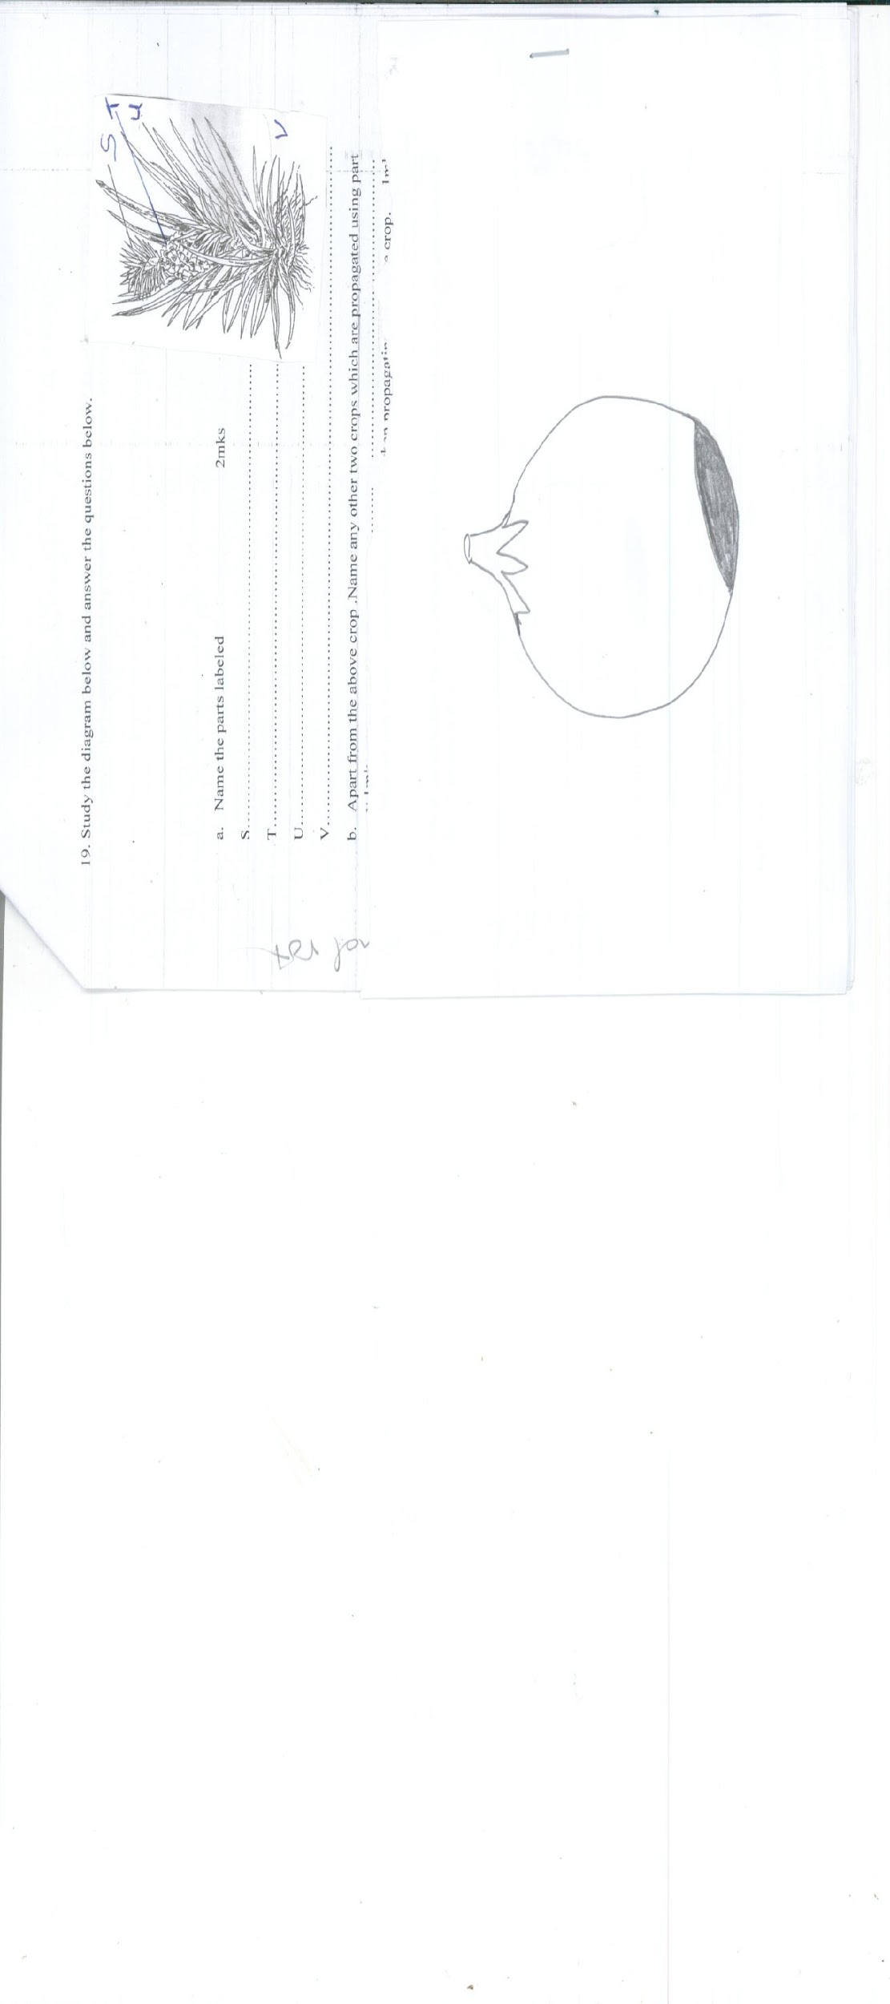

1. Name the parts labeled 2mks

S………………………………………………………………..

T………………………………………………………………..

U……………………………………………………………….

V………………………………………………………………………………………………

1. Apart from the above crop .Name any other two crops which are propagated using part v.1mk…………………………………….. …………………………………………
2. Why are part S and U more preferred than V when propagating the above crop. 1mk

……………………………………………………………………………………………………………………………………………………………………………………………

1. The diagram below shows a certain disease of tomatoes .Study the diagram and answer the questions that follow.

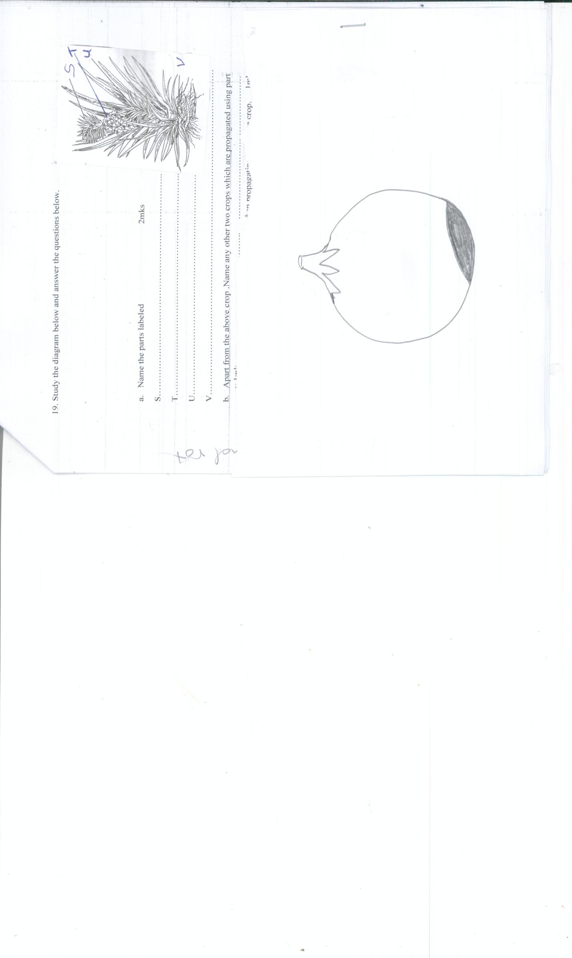

1. Identify the disease 1mk

………………………………………………………………………………..

1. Give two causes of the disease above. 2mks

…………………………………………………………………………………………………………………………………………………………………………………………

1. Give one way of controlling the above disease. 1x1=1mk

………………………………………………………………………………………………

***SECTION C(40MKS)(ANSWER ONLY TWO QUESTIONS FROM THIS SECTION)***

1. (a)Discuss the importance of Agriculture to the economy of Kenya. 5mks

……………………………………………………………………………………………………………………………………………………………………………………………………………………………………………………………………………………………………………………………………………………………………………………………………………………………………………………………………………………………………………

……………………………………………………………………………………………………………………………………………………………………………………………………………………………………………………………………………………………………………………………………………………………………………………………………………………………………………………………………………………………………………

(b) Explain the influence of soil depth on crop production . 5mks

……………………………………………………………………………………………………………………………………………………………………………………………………………………………………………………………………………………………………………………………………………………………………………………………………………………………………………………………………………………………………………

…………………………………………………………………………………………………………………………………………………………………………………………………………………………………………………………………………………………………………………………………………………………………………………………………………………………………………………………………………………………………………

(c)Give five reasons for carrying out minimum tillage. 5mks

……………………………………………………………………………………………………………………………………………………………………………………………………………………………………………………………………………………………………………………………………………………………………………………………………………………………………………………………………………………………………………

……………………………………………………………………………………………………………………………………………………………………………………………………………………………………………………………………………………………………………………………………………………………………………………………………………………………………………………………………………………………………………

(d) Explain the importance of treating water in the farm.5mks

……………………………………………………………………………………………………………………………………………………………………………………………………………………………………………………………………………………………………………………………………………………………………………………………………………………………………………………………………………………………………………

……………………………………………………………………………………………………………………………………………………………………………………………………………………………………………………………………………………………………………………………………………………………………………………………………………………………………………………………………………………………………………

1. (a) Describe various ways through which soil can lose its fertility. 5mks

……………………………………………………………………………………………………………………………………………………………………………………………………………………………………………………………………………………………………………………………………………………………………………………………………………………………………………………………………………………………………………

……………………………………………………………………………………………………………………………………………………………………………………………………………………………………………………………………………………………………………………………………………………………………………………………………………………………………………………………………………………………………………

(b) What is the meaning of the following terms as used in Agricultural production . 4mks

1. Agricultural economic……………………………………..................................

..............................................................................................................................

1. Scarcity ………………………………………………………………………..

…………………………………………………………………………………

1. Preference and choice………………………………………………………………….

…………………………………………………………………………………………..

1. Opportunity cost………………………………………………………………………

………………………………………………………………………………………..

(c) State two conditions under which the opportunity cost is equal to zero. 1mk

………………………………………………………………………………………………

(d) Outline procedure of soil sampling . 5mks

……………………………………………………………………………………………………………………………………………………………………………………………………………………………………………………………………………………………………………………………………………………………………………………………………………………………………………………………………………………………………………

……………………………………………………………………………………………………………………………………………………………………………………………………………………………………………………………………………………………………………………………………………………………………………………………………………………………………………………………………………………………………………

(e) Describe the chemical method of breaking seed dormancy . 5mks

……………………………………………………………………………………………………………………………………………………………………………………………………………………………………………………………………………………………………………………………………………………………………………………………………………………………………………………………………………………………………………

……………………………………………………………………………………………………………………………………………………………………………………………………………………………………………………………………………………………………………………………………………………………………………………………………………………………………………………………………………………………………………

1. (a) Describe the importance of crop rotation . 5mks

……………………………………………………………………………………………………………………………………………………………………………………………………………………………………………………………………………………………………………………………………………………………………………………………………………………………………………………………………………………………………………

……………………………………………………………………………………………………………………………………………………………………………………………………………………………………………………………………………………………………………………………………………………………………………………………………………………………………………………………………………………………………………

(b) Explain the importance of having a title deed . 5mks

……………………………………………………………………………………………………………………………………………………………………………………………………………………………………………………………………………………………………………………………………………………………………………………………………………………………………………………………………………………………………………

……………………………………………………………………………………………………………………………………………………………………………………………………………………………………………………………………………………………………………………………………………………………………………………………………………………………………………………………………………………………………………

( c) discuss the role of trees in soil and water conservation. 5mks

……………………………………………………………………………………………………………………………………………………………………………………………………………………………………………………………………………………………………………………………………………………………………………………………………………………………………………………………………………………………………………

……………………………………………………………………………………………………………………………………………………………………………………………………………………………………………………………………………………………………………………………………………………………………………………………………………………………………………………………………………………………………………

(d) Outline the harmful effect of weeds. 5mks

…………………………………………………………………………………………………………………………………………………………………………………………………………………………………………………………………………………………………………………………………………………………………………………………………………………………………………………………………………………………………………