**FORM 3 AGRICULTURE PP2 MARKING SCHEME**

**NOVEMBER 2022 EXAMINATION**

1. Distinguish the functional difference between across cut saw and a rip saw.

- Cross cut saw cuts wood across the grain while held at angle 450 to the work while rip saw cuts wood along grain while held at angle of 600 to the work. = 1mks

2. Give **two** reasons why ewes disown lambs. (1 mks)

- Painful under and teats.

- Case of malnutrition of the ewe.

- If the lamb is weak and unable to keep up with the ewe

- Sick ewe.

- Still birth.

3. Give four factors to consider when selecting goats for breeding. (2mks)

- healthy

Young age

Should highly prolific

Good mothering ability

Free from deformities

Good conformatiioon

High level of production

4. Name the structure that is used to ensure that honeycomb and brood combs are found in different chambers in the hive. - Queen excluder (1mk)

5. Differentiate between in breeding and out breeding. - Inbreeding is mating closely related individuals e.g. sire and daughter while out breeding is mating of un related animals from the same breed. (Mark as a whole 1mk)

6.Give four symptoms of roundworm (Ascaris) attack. 2mks

- Reduced growth rate.

- Anaemia.

- Blockage of intestines.

- Diarrhoea.

- Loss of weight.

- Presence of worms in the faeces.

- Malnourishment.

- Potbellies.

- Coughing as larvae migrate from the lungs to the trachea.

7. (a) Four importance of keeping rabbits.

-Meat, far, hair/wool

-Rich manure in nutrients

-Used in research station

-Source of income

*Any first 4 x ½ = 2 marks*

(b) Two dual purpose breeds of cattle.

-Simmental

-Red poll

-Sahiwal

*(Any first 2 x ½ = 1 mark)*

8. Two reasons for flushing in sheep.

-To increase ovulation hence chance of twinning

-To improve chances of ovulation

-To enhance implantation of embryo in the uterus

*Any first 2 x ½ = 1 mark*

9. Four qualities of a good vaccine.

-Imparting long life immunity on a single dose.

-Easy to administer

-Has no side effects

-Compatible with other vaccines

-Have long keeping life

-Immunity imparted in as good as natural immunity.

*Any 4 x ½ = 2 marks*

*10*. ***State the role of the following practices when rearing piglets***

(i) Iron injection to prevent anaemia in piglets ***( 1x 1= 1mk***  (ii) tooth clipping- reduce incidence of piglets injuring the mother

Reduce injury among piglets when playing

Reduce chances of injury to the handler

11.***State 4functions of fats and oils in animals body***

* Constituent of body cells
* Supply energy after oxidation
* Excess is used to insulate body/prevent loss of heat
* Protection of vital organs like heart ***(4x ½ =2mk)***

12.***State four reasons for breeding in animals***

* To increase genetic value of livestock hence production capacity to the animal
* To obtain high quality animal products
* To increase the disease resistance of the animals
* To change breed characteristics of an animal for the specific economic purpose. ***2mrks***

13. ***State the functions of each of the following***

(a) Shovel-mixing mortar/manure/concrete

Lifting soil/ manure ( 1 mks)

(b) Strip cup- to detect mastitis infection in milk  ***( 1mk)***

b. ***Why is it necessary to have guard rails in a farrowing pen ( 1mk)***

* ***Prevents sow from crushing piglets***
* Prevents sow from eating creep feed

14. ***Distinguish between the following practices as used in fish farming***

Cropping and harvesting.

Cropping is selective removal of fish of marketable size from the pond harvesting is removal of fish of all size

(1mk)

15. Factors that determine water intake

-Type of feed eaten by the animal

-Physiological status of the animal

-Ambient temperature

-Species of the animal

-Age of the animal/size /weight

-Level of production

-Amount of work by the animal (4 x½=2 mks)

**16.(a) Signs of furrowing in pig (2msk)**

-Restlessness

-Vulvas swells and reddens

-Udder becomes full with a milky substance

-Sow starts to build a nest by collecting some bedding at one corner

17. Four methods of preserving fish. (4 marks)

-Smoking

-Salting

-Freezing

-Deep frying

-Sun drying

Any first 4 x ½ = 2 marks

SECTION B

18. (a) The diagram **below** represents roof of a building.

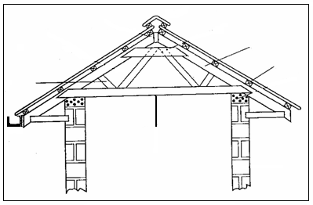

A

D

C

B

(i) Identify the parts labeled **A**, **B**, **C**. (3mks) A - Strut.

B - Purlin.

C - Rafter

D – Cross tie board.

(ii) Give **six** factors considered when siting farm buildings and structures. (3smks)

- Security

- Accessibility.

- Nearness to social amenities.

- Direction of prevailing wind.

- Topography of the area.

- The soil type.

- Government policy.

- Future expansion.

- Farmer preferences / paranomic view.

- Gradient / drainage.

- Sewage disposal.

b.Explain **six** factors which would be considered in choosing materials for construction of farm building and structures. (3mks)

- Availability of the materials to be used.

- Durability of the materials.

- Suitability of the materials to the local environmental condition of the area.

- Needs of the structure.

- Availability of the capital.

- Design of the structure.

- The type of the structure i.e. permanent or temporary. 6 x 1/2 = 3mks

(19) Study the illustrations below of a hard flow foundation in a farm structure

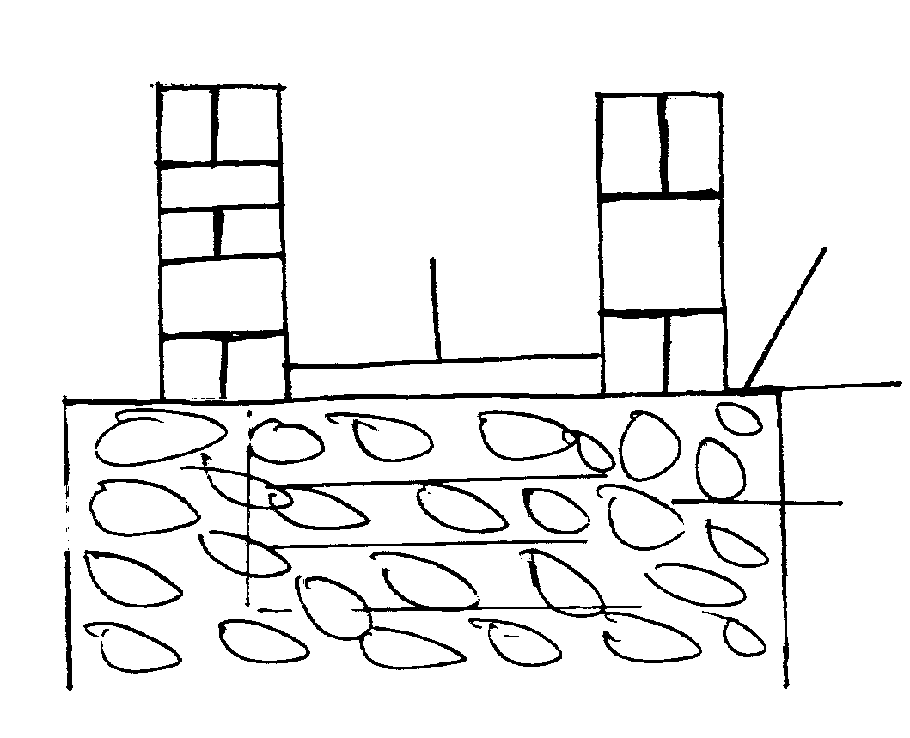

W

R

X

T

(i) Name the parts labeled **R** and **T** (2mks)

R- damp proof course (PVC)

T- Hard core

(ii) State **three** advantages of concrete floor

* Durable
* Fire proof
* Easy to clean
* Attractive ***(3x1=3mks***

20. The diagram below represents some farm tools

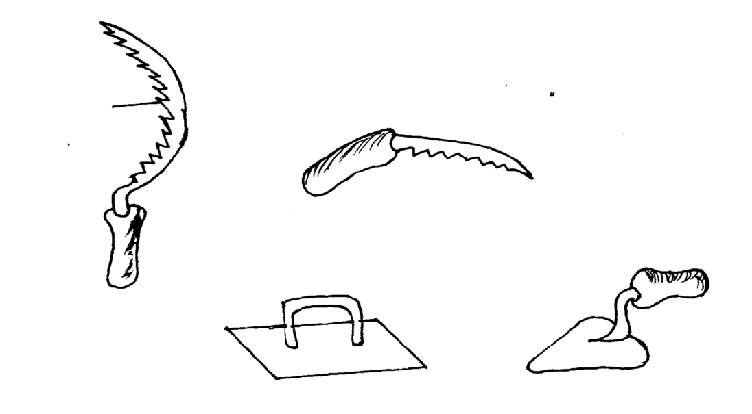

**Teeth**

**U**

**V**

**Y**

(***a) State the use of each tool on the farm 4mks***

S-harvest grass and certain cereals crop e.g finger millet

U-cutting hard branches during pruning of coffee

V-applying screed on the floor

Y-Applying mortar between the blocks , bricks/stones in in walls during construction

***(b) Explain two maintenance practices that should be carried out on the teeth of tools in the diagram***

Clean it after use to remove dirt

sharpen it regularly to improve efficiency

Tooth setting

***Must explain (2x1=2mks)***

**section c**

(21) **Short notes on Friesian breed on**;

(i) **Origin.**

- Holland / Denmark. 1 x 1 =

(ii) **Characteristics.**

(i) It is black with white markings.

(ii) The forehead udder and the legs below the knee are white.

1. The average weight for bull is between 900 - 100 kg while cows weigh

between 700 kg.

(iv) They are heavy feeder owing to their large bodies.

(v) It produces 900 to 1000 kg of milk on average per lactation of 305 days. (vi) Milk butterfat content is about 3.5 to 4% BF.

(vii) Heifers should reach service age at 21 months.

(viii) Friesian calve for the first time at 30 months of age.8 x 1 = 8mks

(b) Describe management practices carried out on a fish pond (11mks)

* Feeding: At the shallow end and at regular intervals
* Fertilizing the fish pond to encourage growth of algae and planktons
* Maintaining water level: Ensure adequate water for oxygen supply
* Changing water occasionally to ensure fresh water
* Desilting fish pond after a while to ensure pond water capacity is maintained
* Trimming grasses and vegetation around the dykes to avoid hideouts for predators
* Liming ponds:To avoid acidic contains
* Repair pond walls and fences
* Control predators
* Cropping to avoid overcrowding
* Cleaning of the pond e g removal of solid materials

*( 11x 1 =11 marks)*

22(a) Describe the rearing of lambs from lambing up to weaning time.

* Supervise lambing incase of malpresentation call for veterinary officer to assist.
* Allow mother to lick the lamb.
* In case of retained placenta give it physical exercise to activate expulsion of placenta.
* Cut and disinfect umbilical cord.
* Ensure the lamb is breathing well and if not apply artificial respiration.
* Ensure the lamb sucks colostrums in the 1st 6 hours of life.
* Give the lambs colostrums for the next 2 – 3 days.
* Lambs should remain with their mothers for the last 2 days.
* Give whole milk for 4 – 6 weeks.
* Lambs which do not receive enough milk should be fed artificially or given to foster mothers.
* Give succulents / soft herbage / concentrates at 6 weeks old.
* Gradual change of feed at weaning age 4 – 5 weeks.
* Give plenty of clean water.
* Deworm to control internal parasite.
* Spray with recommended acaricide to control external parasites.
* Treat lambs when sick.
* Vaccinate lambs to control disease spread.
* Hoof trim to control foot rot disease.
* Keep records
* Weigh lamb at birth and record the weight.

Carry out identification of lambs. (10x1=10mks

(b) State any five factors that should be considered when choosing tools and equipments to use in the farm 5mks

* Suitability: tools should be suitable for the task
* Availability: tools/equipments should be available in the shop
* Cost: tools/equipments should be affordable by the farmer
* Cost of maintenance: should be easily and cheap to maintain
* Operation: should be easy to operate by the farmer
* Durability: should last long one acquired

(c) State **five** differences between Ruminants and non Ruminants. (5mks

|  |  |
| --- | --- |
| **Ruminant** | **Non Ruminant** |
| * + - 1. Chew cud       2. Polygastric       3. Regurgitate food       4. Digest cellulose       5. Have no ptyalin in saliva       6. Digestion and absorption takes place in Rumen.       7. Have alkaline saliva due to ammonia. | 1. Do not chew cud. 2. Monogastric. 3. Cannot regurgitate food. 4. Cannot digest cellulose. 5. Have ptyalin in saliva. 6. Digestion and absorption occur in small intestines. 7. Saliva is neutral. |

(mark as a whole and well matched 5 x 1 = 5mks)

**(23)outline importance of fences in the farm**

They provide security from thieves/ wild animals

They facilitate paddocking/rotational grazing and mixed farming

Keeps other animals out of the farm hence controlling pests and diseases

They add esthetic value to the farm

Live fences act as wind break

Hedges help in soil and water conservation

They provide privacy

They help isolate animals during treatment

(8x1=8mks)

(b) ***Describe the life cycle of a three host tick***  ***(7mks)***

* Eggs are laid of the ground which hatch under conditions into larvae
* Larvae climbs on the first host where it feeds on blood becomes engorged and falls on the ground to moult
* Fallen larvae moults on the ground into nymph
* Nymp climbs on the second host where it feeds on blood, engorges and falls down to moult
* Fallen nymph moults to adult
* Adult climbs on the 3rd host
* It sucks blood, engorges mates and falls down to lay eggs

*Mark as a whole-until the cycle is broken then stop*

*Certify what happens to tick in every host*

(d) Describe the general effects of parasites on livestock

* Cause anemia
* Cause irritation
* Damages skin/internal organs
* Blocks internal organs
* Causes wound which act as route for secondary infection
* Loss of appetite
* Leads to body emaciation/loss of body condition
* May lead to death
* Poor production/low production
* Production/low production
* Production of low quality products

*(5x1= 5marks)*