**NAME: ……………………………………………………………. ADM No:…………………**

**Date: …………………………… Signature:……**

Agriculture

**Paper 2**

**NOVEMBER 2022 EXAMINATION**

**TIME: 2 hours**

**Instructions to Students**

1. Write your name and admission no. in the space provided.
2. Sign and write the date of exam in the space provided.
3. Answer all the questions in this paper.
4. All your answers must be written in the space provided.

**For Examiners use only**

|  |  |  |
| --- | --- | --- |
| **SECTION** | MAXIMUM SCORES | STUDENT SCORES |
| **A** | 30 |  |
| **B** | **20** |  |
| **C** | **40** |  |

FORM 3 AGRICULTURE PP2 2021 TERM 2

SECTION A 30 MKS

1. Distinguish the functional difference between a cross cut saw and a rip saw. = 1mks

2. Give **two** reasons why ewes disown lambs. (1 mks)

.

3. Give four factors to consider when selecting goats for breeding. (2mks)

4. Name the structure that is used to ensure that honeycomb and brood combs are found in different chambers in the hive. (1mk)

5.Differentiate between in breeding and out breeding. ( 1mk)

6.Give four symptoms of roundworm (Ascaris) attack. 2mks

7. (a) State four importance of keeping rabbits.4 x ½ = 2 marks

(b) Givetwo dual purpose breeds of cattle. ( 2 x ½ = 1 mark)

8.Give two reasons for flushing in sheep. Any first 2 x ½ = 1 mark

9. Four qualities of a good vaccine. 4 x ½ = 2 marks

10. **State the role of the following practices when rearing piglets**

(i) Iron injection **( 1x 1= 1mk**

(ii) tooth clipping-1 mks

11.**State 4functions of fats and oils in animals body(4x ½ =2mk)**

12.**State four reasons for breeding in animals**

* **2mrks**

13. **State the functions of each of the following**

(a) Shovel-

( 1 mks)

(b) Strip cup

**( 1mk)**

b. **Why is it necessary to have guard rails in a farrowing pen ( 1mk)**

14. **Distinguish between the following practices as used in fish farming**

i. cropping and harvesting (1mk)

15.State 4 factors that determine water intake in animals

(4 x½=2 mks)

**16.(a)Give 4 Signs of furrowing in pig (2msk)**

17.Give four methods of preserving fish. 4 x ½ = 2 marks

SECTION B 20 MKS

18. (a) The diagram **below** represents roof of a building.

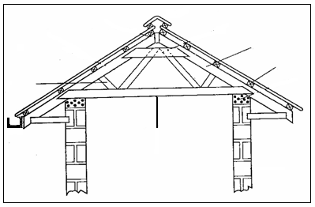

A

D

C

B

(i) Identify the parts labeled **A**, **B**, **C**. (3mks) A -

B -

C -

(ii)Give **six** factors considered when sitting farm buildings and structures. (3smks)

b.State **six** factors which would be considered in choosing materials for construction of farm building and structures. (3mks)

.

(19) Study the illustrations below of a hard flow foundation in a farm structure

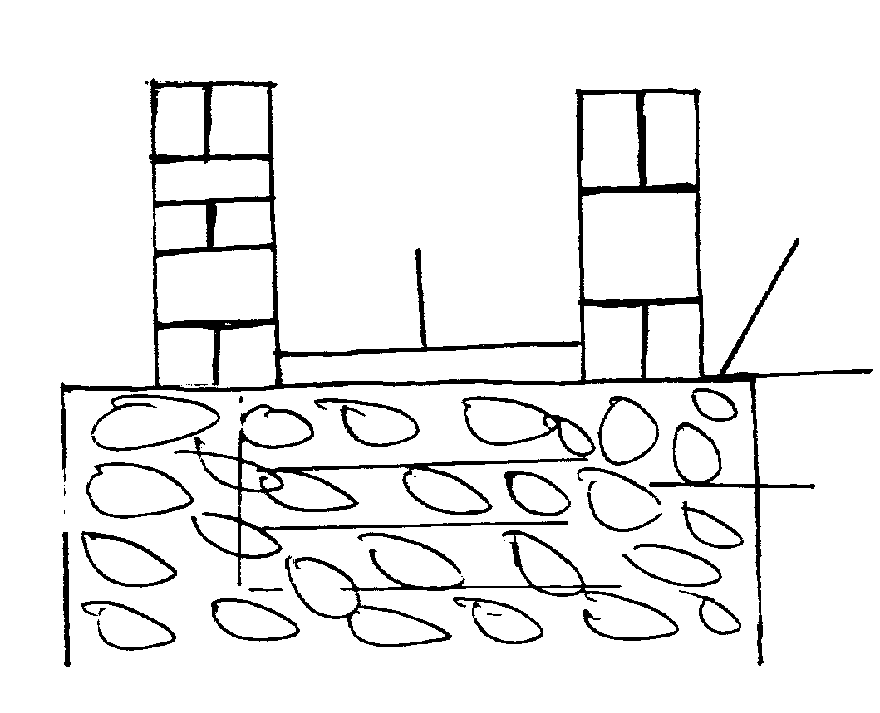

W

R

X

T

(i) Name the parts labeled **R** and **T** (2mks)

R-)

T-

(ii) State **three** advantages of concrete floor

**(3x1=3mks**

20. The diagram below represents some farm tools

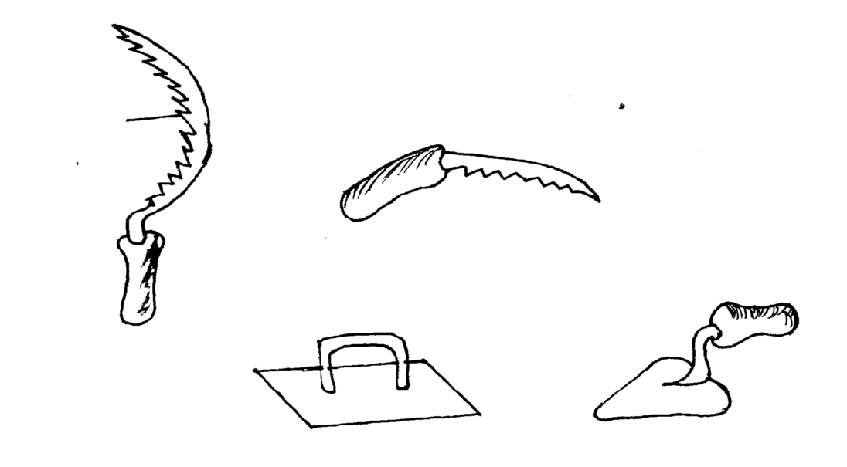

**Teeth**

**U**

**V**

**Y**

(**a) State the use of each tool on the farm. 4mks**

S-

U-

V-

Y-

**(b) Explain two maintenance practices that should be carried out on the teeth of tools in the diagram**

**(2x1=2mks)**

**SECTION BC 40 MKS**

**ATTEMPT ANY TWO QUESTIONS**

(21) Write Short notes on Friesian breed of cattle on;

(i) **Origin.**

. 1 x 1 =

(ii) **Characteristics.**

8 x 1 = 8mks

(b) Describe management practices carried out on a fish pond (11mks)

22(a) Describe the rearing of lambs from lambing up to weaning time. (10x1=10mks

(b) State any five factors that should be considered when choosing tools and equipments to use in the farm 5mks

(c) State **five** differences between Ruminants and non Ruminants. (5mks

**(23)Outline importance of fences in the farm**(8x1=8mks)

(b) **Describe the life cycle of a three host tick**  **(7mks)**

(d) Describe the general effects of parasites on livestock

(5x1= 5marks)