**Name: …………………………………………………………… Adm no ……..…...................................**

**School: ……………………………………………………....…. Candidate’s sign ……………………....**

**Date: ……………………………………………………………**

**443/2**

**AGRICULTURE**

**PAPER 2**

**TIME: 2 HOURS**

**PANGANI GIRLS’ HIGH SCHOOL**

**POST MOCK 2022**

***Kenya Certificate of Secondary Education (KCSE)***

***Feb 2022***

*Kenya Certificate of Secondary Education (K.C.S.E.)*

**FORM FOUR**

**INSTRUCTIONS TO CANDIDATES:**

* *Write* ***your name*** *and* ***Index number*** *and* ***sign*** *in the spaces provided above.*
* *Answer* ***ALL*** *the questions in section* ***A*** *and* ***B*** *in the spaces provided in this booklet.*
* *Answer* ***any two*** *questions in section* ***C*** *in the spaces provided after the last question.*

***For Examiner’s Use Only:***

|  |  |  |  |
| --- | --- | --- | --- |
| **SECTION** | **QUESTIONS** | **MAXIMUM SCORE** | **CANDIDATES SCORE** |
| A | 1-18 | 30 |  |
| B | 19-21 | 20 |  |
| C | 22-24 | 40 |  |
|  | **TOTAL** | **90** |  |

**SECTION A (30MARKS)**

***Answer all the questions in this section.***

1. State two reasons of using farm tools and equipment in the farm. (2mks)

…………………………………………………………………………………………………………………..…………………………………………………………………………………………………………………..…………………………………………………………………………………………………………………..

2. State three reasons that would make a farmer opt to rear indigenous cattle breeds instead of exotic cattle breeds. (1 ½ mks)

…………………………………………………………………………………………………………………..…………………………………………………………………………………………………………………..…………………………………………………………………………………………………………………..

…………………………………………………………………………………………………………………..

3. State three characteristics of Bacterian type of camel. (1 ½ mks)

…………………………………………………………………………………………………………………..…………………………………………………………………………………………………………………..…………………………………………………………………………………………………………………..…………………………………………………………………………………………………………………..

4. Name four factors that influence the pulse rate of an animal. (2mks)

…………………………………………………………………………………………………………………..…………………………………………………………………………………………………………………..…………………………………………………………………………………………………………………..…………………………………………………………………………………………………………………..…………………………………………………………………………………………………………………..…………………………………………………………………………………………………………………..

5. State three signs of attack by endoparasites a farmer can observe. (1 ½ mks)

…………………………………………………………………………………………………………………..…………………………………………………………………………………………………………………..…………………………………………………………………………………………………………………..…………………………………………………………………………………………………………………..

6. State four factors that determine the amount of food given to an animal. (2mks)

…………………………………………………………………………………………………………………..…………………………………………………………………………………………………………………..…………………………………………………………………………………………………………………..…………………………………………………………………………………………………………………..…………………………………………………………………………………………………………………..…………………………………………………………………………………………………………………..

7. Name three reasons that would make a farmer use a machakos dip instead of a plunge dip to control ticks. (1 ½ mks)

…………………………………………………………………………………………………………………..…………………………………………………………………………………………………………………..…………………………………………………………………………………………………………………..…………………………………………………………………………………………………………………..

8. State four factors considered when selecting construction materials. (2mks)

…………………………………………………………………………………………………………………..…………………………………………………………………………………………………………………..…………………………………………………………………………………………………………………..…………………………………………………………………………………………………………………..…………………………………………………………………………………………………………………..

9. Name three methods a farmer can use when selecting livestock for breeding. (1 ½ mks)

…………………………………………………………………………………………………………………..…………………………………………………………………………………………………………………..…………………………………………………………………………………………………………………..…………………………………………………………………………………………………………………..

10. Mention three signs of heat in a doe. (1 ½ mks)

…………………………………………………………………………………………………………………..…………………………………………………………………………………………………………………..…………………………………………………………………………………………………………………..…………………………………………………………………………………………………………………..

11. Mention four reasons that would make a farmer carry out identification to his herd. (2mks)

…………………………………………………………………………………………………………………..…………………………………………………………………………………………………………………..…………………………………………………………………………………………………………………..…………………………………………………………………………………………………………………..…………………………………………………………………………………………………………………..

12. State two diseases that commonly affect bees in bee farming. (2mks)

…………………………………………………………………………………………………………………..…………………………………………………………………………………………………………………..

13. State four methods a farmer can use when preserving fish after harvesting. (2mks)

…………………………………………………………………………………………………………………..…………………………………………………………………………………………………………………..…………………………………………………………………………………………………………………..…………………………………………………………………………………………………………………..

14. State four factors that determine the choice of poultry rearing system that a farmer chooses to use.

(2mks)

…………………………………………………………………………………………………………………..…………………………………………………………………………………………………………………..…………………………………………………………………………………………………………………..…………………………………………………………………………………………………………………..

…………………………………………………………………………………………………………………..

15. State one significance of mobile calf pen in calf rearing. (1mk)

…………………………………………………………………………………………………………………..…………………………………………………………………………………………………………………..

16. State two disadvantages of a two stroke engine. (1mk)

…………………………………………………………………………………………………………………..…………………………………………………………………………………………………………………..…………………………………………………………………………………………………………………..

17. State two factors that could cause sudden stopping of a tractor engine. (1mk)

…………………………………………………………………………………………………………………..…………………………………………………………………………………………………………………..…………………………………………………………………………………………………………………..…………………………………………………………………………………………………………………..

18. State four disadvantages of animal drawn implements over tractor drawn implements. (2mks)

…………………………………………………………………………………………………………………..…………………………………………………………………………………………………………………..…………………………………………………………………………………………………………………..

…………………………………………………………………………………………………………………..…………………………………………………………………………………………………………………..

**SECTION B (20MARKS)**

***Answer all questions in this section.***

19. The diagram below shows a tractor drawn implement. Study it and answer the questions that follow.

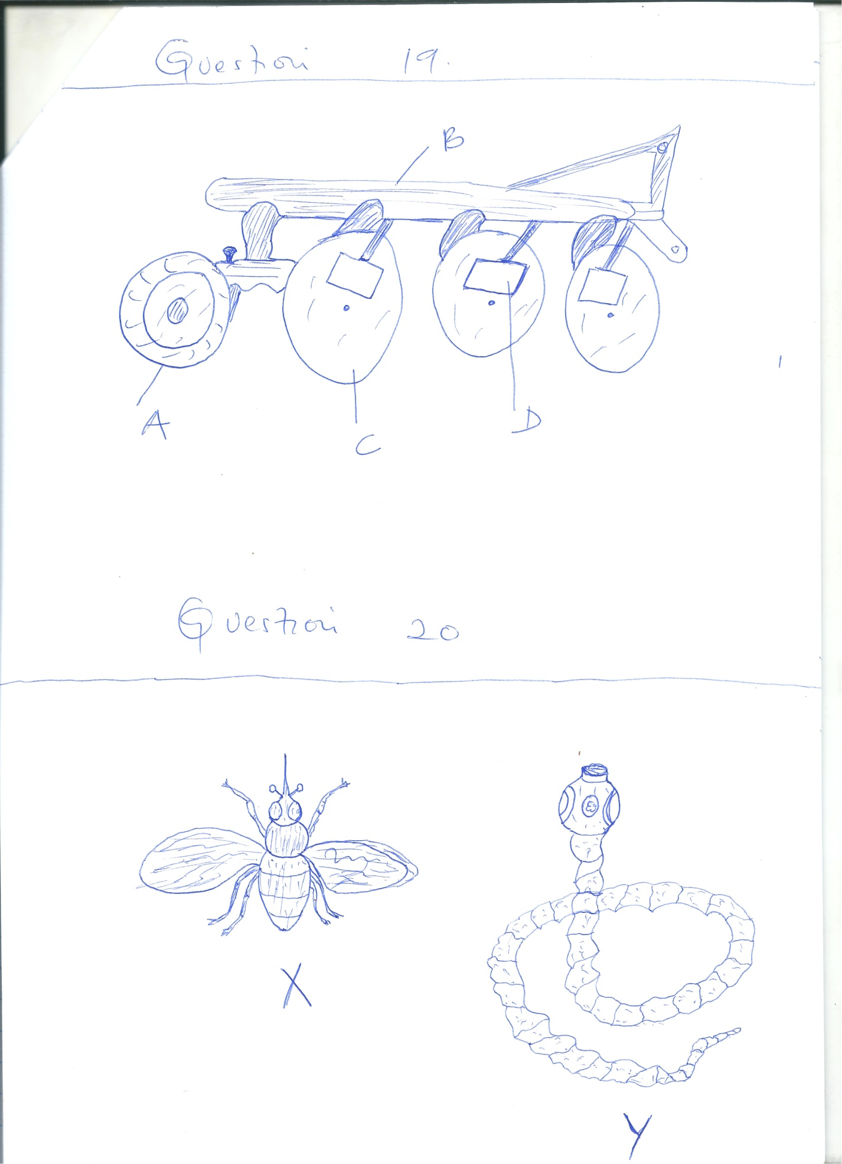

a) Name the parts A, B, C and D. (4mks)

…………………………………………………………………………………………………………………..…………………………………………………………………………………………………………………..

…………………………………………………………………………………………………………………..…………………………………………………………………………………………………………………..

b) State two advantages of using the above implement over mould- board plough. (2mks)

…………………………………………………………………………………………………………………..…………………………………………………………………………………………………………………..

…………………………………………………………………………………………………………………..

c) State the function of the parts labeled. (2mks)

i) A

…………………………………………………………………………………………………………………..

ii) D

…………………………………………………………………………………………………………………..

20. The diagram below shows livestock parasites. Study the diagrams and answer the questions that follow.

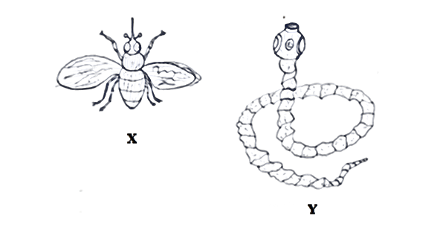

a) Identify the parasites X and Y above. (2mks)

…………………………………………………………………………………………………………………..…………………………………………………………………………………………………………………..

b) State two effects that are caused by the parasite labeled X on the animal’s body. (2mks)

…………………………………………………………………………………………………………………..…………………………………………………………………………………………………………………..

…………………………………………………………………………………………………………………..

c) Name one disease transmitted by parasite labeled X above. (1mk)

…………………………………………………………………………………………………………………..

…………………………………………………………………………………………………………………..

d) State three measures taken to control the parasite labeled Y above. (3mks)

…………………………………………………………………………………………………………………..

…………………………………………………………………………………………………………………..

…………………………………………………………………………………………………………………..

…………………………………………………………………………………………………………………..

21. Study the diagram below and answer the questions that follow.

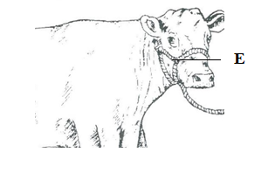

a) Identify the livestock equipment marked E above. (1mk)

…………………………………………………………………………………………………………………..

…………………………………………………………………………………………………………………..

b) State two reasons that make branding be discouraged as a method of livestock identification.

(1mk)

…………………………………………………………………………………………………………………..

…………………………………………………………………………………………………………………..…………………………………………………………………………………………………………………..

…………………………………………………………………………………………………………………..

**SECTION C (40 MARKS)**

***Answer any two questions.***

22. a) State five factors that predispose livestock to diseases. (10mks)

b) State and explain five factors a farmer will consider when siting beehives in the farm. (10mks)

23. a) Briefly state and explain five equipment a farmer will need when milking and state their uses.

(10mks)

b) Explain five factors to consider when selecting a breeding stock. (10mks)

24. a) State and explain four materials collected by bees. (8mks)

b) State and explain the use of four equipments a honey harvester would require to have when

harvesting honey. (8mks)

c) List four main reasons that make fish farming popular. (4mks)

…………………………………………………………………………………………………………………..

…………………………………………………………………………………………………………………..

…………………………………………………………………………………………………………………..

…………………………………………………………………………………………………………………..

…………………………………………………………………………………………………………………..

…………………………………………………………………………………………………………………..

…………………………………………………………………………………………………………………..

…………………………………………………………………………………………………………………..

…………………………………………………………………………………………………………………..

…………………………………………………………………………………………………………………..

…………………………………………………………………………………………………………………..

…………………………………………………………………………………………………………………..

…………………………………………………………………………………………………………………..

…………………………………………………………………………………………………………………..

…………………………………………………………………………………………………………………..

…………………………………………………………………………………………………………………..

…………………………………………………………………………………………………………………..

…………………………………………………………………………………………………………………..

…………………………………………………………………………………………………………………..

…………………………………………………………………………………………………………………..

…………………………………………………………………………………………………………………..

…………………………………………………………………………………………………………………..

…………………………………………………………………………………………………………………..

…………………………………………………………………………………………………………………..

…………………………………………………………………………………………………………………..

…………………………………………………………………………………………………………………..

…………………………………………………………………………………………………………………..

…………………………………………………………………………………………………………………..

…………………………………………………………………………………………………………………..

…………………………………………………………………………………………………………………..

…………………………………………………………………………………………………………………..

…………………………………………………………………………………………………………………..

…………………………………………………………………………………………………………………..

…………………………………………………………………………………………………………………..

…………………………………………………………………………………………………………………..

…………………………………………………………………………………………………………………..

…………………………………………………………………………………………………………………..

…………………………………………………………………………………………………………………..

…………………………………………………………………………………………………………………..

…………………………………………………………………………………………………………………..

…………………………………………………………………………………………………………………..

…………………………………………………………………………………………………………………..

…………………………………………………………………………………………………………………..

…………………………………………………………………………………………………………………..

…………………………………………………………………………………………………………………..

…………………………………………………………………………………………………………………..

…………………………………………………………………………………………………………………..

…………………………………………………………………………………………………………………..

…………………………………………………………………………………………………………………..

…………………………………………………………………………………………………………………..

…………………………………………………………………………………………………………………..

…………………………………………………………………………………………………………………..

…………………………………………………………………………………………………………………..

…………………………………………………………………………………………………………………..

…………………………………………………………………………………………………………………..

…………………………………………………………………………………………………………………..

…………………………………………………………………………………………………………………..

…………………………………………………………………………………………………………………..

…………………………………………………………………………………………………………………..

…………………………………………………………………………………………………………………..

…………………………………………………………………………………………………………………..

…………………………………………………………………………………………………………………..

…………………………………………………………………………………………………………………..

…………………………………………………………………………………………………………………..

…………………………………………………………………………………………………………………..

…………………………………………………………………………………………………………………..

…………………………………………………………………………………………………………………..

…………………………………………………………………………………………………………………..

…………………………………………………………………………………………………………………..

…………………………………………………………………………………………………………………..

…………………………………………………………………………………………………………………..

…………………………………………………………………………………………………………………..

…………………………………………………………………………………………………………………..

…………………………………………………………………………………………………………………..

…………………………………………………………………………………………………………………..

…………………………………………………………………………………………………………………..

…………………………………………………………………………………………………………………..

…………………………………………………………………………………………………………………..

…………………………………………………………………………………………………………………..

…………………………………………………………………………………………………………………..

…………………………………………………………………………………………………………………..

…………………………………………………………………………………………………………………..

…………………………………………………………………………………………………………………..

…………………………………………………………………………………………………………………..

…………………………………………………………………………………………………………………..

…………………………………………………………………………………………………………………..

…………………………………………………………………………………………………………………..

…………………………………………………………………………………………………………………..

…………………………………………………………………………………………………………………..

…………………………………………………………………………………………………………………..

…………………………………………………………………………………………………………………..

…………………………………………………………………………………………………………………..

…………………………………………………………………………………………………………………..

…………………………………………………………………………………………………………………..

…………………………………………………………………………………………………………………..