**Name: …………………………….……………………………………… Adm no ……..….......... Class.................**

**231**

**BIOLOGY**

**FORM TWO**

**OCT/NOV 2022 – END TERM**

**TIME: 1 HRS**

**JOINT EXAMINATION**

**INSTRUCTIONS TO CANDIDATES:**

* Answer **ALL** the questions
* Answers should be written in the spaces provided

1. Define the following branches of Biology. (2mks)

i) Genetics…………………………………………………………………...................................

.........................................................................................................................................................

ii) Entomology…....................................................………………………………………………

…………………………………………………………………………………………................

2. (a) Define the term species. (2mks)

………………………………………………………………………………………………………………………………………………………………………………………………………………………………………………………………………………………………………………

(b) Which taxonomic group has the largest number of members?.........................................(1mk)

3. (a) Name the laboratory apparatus used for the following; (2mks)

(i) Catching small flying insects.......................…………………………………………………..

(ii) Sucking small animals from rock surfaces or barks of trees.………………………………..

4. State the functions of each of the following organelles.

1. Nucleolus……………………………….…………………………..………………............(1mk)
2. Golgi apparatus……………………………….…………………………..……...................(2mks)

…………………………………………………………..………………………………………………….…………………………………………………………..…………………………………

1. Name any **three** specialized plant cells. (3mks)

………………………………………………………………………………………………………………………………………………………………………………………………………………………………………………………………………………………………………………………………………

6. The figure below shows apparatus at the start of an experiment to investigate the digestion of an emulsion of fat droplets in water by enzyme **A**.

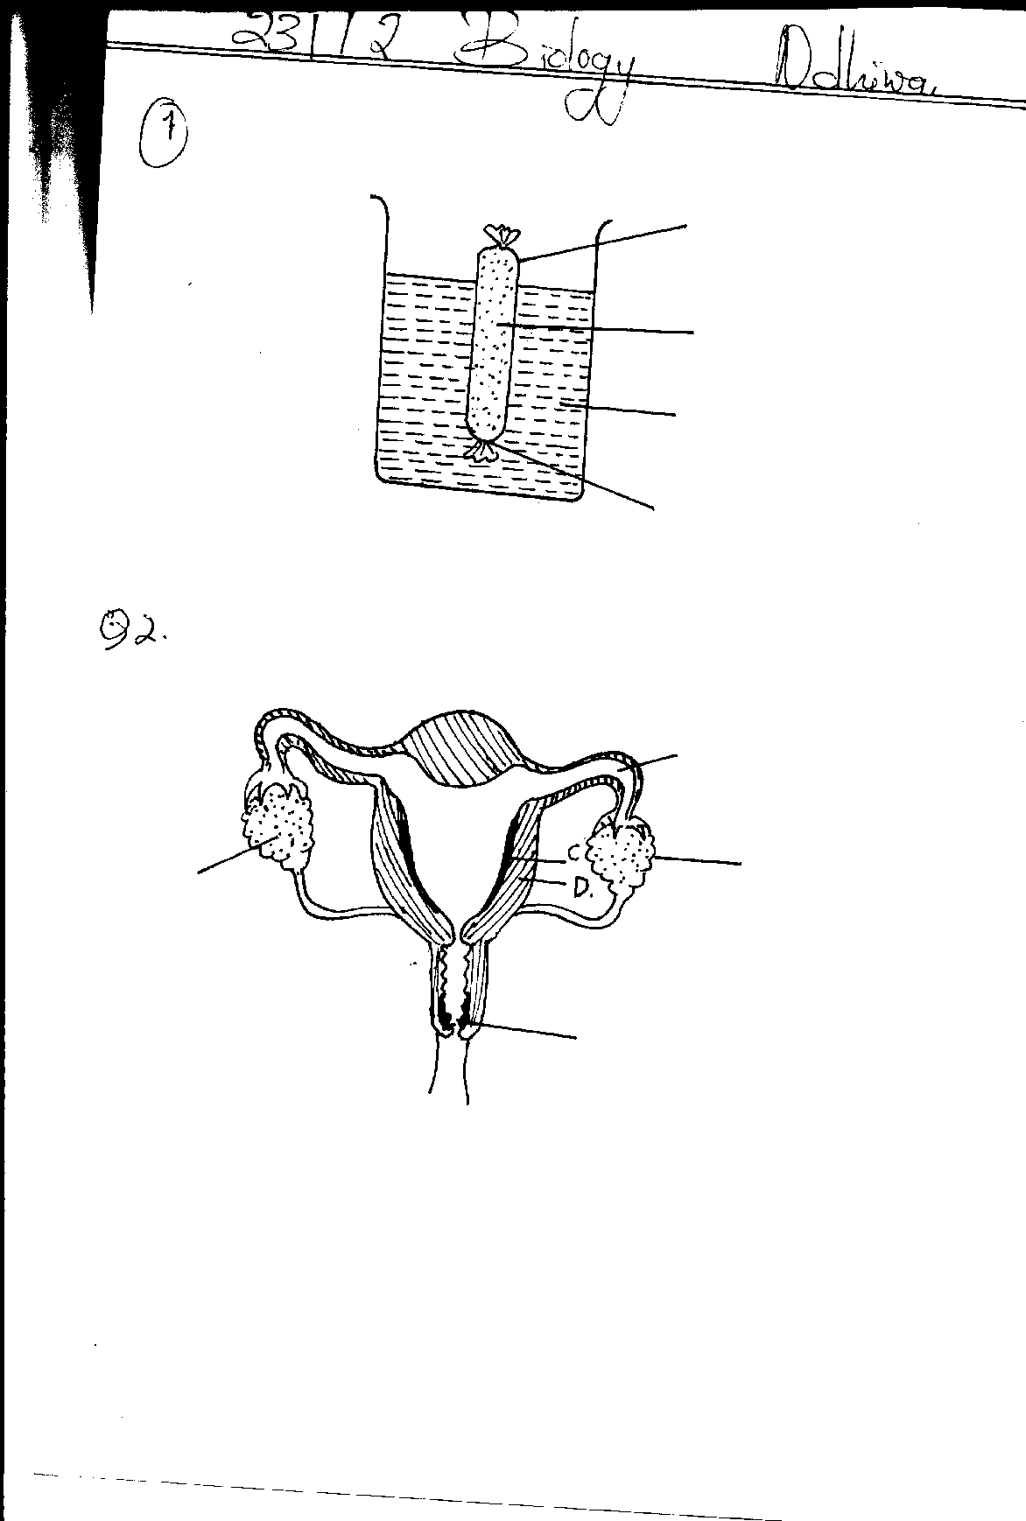

Partially permeable membrane

Emulsion of fat droplets in water + Enzyme **A**

Water + pH indicator

Tightly tied

The pH indicator is green in a pH of 7, blue when the pH is above 7 and red when it is below 7. The apparatus is kept at 40oC for 20 minutes during which time the indicator changes from green to red.

1. Describe how the products of fat digestion enter a person’s blood. (1mk)

……………………………………………………………………………………………..………………………………………………………………………………………………………

1. i) State the identity of enzyme **A**. ......................................................................................(1mk)

ii) Explain why the apparatus was kept at 40oC.................................................................(1mk)

1. Name the products of digestion of the emulsion by enzyme **A**. (2mks)

……………………………………………………………………………………………………………………………………………………………………………………………………

1. Describe the process which led to the change in pH (3mks)

………………………………………………………………………………………………………………………………………………………………………………………………………………………………………………………………………………......................................................................................................................................................................................

7. i) State the product of photolysis in photosynthesis. (3mks)

…………………………………………………………………………………………………………….………………………………………………………………………………………………….......................................................................................................................................................................

..............................................................................................................................................................

ii) Give **two** adaptation of a leaf for photosynthesis. (2mks)

………………………………………………………………………………………………………………………………………….........................................................................................................................................................................…………………………………………………………………..

8. a) State **two** roles of bile juice. (2mks)

……………………………………………………………………………………………………………..…………………………………………………………………………………………………………..………………………………………………………………………………………………..

b) Name two salts in bile that aid in emulsification of fats. (2mks)

............................................................................................................................................................................................................................................................................................................................................

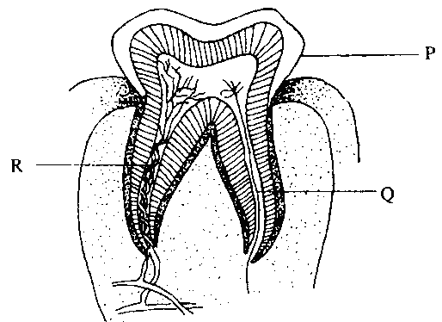9. The diagram below represents a longitudinal section of a human tooth.

a) Identify the type of tooth. ............................................(1mk)

b) Give one reason for your answer in (a) above. (1mk)

....................................................................................................

c) State one function of the tooth. (1mk)

....................................................................................................

d) State the function of the part labeled Q (1mk)

...........................................................................................................................................................

10 a) Name **three** forces that maintain transpiration stream. (3mks) ……………………………………………………………………………………………………………..……………………………………………………………………………………………………..……………………………………………………………………………………………………………..........................……………………………………………………………………………………..

b) Explain **two** adaptations of xylem tissue to its function. (2mks)

……………………………………………………………………………………………………………..……………………………………………………………………………………………………………..……………………………………………………………………………………………………………..

11. a) State the advantages of having the following blood types.

1. Blood type AB: …………………………………………………………………………..(1mk)

……………………………………………………………………………………………………

1. Blood type O: ………………………………………………………………………….....(1mk)

b) State **four** ways in which the red blood cells are adapted to their function (4mks)

……………………………………………………………………………………………………………..……………………………………………………………………………………………………………..…………………………………………………………………………………………………………….....................................................................................................................................................................

1. Name the antigens that determine human blood groups. (2mks)

……………………………………………………………………………………………………………..……………………………………………………………………………………………………………..………….............................................................................................................................................................................

13. State **three** theories that explains the mechanism of opening and closing of the stomata: (3mks)

…………………………………………………………..……………………………………………………………………………………………………………..……………………………………………………………………………………………......................................................................................................

1. The diagram below represents a model of lungs and thorax. When rubber sheet is pulled downwards the balloons inflate; and when it is raised the balloons deflate.
   1. What parts of the mammalian body are represented by;
      1. Glass tubes.………………………………..(1mk)
      2. Bell jar. …………………………………..(1mk)
      3. Rubber sheet. ……………………………(1mk)
      4. Balloons. ………………………………..(1mk)



b) State the importance of breathing through the nose than through the mouth (2mks)

...................................................................................................................................................................................................................................................................................................................................

15. The oxidation of a certain substrate is represented by the chemical equation shown below.

C57H104O6 + 80O2 57C02 + Energy

1. Calculate the respiratory quotient (RQ) of the substrate. (2mks)
2. Identify the above substrate. …………………………………………………………..… (1mk)

16. An animal is found to have large glomeruli and short loop of Henles .Account for the presence of

i) Large glomeruli…………………………………………………………………………… (1mk)

ii) Short loop of Henle. …………………………………………………………………………(1mk)

iii) State the possible aquatic habitat………………………………………………………..… (1mk)

17. Study the diagram below and answer the questions that follow

**Further excess**

**X**

**Excess corrective mechanism A**

**Negative feedback**

**Norm Norm**

**Negative feedback**

**Deficiency corrective mechanism B**

**X**

**Further deficiency**

a) Name the principle labeled X ………………………………………………………… (1mk) b) If the above diagram represented blood sugar regulation

i) State the corrective mechanisms carried out at A (2mks)

.................................................................................................................................................................................................................................................................................................................................................................................................................................................................................

ii) The condition that may result from the further excess (1mk)

.........................................................................................................................................................

iii) The hormone that would be responsible for correcting the deficiency (1mk)

...........................................................................................................................................................

18. a) The skin as an organ plays a role in Homeostasis. Name **two** roles of the human skin in homeostasis. (2mks)

………………………………………………………………………………………..........................................................................................................................................................................................................................................………………………………………………………………………………………

b) Melanocytes are cells of the skin responsible for production of a skin pigment.

1. Name the pigment produced by melanocytes..................................................................**(**1mk)
2. In which layer of the epidermis of the skin are melanocytes found?...............................(1mk)
3. State the primary function of the pigment named in (b)(i) above. (1mk)

………………………………………………………………………………………........................................................................................................................................................................................................

19. List down two economic importance anaerobic respiration agriculture (2mks)

………………………………………………………………………………………........................................................................................................................................................................................................

………………………………………………………………………………………........................................................................................................................................................................................................

**Success Success Success**