**BIOLOGY FORM 1 2022 MARKING SCHEME**

1. State the use of the following apparatus in collecting and observing organisms (3mks)
2. Pooter

**Sucking small animals from rock surfaces or barks of trees.**

1. Hand lens

**Enlarging small objects**

1. Pitfall trap

**Catching crawling animals.**

1. The scientific name for French bean is *Phaseolus Vulgaris*
2. What taxon does the term *Phaseolus* represent? (1mk)

**Genus**

1. State two rules that are followed when giving a scientific name to an organism. (2mks)

**The first name is that of a genus and it should begin with a capital letter, and the second name is that of a species and it should be written in small letter.**

**Printed in italics in books and printed works but in hand written manuscripts and typed works they should be underlined as separate words.**

**Specific name frequently written with the name of a scientist who first adequately described and named the organism.**

**Latinized for a new described animal or plant species where latin name is missing.**

1. a) What is meant by the term taxonomy (1mk)

**Scientific study of classification**

1. When are two organisms considered to belong to the same species? (2mks)

**When they can freely or naturally interbreed to give rise to fertile offspring.**

1. Name the branch of biology that deals with the study of zooplanktons. (1mk)

**Zoology**

1. Four organisms were classified using the binomial nomenclature as below.

Organism Name

V Drosophila melanogaster

W Canis lupus

X Rana temporaria

Y Canis familiaris

1. Name two organisms that are closely related. (2mks)

**Organism W and Y**

1. Give a reason for your answer in (a) above. (1mk)

**Same genus – canis**

1. Mango is known as MANGIFERA INDICA
2. Write down the scientific name given above following the acceptable system of naming. (1mk)

***Mangifera indica***

1. What is the scientific naming system called? (1mk)

**Binomial nomenclature**

1. a) What is the formula for calculating linear magnification using a light microscope? (1mk)

**Magnification = eye – piece lens magnification x Objective lens magnification.**

(b) State two functions of the following cell organelle.

Nucleolus (1mk)

**Ribosomes synthesis**

Centrioles (1mk)

* **cell division**
* **formation of cilia and flagela**
* **synthesis myofibrils of spindle fibres.**

Mitochondrion (1mk)

**Site for aerobic respiration**

Chloroplast (1mk)

**Site for photosynthesis**

Golgi body (2mks)

* **packages and transports gylcoproteins**
* **Produces lysosomes/secretions of synthesized products/formation of secretory vescicles**

1. Give the functions of the following parts of a microscope. (5mks)

Condenser

**Concentrates light rays on the object**

Fine adjustment knob

**Raises or lowers body tube over a short distance to bring image into sharp focus.**

Eye piece

**Magnifies further the magnification by objective lens and makes appropriate focus.**

Objective lens

**Magnifies the object**

Diaphragm

**Requlates the amount of light passing through the object.**

1. Define the following terms
2. Magnification (1mk)

**Ability to enlarge the image of the specimen.**

1. Resolution (1mk)

**Separating objects that are close to one another as distinct objects.**

1. Give three differences between a plant cell and an animal cell. (3mks)

|  |  |
| --- | --- |
| **Plant cell** | **Animal cell** |
| * **Usually large** * **Regular in shape** * **Has no centriole** * **Store starch, oils and proteins** * **Peripheral nucleus** * **Thin layer of cytoplasm** * **Some have chloroplasts** | * **Often smaller** * **Irregular in shape** * **Has centriole** * **Stores glycogen and fat** * **Central nucleus** * **Losts of cytoplasm** * **Has no chloroplasts** |

1. The figure below is a diagram of a cell as seen under the light microscope. The microscope’s eye piece lens had a magnification of x10.

A

B

Cell wall

Mg X40

1. Name three structure that show that this is a plant cell and not an animal cell. (3mks)

* **Cell wall**
* **Peripheral nucleus**
* **Chloroplast**
* **Tonoplast**

1. Name one chemical compound that is only found in the structure labeled A and state its function.

(2mks)

**Chlorophyll – Trap light energy used in the process of photosynthesis.**

1. Explain why the following processes are important during the preparation of temporary slides.
2. Staining (1mk)

**To improve the appearance and clarity of the specimen**

**To make organelles distinct**

**For easy differentiation of organelles**

1. Use of a sharp cutting blade. (1mk)

**To avoid distortion or damage of cells.**

1. In a class experiment to establish the size of an onion cell, a learner observed the following on the microscope field of view.

If the student counted 20 cells across the diameter of this field of view, calculate the size of one cell micrometers. (3mks)

**Size of cell = $\frac{diameter of field of view}{Number of cells}$**

$$=\frac{4 x 1000}{20}$$

$$=200um$$

1. a) List four skills that you develop as you study biology. (4mks)

* **Observing**
* **Identifying**
* **Recording**
* **Classifying**
* **Measuring**
* **Analyzing**
* **Evaluating**

(b) List three careers that require study of biology. (3mks)

* + **Medicine**
  + **Pharmacy**
  + **Nutrition**
  + **Food technology**
  + **Veterinary practice**
  + **Public health**
  + **Dentistry**
  + **Agriculture**
  + **Animal husbandry**
  + **Horticulture**
  + **Environmental studies**

1. State two importance of classification of living organisms. (2mks)

* **To identify living organisms and place them into their correct groups.**
* **To understand evolutionary relationship between different organisms/to know pathways of change of organisms.**
* **To arrange information about living organisms in order.**
* **It enables biologists to predict the characteristics of organisms.**
* **To enable easier and systematic study of organisms.**
* **Place organisms with similar characteristics together, those with different characteristics separately.**

1. Name five kingdoms of classification and in each case give an example. (5mks)
2. **Monera – Blue, green algae, bacteria**
3. **Protoctista – Amoeba, algae like diatoms**
4. **Fungi – Bread mould, mushroom, yeast.**
5. **Plantae – Maize, beans, garden peas.**
6. **Animalia – Human being, Leopard, domestic dog.**
7. Distinguish between heterotrophism and autotrophism. (2mks)

**Hetorotraphism - Mode of nutrition where organisms feed on ready made food.**

**Autotrophism – Mode of nutrition where organisms manufacture their own food from simple substances like H20 and CO2.**

1. Name the building blocks of: (2mks)
2. Lipids **Fatty acids and glycerol**
3. Proteins **Amino acids**
4. An experiment was set up as shown below to investigate a condition necessary for photosynthesis. 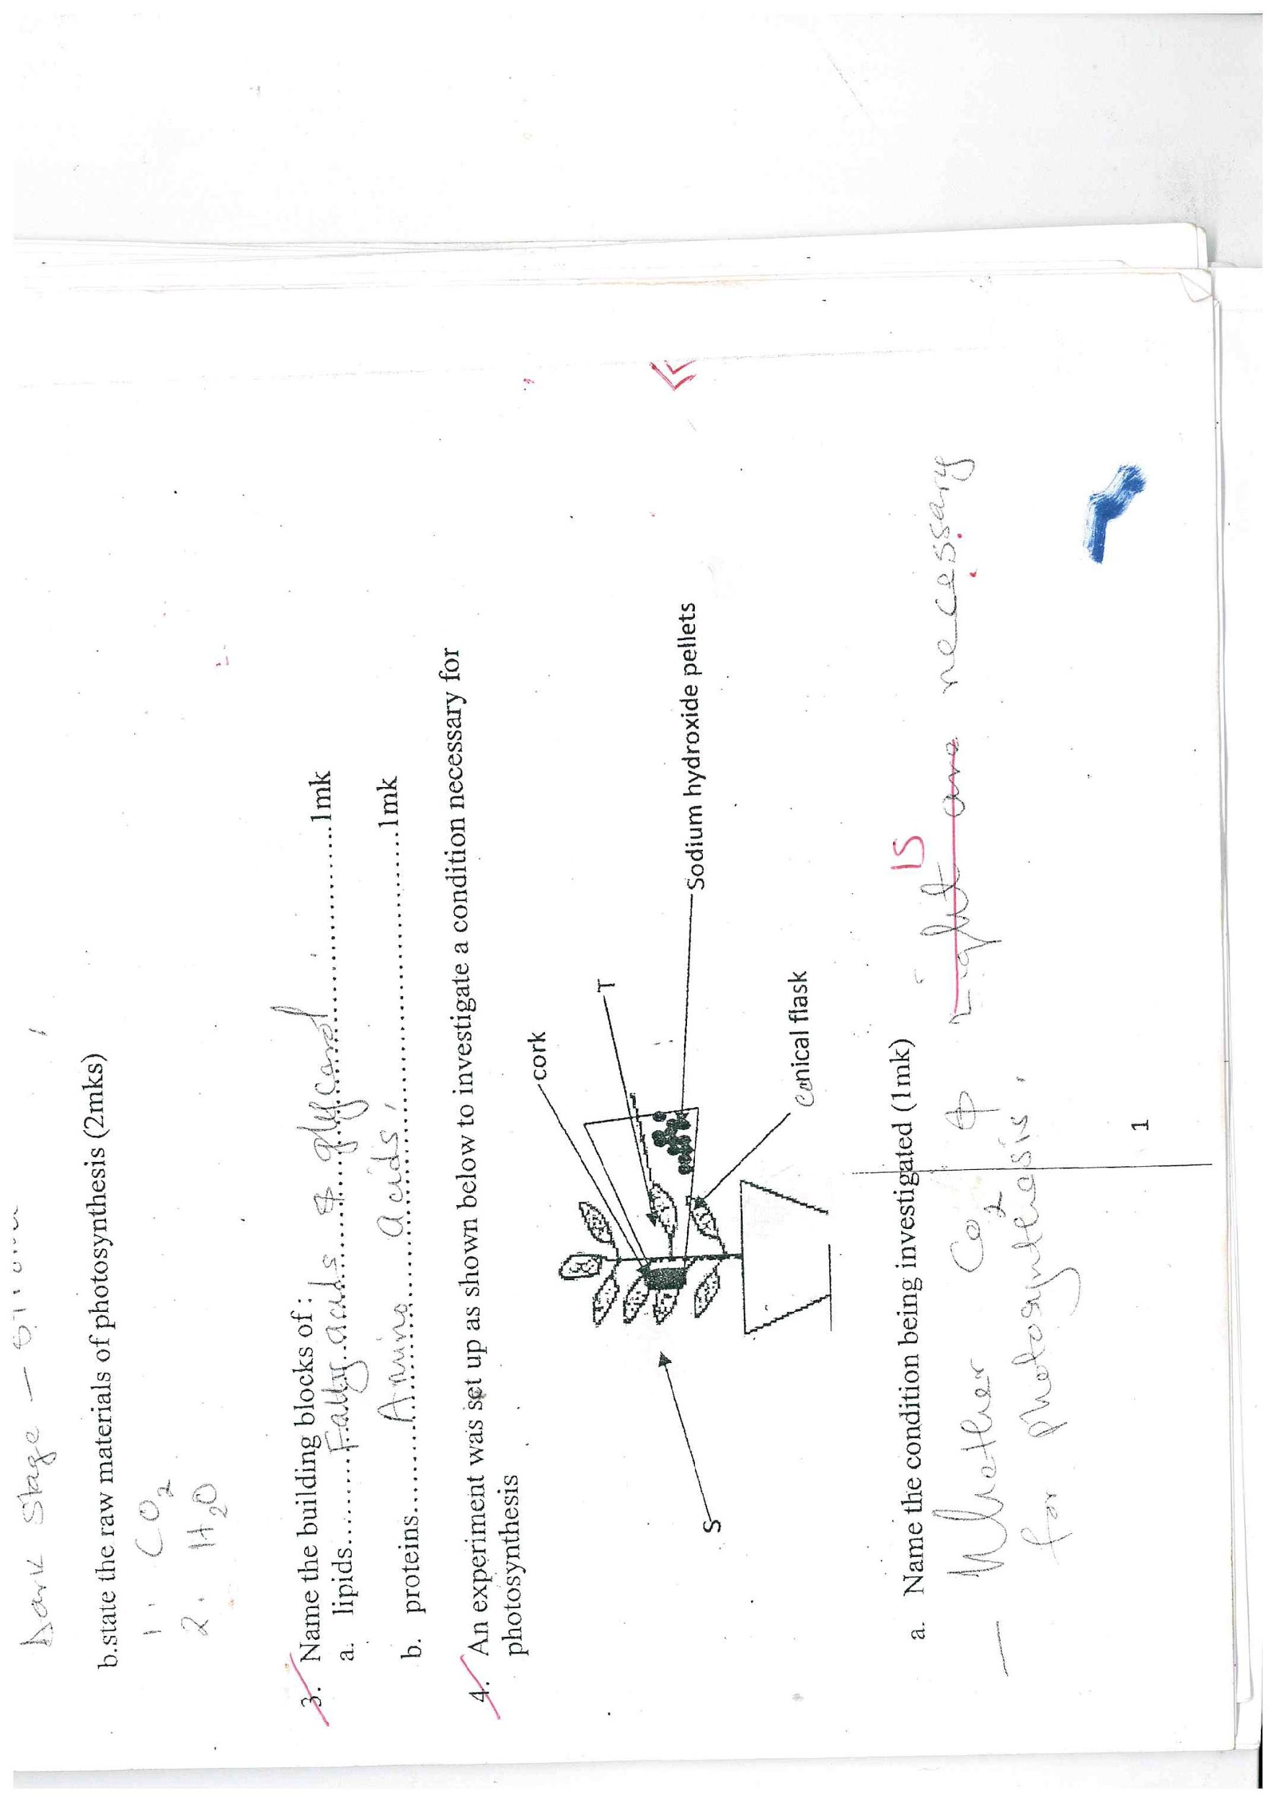
5. Name the condition being investigated. (1mk)

**Whether CO2 is necessary for photosynthesis.**

1. What is the role of sodium hydroxide pellets. (1mk)

**To absorb CO2**

1. Explain the expected results when leaf S and T are tested for starch. (2mks)

**S – Retains colour of iodine**

**T – Blue – Black**

1. Below is a list of carbohydrates; sucrose, fructose, cellulose, galactose, glycogen, maltose.
2. Name two monosaccharide’s (2mks)

**Galactose, fructose**

1. Name two disaccharides (2mks)

**Maltose, sucrose**

1. Name two polysaccharides (2mks)

**Glycogen, cellulose**

1. a) Explain the importance of the following stages in an experiment to test for presence of starch in a leaf.
2. Dipping the leaf in hot water. (1mk)

* **Killing the cells in the leaf./stopping and chemical reaction**
* **Open starch granules.**

1. Boiling the leaf in alcohol methylated spirit. (1mk)

* **Remove chlorophyll**

1. Adding iodine. (1mk)

**To test for starch**

1. What are the expected results if:
2. Starch is present. (1mk)

**Blue – Black**

1. Starch is absent (1mk)

**Colour of iodine retained.**

1. What are the expected results if a variegated leaf is used? (1mk)

**The green parts turn Blue- Black.**

**The yellow parts retain brown colour of iodine solution**

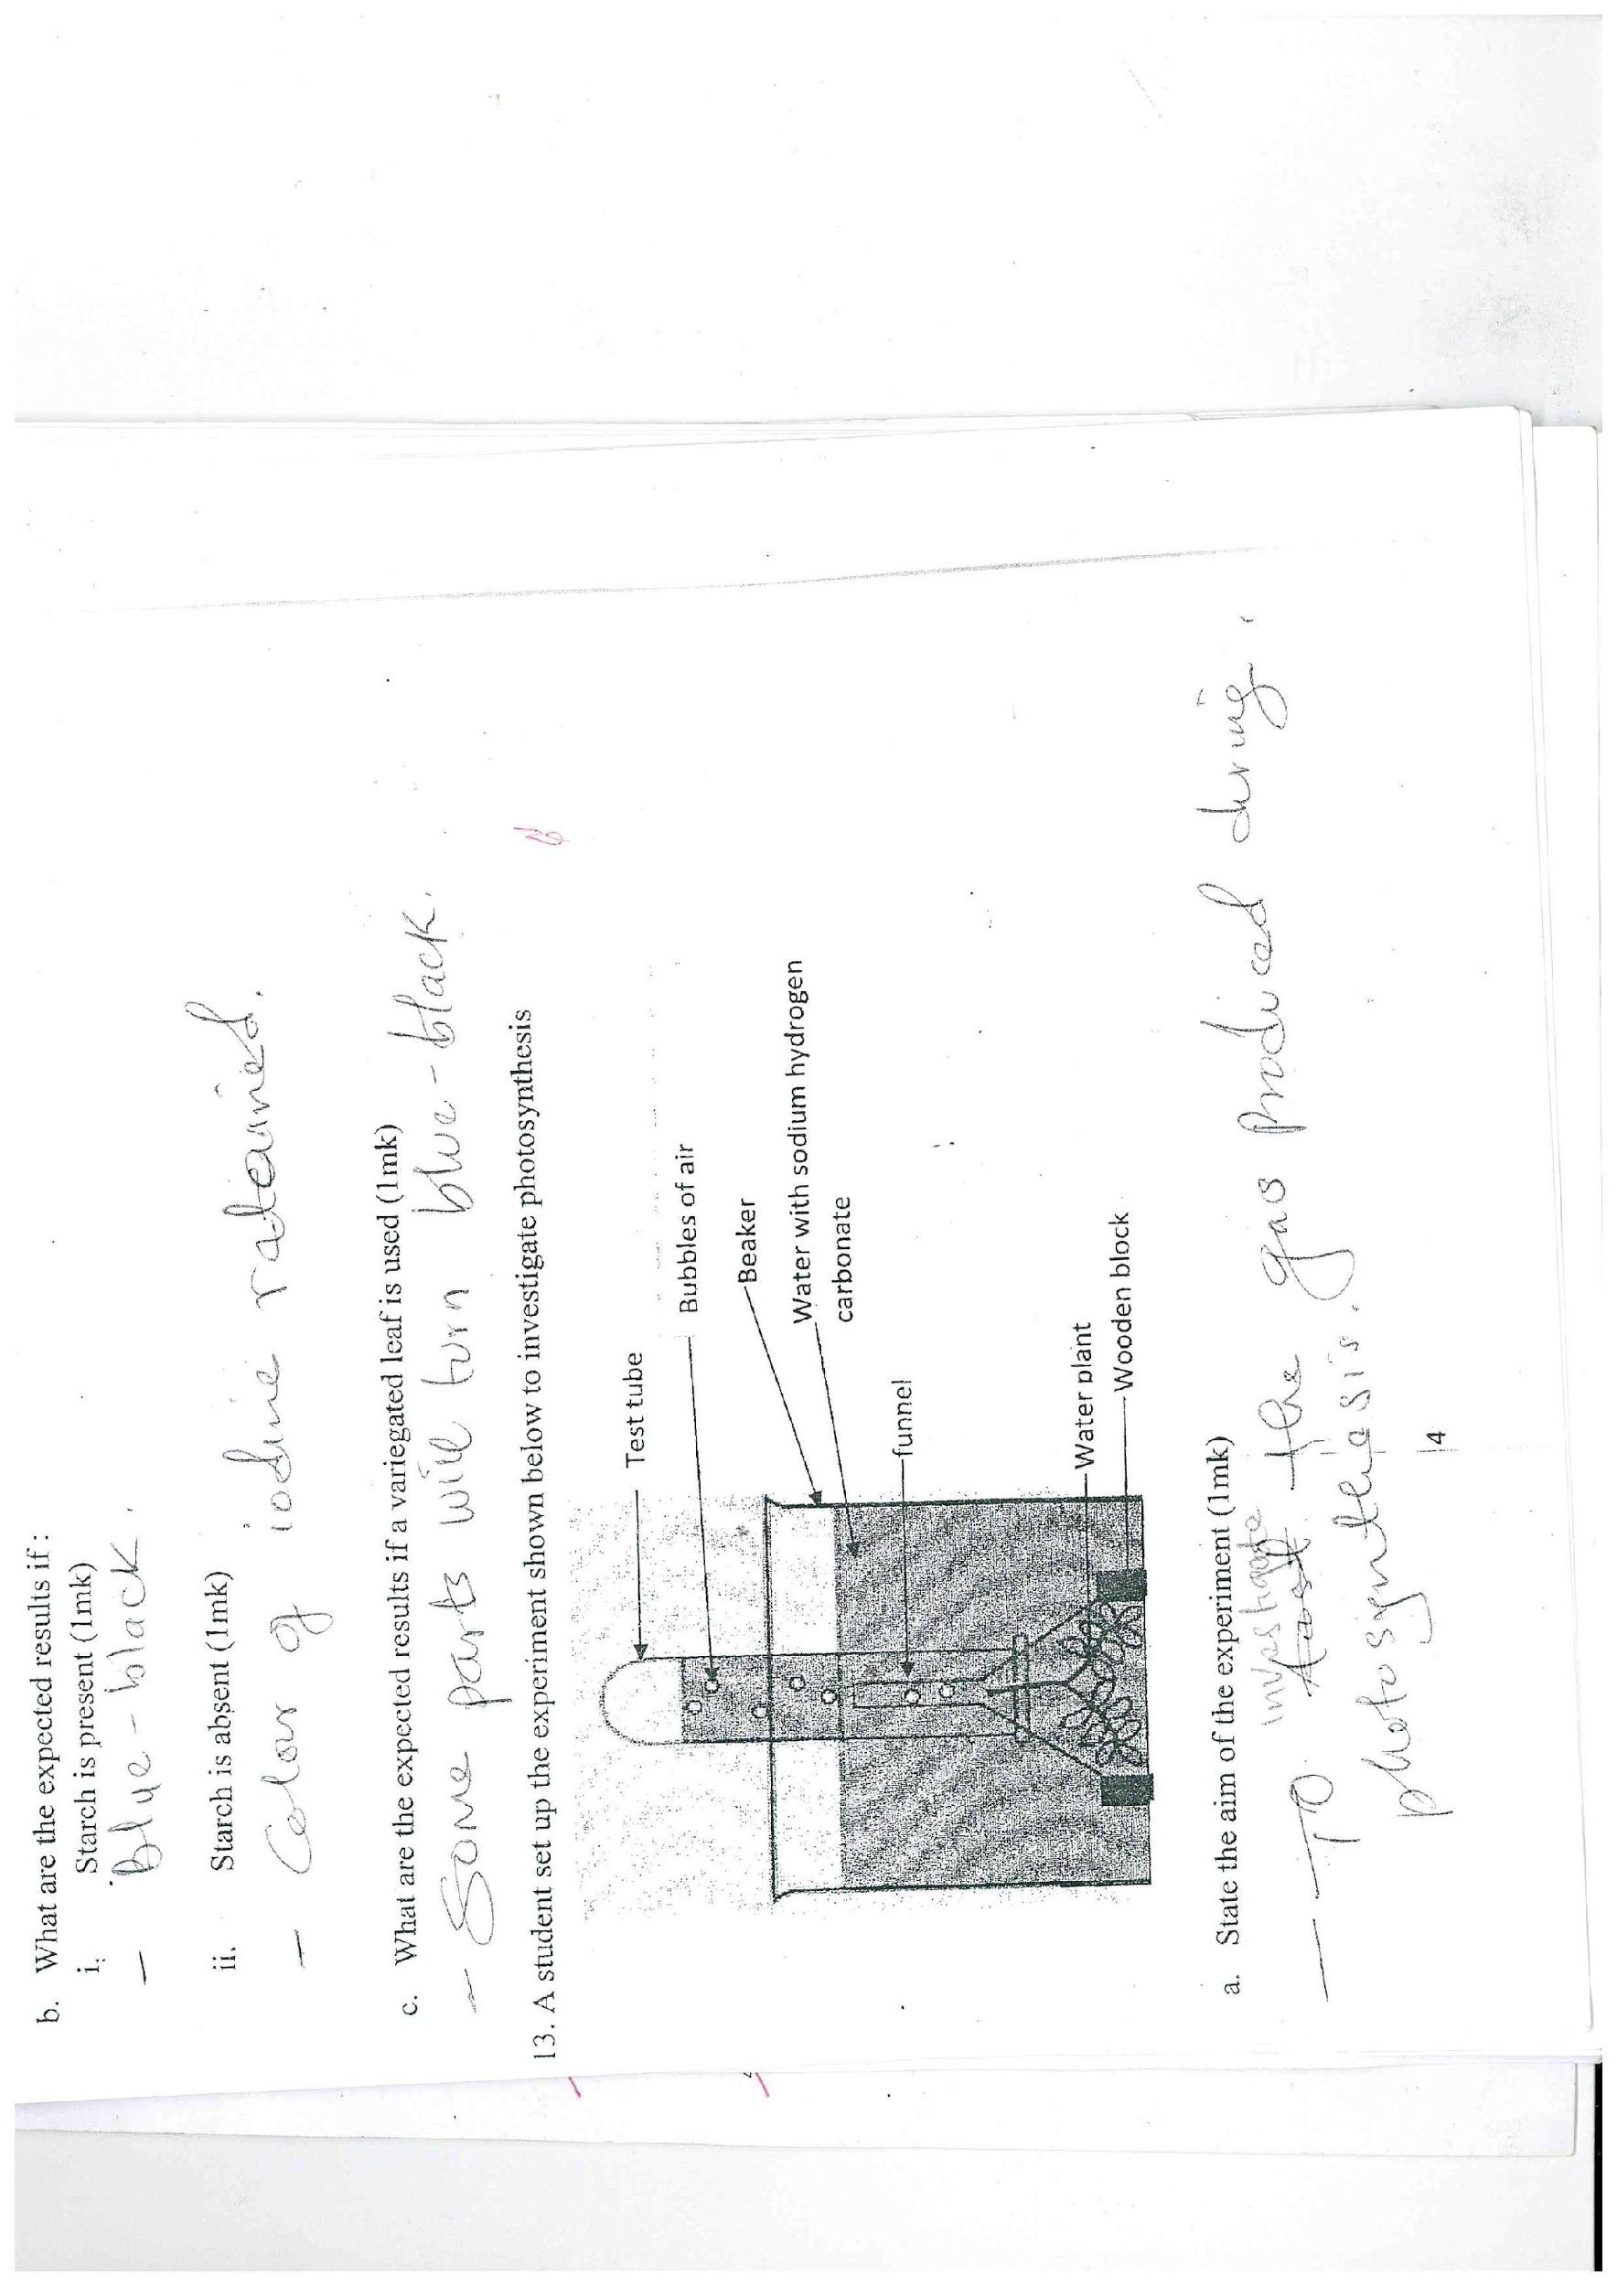

1. A student set up the experiment shown below to investigate photosynthesis.
2. State the aim of the experiment. (1mk)

* **To investigate the gas produced during photosynthesis.**

1. Explain why
2. Sodium hydrogen carbonate was added to the water. (1mk)

**To add concentration of CO2 in H2O.**

1. A water plant was used. (1mk)

**Adapted to photosynthesise in H20**

1. How can a student test for the gas given out? (1mk)

**Use of a glowing splint.**

1. State two other factors affecting photosynthesis that the experiment can be used to investigate. (2mks)

* **Effect of light intensity on the rate of photosynthesis.**
* **Effect of CO2 concentration on the rate of photosynthesis.**

1. Name the cell organelle present in an animal cell but absent in a plant cell. (1mk)

**Pinocytic vesicle**

**Centriole**

1. Explain the following
2. The leaf of a plant is broad and flat. (1mk)

**To increase the surface area for photosynthesis.**

1. A plant cell does not burst when placed in distilled water. (1mk)

**Has rigid cellulose cell wall.**

1. The diagram below represents a certain physiological process. Study it carefully and answer the questions that follow.

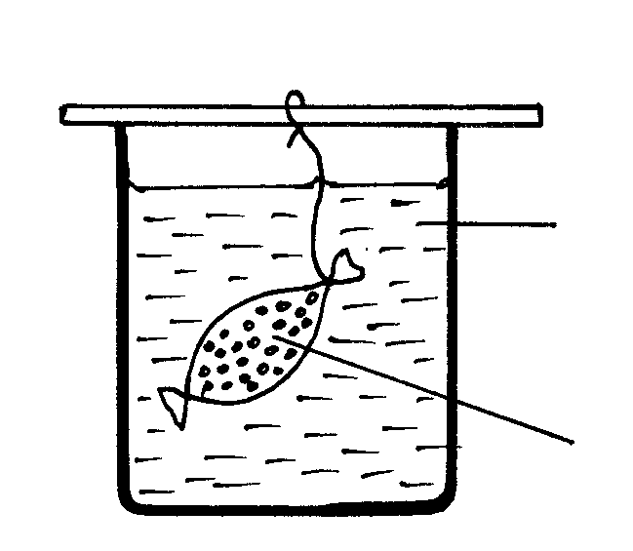

String

Iodine solution

Starch solution

Visking tubing

Beaker

1. State the physiological process illustrated above (1mk)

**Diffusion**

1. What will happen to the visking tubing after two hours? (1mk)

**The contents of the visking tubing turned blue-black.**

1. Account for the result in (b) above (3mks)

**The iodine molecules will move from the beaker where they are highly concentrated to the visking tubing where they are lowly concentrated by diffusion.**

**Starch molecules are too large to pass through the semi-permeable visking tubing while the iodine molecules are small sized hence diffused.**

1. Give three factors that affect the physiological process named in (a) above. (3mks)

* **Temperature**
* **Surface area**
* **Thickness of tissue/membrane/wall**
* **Size of molecules**
* **Type of medium**
* **Surface area to volume ratio.**

1. State two roles of the physiological process in (a) above in living organisms. (2mks)

**Gaseous exchange**

**Absorption of materials**

**Translocation of manufactured food material**

**Excretions of nitrogeneous waste**

1. Distinguish between haemolysis and plasmolysis. (2mks)

**Haemolysis – Bursting of a red blood cell put in hypotonic solution.**

**Plasmolysis – Process where a plant cell shrink and become flaccid when put in hypertonic solution.**

1. Name the elements that form carbohydrates. (3mks)

**Carbon**

**Hydrogen**

**Oxygen**