**MARKING SCHEME**

**PANGANI GIRLS POST MOCK**

*(Kenya Certificate of Secondary Education)*

**BIOLOGY THEORY**

**Instructions**

**For Examiner’s Use Only**

|  |  |  |
| --- | --- | --- |
| **Question** | **Maximum Score** | **Candidate’s Score** |
| 1-33 | 80 |  |

***This paper consists of 13 printed pages. Candidates should check the question paper to ascertain that all the pages are printed as indicated and no questions are missing***

1. Below is an image of a biological vector. Use it to answer questions that follow.

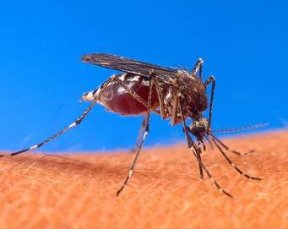

(a) Identify the parasite transmitted into human blood by the organism. (1 mark)

**Plasmodium species//*Plasmodium vivax//Plasmodium malariae//Plasmodium ovale//Plasmodium falciparum***

(b) Name the blood cells that are destroyed by the parasite in (a) above. (1 mark)

**Red blood cells//Erythrocytes.**

(c) State one biological method used to eradicate the larvae of this organisms. (1 mark)

**Fish feeding on the larvae;**

2. Give the structural adaptations of the following in an insect pollinated plant.

(a) Pollen grain. (1 mark)

**Rough //sticky to stick onto the body of the insect.**

(b) Stigma. (1 mark)

**Occur inside the flower ensuring that the insects brush against them as they look for nectar;// Sticky so that pollen grains from the body of an insect stick onto it; any 1**

3. State the causative agents of the following diseases

(i) Tuberculosis. (1 mark)

***Mycobacterium tuberculosis;* should be underlined separately.**

(i) Syphilis (1 mark)

***Treponema pallidum;* should be underlined separately.**

4. Use the illustration below to answer questions that follow.

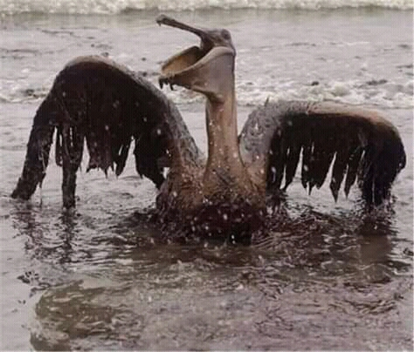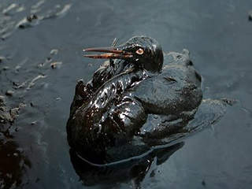

(a) Identify the type of pollution that has such an effect. (1 mark)

**Water pollution;**

(b) State two effects of the type of pollution identified in (a) above to the organism. (2 marks)

**Oil soaks the feathers hindering locomotion;**

**Birds remove oil using their beaks swallowing some of the oil causing poisoning;**

5. Identify the following types of responses:

(a) Pollen tube growing towards the ovary (1 mark)

**Positive Chemotropism;**

(b) Maggots moving away from light. (1 mark)

**Negative Phototaxis;**

6. State two activities of the cell that are controlled by the nucleus. (2 marks)

**Cell division;//Growth;//respiation**

7. Distinguish between botany and zoology. (1 mark)

**Botany is a branch of science that deals with study of plants while zoology is a branch of science that deals with study of plants;**

8. The field of view of a light microscope appeared as shown below in diagram A and the diameter in A

was occupied by cells as shown in B.

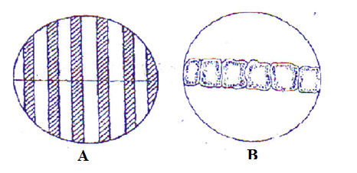

Calculate the length of one cell. (2 marks)

**Length of one cell= Diameter of field of view in um ; 6000 um = 1000um;**

**Number of cells 6**

9. State two importance of water in germination of seeds. (2 marks)

**Dissolve food substances//soften testa//hydrolyze food substances//activate enzyme any 2**

10. Why is sexual reproduction advantageous in flowering in plants? (2 marks)

**Hybrid vigour;**

**Causes variations;**

11. Below is an illustration of an organism captured by students during a practical lesson.

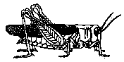

(a) Identify two features that enable the organism to be placed in the phylum Arthropoda. (2 marks)

**Segmented body;**

**Jointed appendages;**

**Bilateral symmetry;**

**Presence of exoskeleton;**

(b) Explain why the organism will die when Vaseline is applied on its thorax. (1 mark)

**Blocks the spiracles and thus no inhalation;**

12. Name two properties of enzyme amylase. (2 marks)

**Works best under alkaline pH;**

**Substrate specific;**

**Protein in nature;**

**Calatlyst;**

**Affected by temperatures;**

13. State the significance of natural selection. (2 marks)

**Formation of new species;**

**Elimination of undesirable characteristics;**

14. Explain why a plant shoot develops lateral branches when its tip is removed. (2 marks)

**Tip has a higher concentration of auxins,when the tip of shoot is removed auxin concentration is lowerd; less auxin concentration stimulates sprouting of lateral btranches;**

15. Why is eating a lot of biscuits harmful to the teeth. (2 marks)

**Sugar in biscuits get logged in between teeth, bacteria break down the sugars releasing acids; that corrode the enamel that cause tooth decay;**

16. The diagram below shows the structure of a neurone.

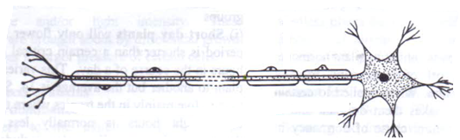

(a) Identify the neurone and state its function (2 marks)

**Motor neurone; transmit nerve impulses from central nervous system to the effectors;**

(b) Name the part of the brain that is involved in learning and memory. (1 mark)

**Cerebrum;**

17. Explain what happens to the internal structures of the human eye when a student reading a white printed paper on a bright sunny day enters a dark room for examinations. (3 marks)

**Radial muscles of the iris contract, circular muscles relax; and pupil enlarges this allows more light for perception of objects;**

18. Why is it important that the radicle develops first during germination? (2 marks)

**For absorptions of minerals salts and water;**

**Anchorage;**

19. (a) Explain one event of mitosis that restores the genetic constitution of an organism. (1 mark)

**Replication of chromosomes during interphase produces doubling chromosomes for sharing out;/ Alignment of spindle at equator during metaphase without association of homologous chromosomes prepares for separation of replicated chromatids;/the separation of chromatids during anaphase will result in same number of chromosomes in daughter cells;**

(b) Identify the following types of cell division:

(i) Division of generative nucleus into male nuclei. (1 mark)

**Mitosis;**

(ii) Division of cells lining the seminiferous tubules. (1 mark)

**Meiosis;**

20. State two observable characteristics that show discontinuous variations in *Drosophila melanogaster*

(2 marks)

**Wing length;-long dominant over vestigial wing**

**Eye colour;-red eyes dominant over white eye.**

**Size of abdomen;-broad abdomen dominant over narrow abdomen**

**Body colour ;-grey body colour dominant over black body colour**

21. Explain why athletes breathe quickly and deeply after a 100 meters sprint. (3 marks)

**To increase the supply of oxygen; required to get rid of lactic acid; due to anaerobic respiration;**

22.(a) State two proteins that determine human blood groups. (1 mark)

**Antigen A;/antigen B;/rhesus factor/ all mentioned to get a mark:**

(b)(i) What is the role of blood capillary? (1 mark)

**Site for exchange of substances;**

(ii) Explain why blood does not clot in undamaged blood vessels. (1 mark)

**Presence of prothrombin in blood//presence of heparin;**

23.(a) List one type of chromosomal aberrations. (1 mark)

**Deletion //duplication//inversion//tranlocation//non disjunction// any 1**

(a) State one advantage of polyploidy in modern farming. (1mark)

**Increased yields//early maturity//resistance to drought,pests and disease//any 1**

24. Explain:

(a) Why insulin is not administered orally. (1 mark)

**Insulin is a hormone that is transmitted through blood;**

(b) Why stomach wall is lined with mucus (1 mark)

**To prevent autodigestion;**

25.(a) what is homeostasis? (1 mark)

**Self adjusting mechanism that maintains a steady internal state in organisms;**

(b) State two behavioral mechanisms used by snakes to increase their body temperature. (2 marks)

**Coiling;**

**Basking;**

26. Explain why only a small amount of food materials taken up by herbivores is passed on to secondary consumers. (2 marks)

**Absorbed food is used in cell metabolism;**

**Lost in excretion;**

27. Below is a diagram of a respiratory surface. Use it to answer questions that follow.

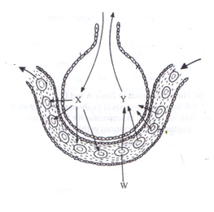

(a) Name the physiological process involved in the exchange of gases in the structure above. (1 mark)

**Diffusion;**

(b) Identify the substance in cell labeled w that has high affinity for gas X. (1 mark)

**Haemoglobin;**

(c) State the advantage of gas Y being transported in cells labeled W (1 mark)

**Does not affect the pH of blood;**

**Efficient in loading and offloading of oxygen**;

28. (a) Explain why when transplanting a young plant, it is advisable to remove some leaves. (2 marks)

**Reduce the surface area/number of stomata exposed to envinronmental factors; thus lower the rate of transpiration;**

(b) Give one role of xylem vessels other than transport (1 mark)

**Mechanical support;**

29. The diagram below shows a specimen that was obtained from a tree

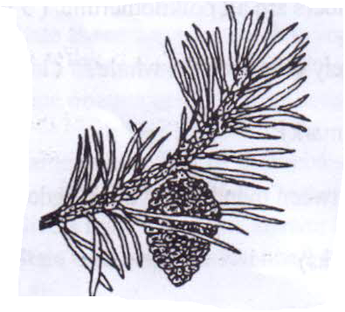

(a) Identify the class the plant from which the specimen was obtained from belongs to. (1 mark)

**Coniferales;**

(b) Identify two observable characteristics that supports your answer in (a) above. (2 marks)

**Has cones;**

**Needle shaped leaves;**

30. State two characteristics of a bony fish which enable it to reduce friction in water. (2 marks)

**Streamlined body;/inflexible head;/scales overlap and are pointed backwards;/mucus covering the body;**

31. (a) Identify the structural difference between the wing of a bird and the wing of an insect (1 mark)

|  |  |
| --- | --- |
| Wing of a bird | Wing of an insect |
| **originates from the** **endoskeleton** | **originates from the exoskeleton;** |
| **Has bones** | **No bones;any 1** |

(b) Identify the type of evolution exhibited by the wings of birds and insects and state the name given to such structures. (2 marks)

**Convergent evolution; analogous structures;**

32. Use the illustration below to answer questions that follow

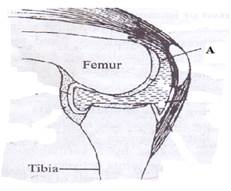

(a) Identify the fluid labeled A and state its function. (2 marks)

**Synovial fluid;provides oxygen and nutrients/lubricates the joints and reduces friction/absobs shock;any 1**

(b) Name the type of joint shown above. (1 mark)

**Hinge joint;**

33. (a) what is the role of a pollen tube. (1 mark)

**Facilitates transfer of male nuclei to the embryo sac;**

(b) Identify the role of the following hormones in males:

(i) Follicle stimulating hormone. (1 mark)

**Synthesis of sperms;**

(ii) Testosterone. (1 mark)

**Development of secondary sexual characteristics in males/production and maturation of sperms;any 1**