NAME: ………………………………………….……… INDEX NO……………………CLASS…………
ADM NO: .........................................DATE…………………………. SIGN………………………………

231/3
BIOLOGY
PAPER 3
PRACTICAL
TIME: 1 ¾ HOURS
PANGANI GIRLS’ HIGH SCHOOL
POST MOCK 2022

Kenya Certificate of Secondary Education( K.C.S.E.)

Instructions to candidate
- Answer ALL questions
- You are required to spend the first 15 min of 1³/₄ hours allowed for this paper reading the whole paper before carefully before commencing your work.
- Answer must be written in the spaces provided in the question paper
- Don’t insert additional page /paper

FOR EXAMINER USE ONLY
QUESTIONS | MAXIMUM SCORE | CANDIDATE SCORE
1 | 14
2 | 13
3 | 13
TOTAL | 40

- You are provided with specimen A and B
- Name the sub-division to which the specimen belong (1mk)
…………………………………………………………………………………………………...
- Name the class to which the specimens belong (2mks)
A…………………………………………..
B…………………………………………..
- State three observable differences between the leaves of specimen A and B (3mks)
Leaves A | Leaves B
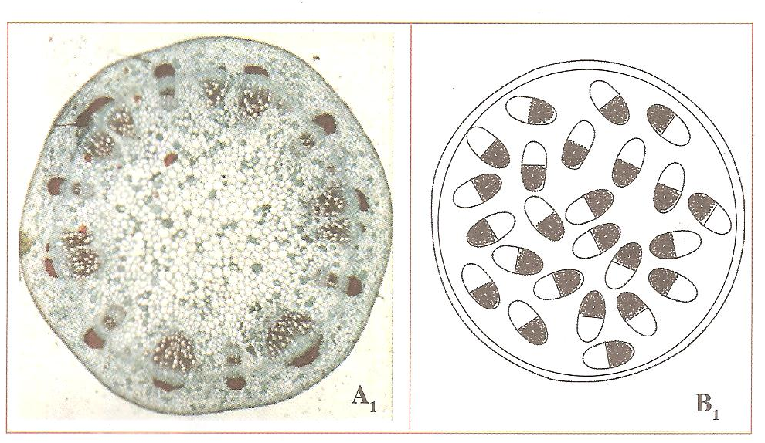
- The diagram below show the cross-sections of stems obtained from specimens A and B

- Match the stem cross-sections with the specimens (2mks)
……………………………………………………………………………………………………………………………………………………………………………………………….
- Outline three differences between the two stems (3mks)
Specimen A₁ | Specimen B₁

- Suggest the agent of pollination of the flowers of specimen A (1mk)
………………………………………………………………………………………………..
Give reason for your answer (1mk)
…………………………………………………………………………………………………

- You are provided with photographs of specimens labeled K (gills) and L (lungs). Examine them and answer the questions that follow.
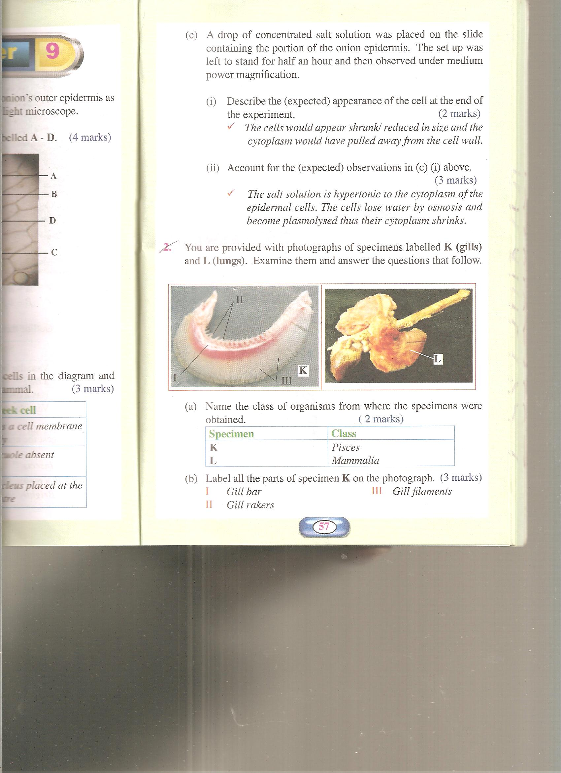

- Name the class of organisms from where the specimens were obtained (2mks)
Specimen | Class
K
L

- Label all the parts of specimen K on the photograph (3mks)
I…………………………
II………………………..
III………………………
- State the functions of each of the parts you have labeled in (b) above (3mks)
………………………………………………………………………………………………………………………………………………………………………………………………………………………………………………………………………………………………………………………………………………………………………………………………………………………………
- State three ways in which the part labeled L is adapted to its functions (6mks)
………………………………………………………………………………………………………………………………………………………………………………………………………………………………………………………………………………………………………………………………………………………………………………………………………………………………………………………………………………………………………………………………………………………………………………………………………………………………………………………………………………………………………………………………………………………

- State the functional relationship between specimens K and L (1mk)
………………………………………………………………………………………………………………………………………………………………………………………………………………
- You are provided with:
- 1ml Olive oil
- K₁ (Concentrated sodium hydrogen carbonate solution)
- K₂
- Irish potato
- Test tube
- Iodine solution
Label two test tubes X and Y. Into each test tube; put 2cm³ of water and 8 drops of Olive oil. To the test tube labeled X, add 8 drops of Liquid K₁. Shake both test tubes and allow the contents to stand for 2 minutes
- (i) Record your observation in: (2mks)
Test tube X
………………………………………………………………………………………………………………………………………………………………………………………………………………………………………………………………………………………………………
Test tube Y
………………………………………………………………………………………………………………………………………………………………………………………………………………………………………………………………………………………………………
(ii) Name the process that has taken place in test tube X (1mk)
…………………………………………………………………………………………………
(iii) Stage the significance of the process named in (a) (i) above in digestion (1mk)
………………………………………………………………………………………………….
(iv) Name the:
- Digestive juice in human beings that has the same effect on oil as liquid K₁ (1mk)
………………………………………………………………………………………
- Region of alimentary canal where the juice is secreted (1mk)
…………………………………………………………………………………………
- Label two test tubes E and F. place 2cm³ of liquid K₂ into each. Add a drop of iodine solution into each test tube
- Record your observations (1mk)
………………………………………………………………………………………….

- Suggest the identity of liquid K₂ (1mks)
…………………………………………………………………………………………
- Cut out a cube whose sides are 1cm from the irish potato provided. Crush the cube to obtain a paste and place the paste in the test tube labeled E. Leave the set up for at least 30minutes
Record your observations (2mks)
……………………………………………………………………………………………….
………………………………………………………………………………………………
……………………………………………………………………………………………….
- Account for the results in (b) (iii) above (2mks)
……………………………………………………………………………………………………………………………………………………………………………………………………………………………………………………………………………………………………………………………………………………………………………………………………………………………………………………………………………………………….

