**CHEMISTRY FORM 1 2022 MARKING SCHEME**

1. a) In the boxes provided below show how molecules are spaced in solids, liquids and gases in

terms of kinetic theory. (3mks)

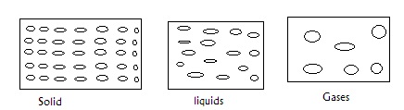

b) What conclusion can you make regarding densities of solids, liquids and gases as per the

packaging of molecules in 1 (a) above. (1mk)

**Solids have very high density, liquids have high density gases have low density.**

1. State whether the substances given below are elements, compounds or mixtures. (4mks)

|  |  |
| --- | --- |
| Substance |  |
| 1. Piece of Aluminium metal | **Element** |
| 1. Sugar | **Compound** |
| 1. Solution of common salt | **Mixture** |
| 1. Crude oil | **mixture** |

1. Study the flow chart below and answer the questions that follows.

Water

Sand

Mixture A

Liquid X

Solid Y

Process B

1. Name process B. (1mk)

**Filtration**

1. Give one reason why it’s possible to separate the mixture A above using process B.

(1mk)

**It contains an insoluble solid.**

1. Give the name for
2. Liquid X **filtrate (**1mk)
3. Solid Y **residue** (1mk)
4. Give one application of process B in day to day life. (1mk)

Filtering water for domestic use.

**Purification of drinking water in water treatment plants.**

1. State the method of separation suitable for the following mixtures.
2. Iron fillings and sulphur powder. (1mk)

**Magnetism**

1. Dye from flowers. (1mk)

**Chromatography.**

1. Petrol from crude oil. (1mk)

**Fractional distillation**

1. Oil from nuts. (1mk)

**Solvent extraction.**

1. The diagram below represents arrangement of particles in a substance. Study it and answer the questions that follow.

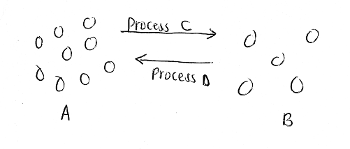

1. Name process C. (1mk)

**Evaporation/vaporisation**

1. Name two substances that undergo sublimation. (2mks)

* **Iodine crystals**
* **Dry ice**
* **Benzoic acid**
* **Ammonium chloride**
* **Aluminium chloride**
* **Iron (III) Chloride**

1. What name is given to process D? (1mk)

**condensation**

1. a) If common salt is added to wax, what effect will it have on the temperature at which it melts? (1mk)

**The melting point will be lowered.**

b) When alcohol is heated, it changes to gas at 780C.

i) What is the name given to this temperature? (1mk)

**Boiling point**

(ii) What will happen to this temperature if an impurity like salt is added to ethanol? (1mk)

**It will be increased.**

1. Given the following substances and their PH values, indicate whether they are neutral, strongly acidic, weakly acidic, weakly alkaline or strongly alkaline. (7mks)

|  |  |  |
| --- | --- | --- |
| Substance | PH Value | Nature |
| 1. Sugar solution | 7.0 | **Neutral** |
| 1. Blood | 7.4 | **Weakly alkaline** |
| 1. Sulphuric (VI) acid | 1.0 | **Strongly acidic** |
| 1. Tooth paste | 8.0 | **Weakly alkaline** |
| 1. Black coffee | 5.0 | **Weakly acidic** |
| 1. Sodium hydroxide solution | 14.0 | **Strongly alkaline** |
| 1. Urine | 6.0 | **Weakly acidic** |

1. State 2 ways through which the youth of Kenya can avoid abusing drugs. (2mks)
2. **Proper use of leisure time. E.g. religious activities helping the elderly and sick etc to keep themselves busy.**
3. **Avoiding wrong peer groups that may influence them wrongly on drugs.**
4. **Educate the youth on the effects of drug abuse.**
5. A form one student at Moja High School lit a Bunsen burner with its air hole fully open.

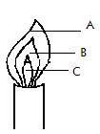

1. Which colour was the part labeled A? (1mk)

**Blue**

1. Identify the hottest part of the flame. (1mk)

**A**

1. Which was the almost colourless region? (1mk)

**C**

1. Classify each of the following substances as either conductors or non-conductors. (5mks)
2. Copper metal  **Conductor.**
3. Paraffin **Non-Conductor**
4. Glass **Non-Conductor**
5. Graphite **Conductor**
6. Magnesium **Conductor**
7. Three pure pigments were prepared and their spots placed on a filter paper as shown below. The pure pigments are A, B and C. a mixture D was also place on the filter paper at the same time with the pure pigments.

The filter paper was then dipped in ethanol solvent and left for an hour. The results obtained were as shown below.

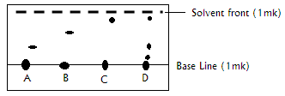

1. Which of the three pure pigments is most sticky? Give a reason for your answer. (2mk)

**A – Has moved the shortest distance from the baseline.**

1. Which pure pigment is not present in the mixture D? (1mk)

**B**

1. Show on the diagram the solvent front and the base line. (2mks)
2. a) What is an acid-base indicator? (1mk)

**A substance which has one colour in an acid and a different one in a base.**

b) Name any three common indicators used in chemistry and give their colours in acid solution. (3mks)

|  |  |
| --- | --- |
| **Indicator** | **Colour in acid** |
| 1. **litmus paper** | **Red** |
| 1. **phenolphthalein** | **Colourless** |
| 1. **methyl orange** | **Red** |

(c) What is the advantage of universal indicator over other common acid-base indicators?

(1mk)

**It shows the strength of an acid or base unlike other indicators.**

1. Citric acid, lactic acid, methanoic acid and hydrochloric acid are found in various substances in plants and in various substances in plants and animals. State where these acids occur. (4mks)

|  |  |
| --- | --- |
| Acid | Where found |
| 1. Citric acid | **Citrus fruits** |
| 1. Lactic acid | **Sour milk** |
| 1. Methanoic acid | **Bee/Ant sting, Nettle plant** |
| 1. Hydrochloric acid | **Stomach** |

1. I. A student mixed iron fillings with sulphur powder in a watch glass. The mixture was heated and a new substance was formed.
2. Is this a physical or chemical change? **Chemical.** (1mk)
3. Give two reasons to support your answer in (a) above. (2mks)

* **Its irreversible**
* **A new substance was formed**

1. What name is given to the substance formed after heating sulphur and iron together?

(1mk)

**Iron (II) Sulphide.**

II. Determine whether the following substances undergo chemical or physical changes when heated.

(4mks)

|  |  |
| --- | --- |
| Substance | Type of change |
| 1. Ice | **Physical** |
| 1. Zinc oxide | **Physical** |
| 1. Iodine crystals | **Physical** |
| 1. Copper (II) Carbonate | **Chemical** |

1. Write simple word equations for the following reactions. (5mks)
2. Magnesium and oxygen.

**Magnesium + oxygen magnesium oxide**

1. Carbon and oxygen (excess)

**Carbon + oxygen (excess) carbon (IV) oxide**

1. Zinc and Hydrochloric acid

**Zinc + Hydrochloric acid Zinc Chloride + Hydrogen**

1. Sodium Carbonate and Hydrochloric acid

**Sodium Carbonate + Hydrochloric acid Sodium Chloride + Carbon (IV) Oxide + water**

1. Calcium oxide and Sulphuric (VI) acid.

**Calcium oxide + sulphuric acid Calcium Sulphate + water**

1. a) Give the chemical name of rust (1mk)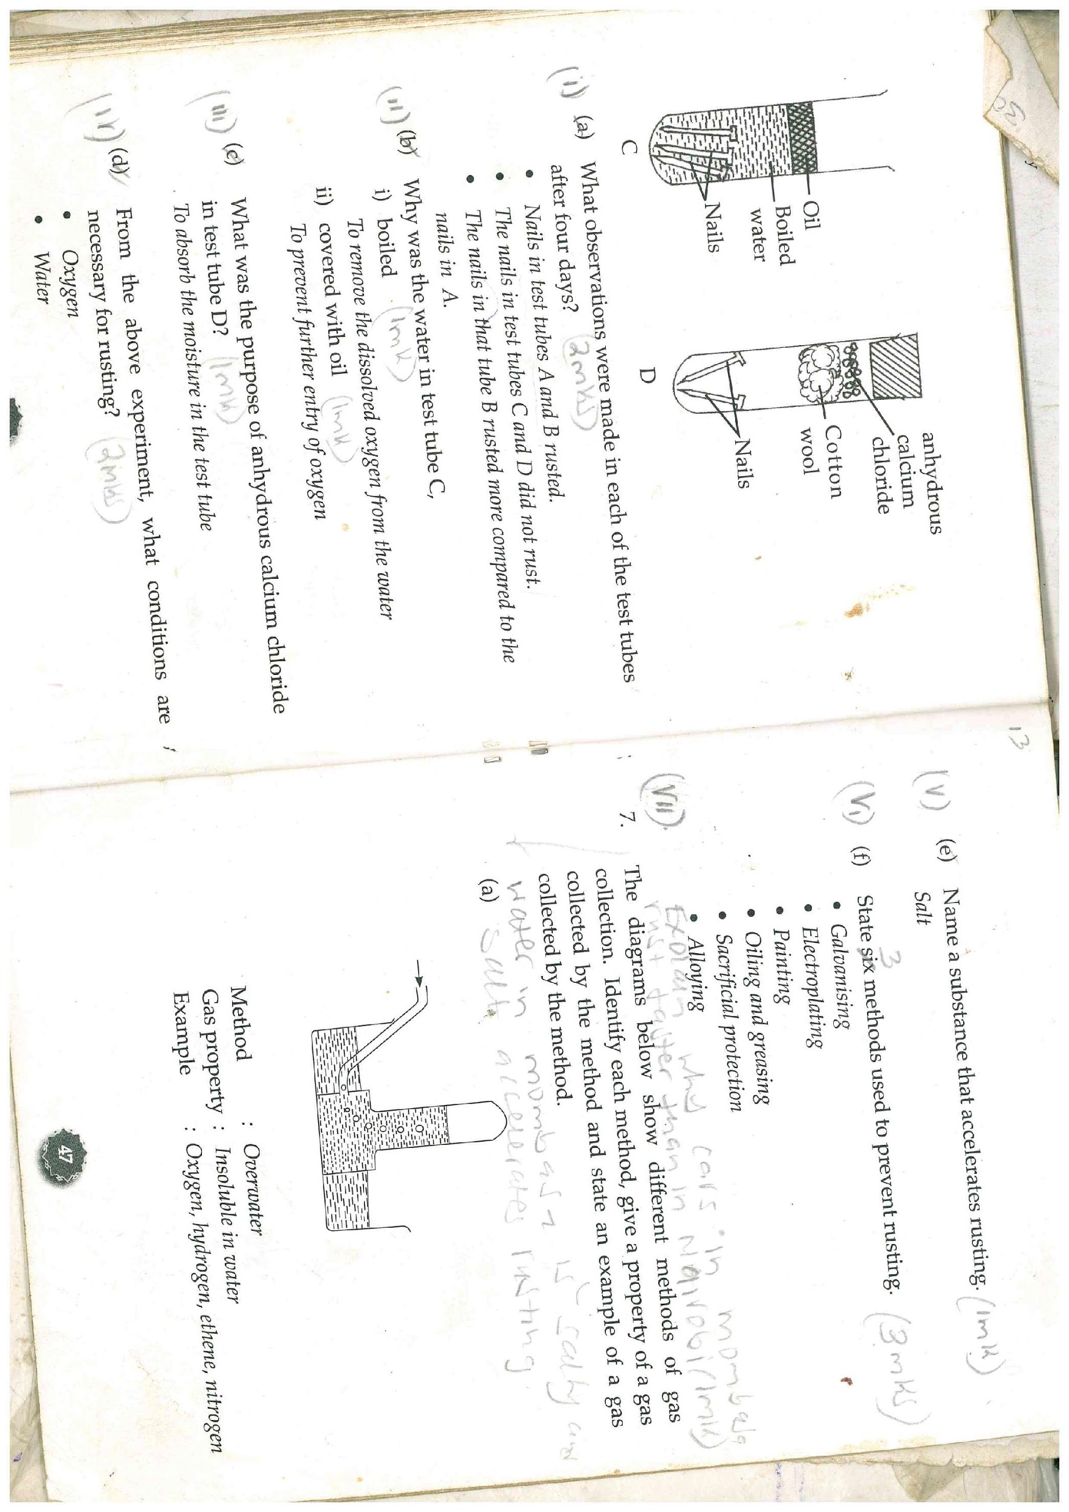

**Hydrated Iron (III) Oxide.**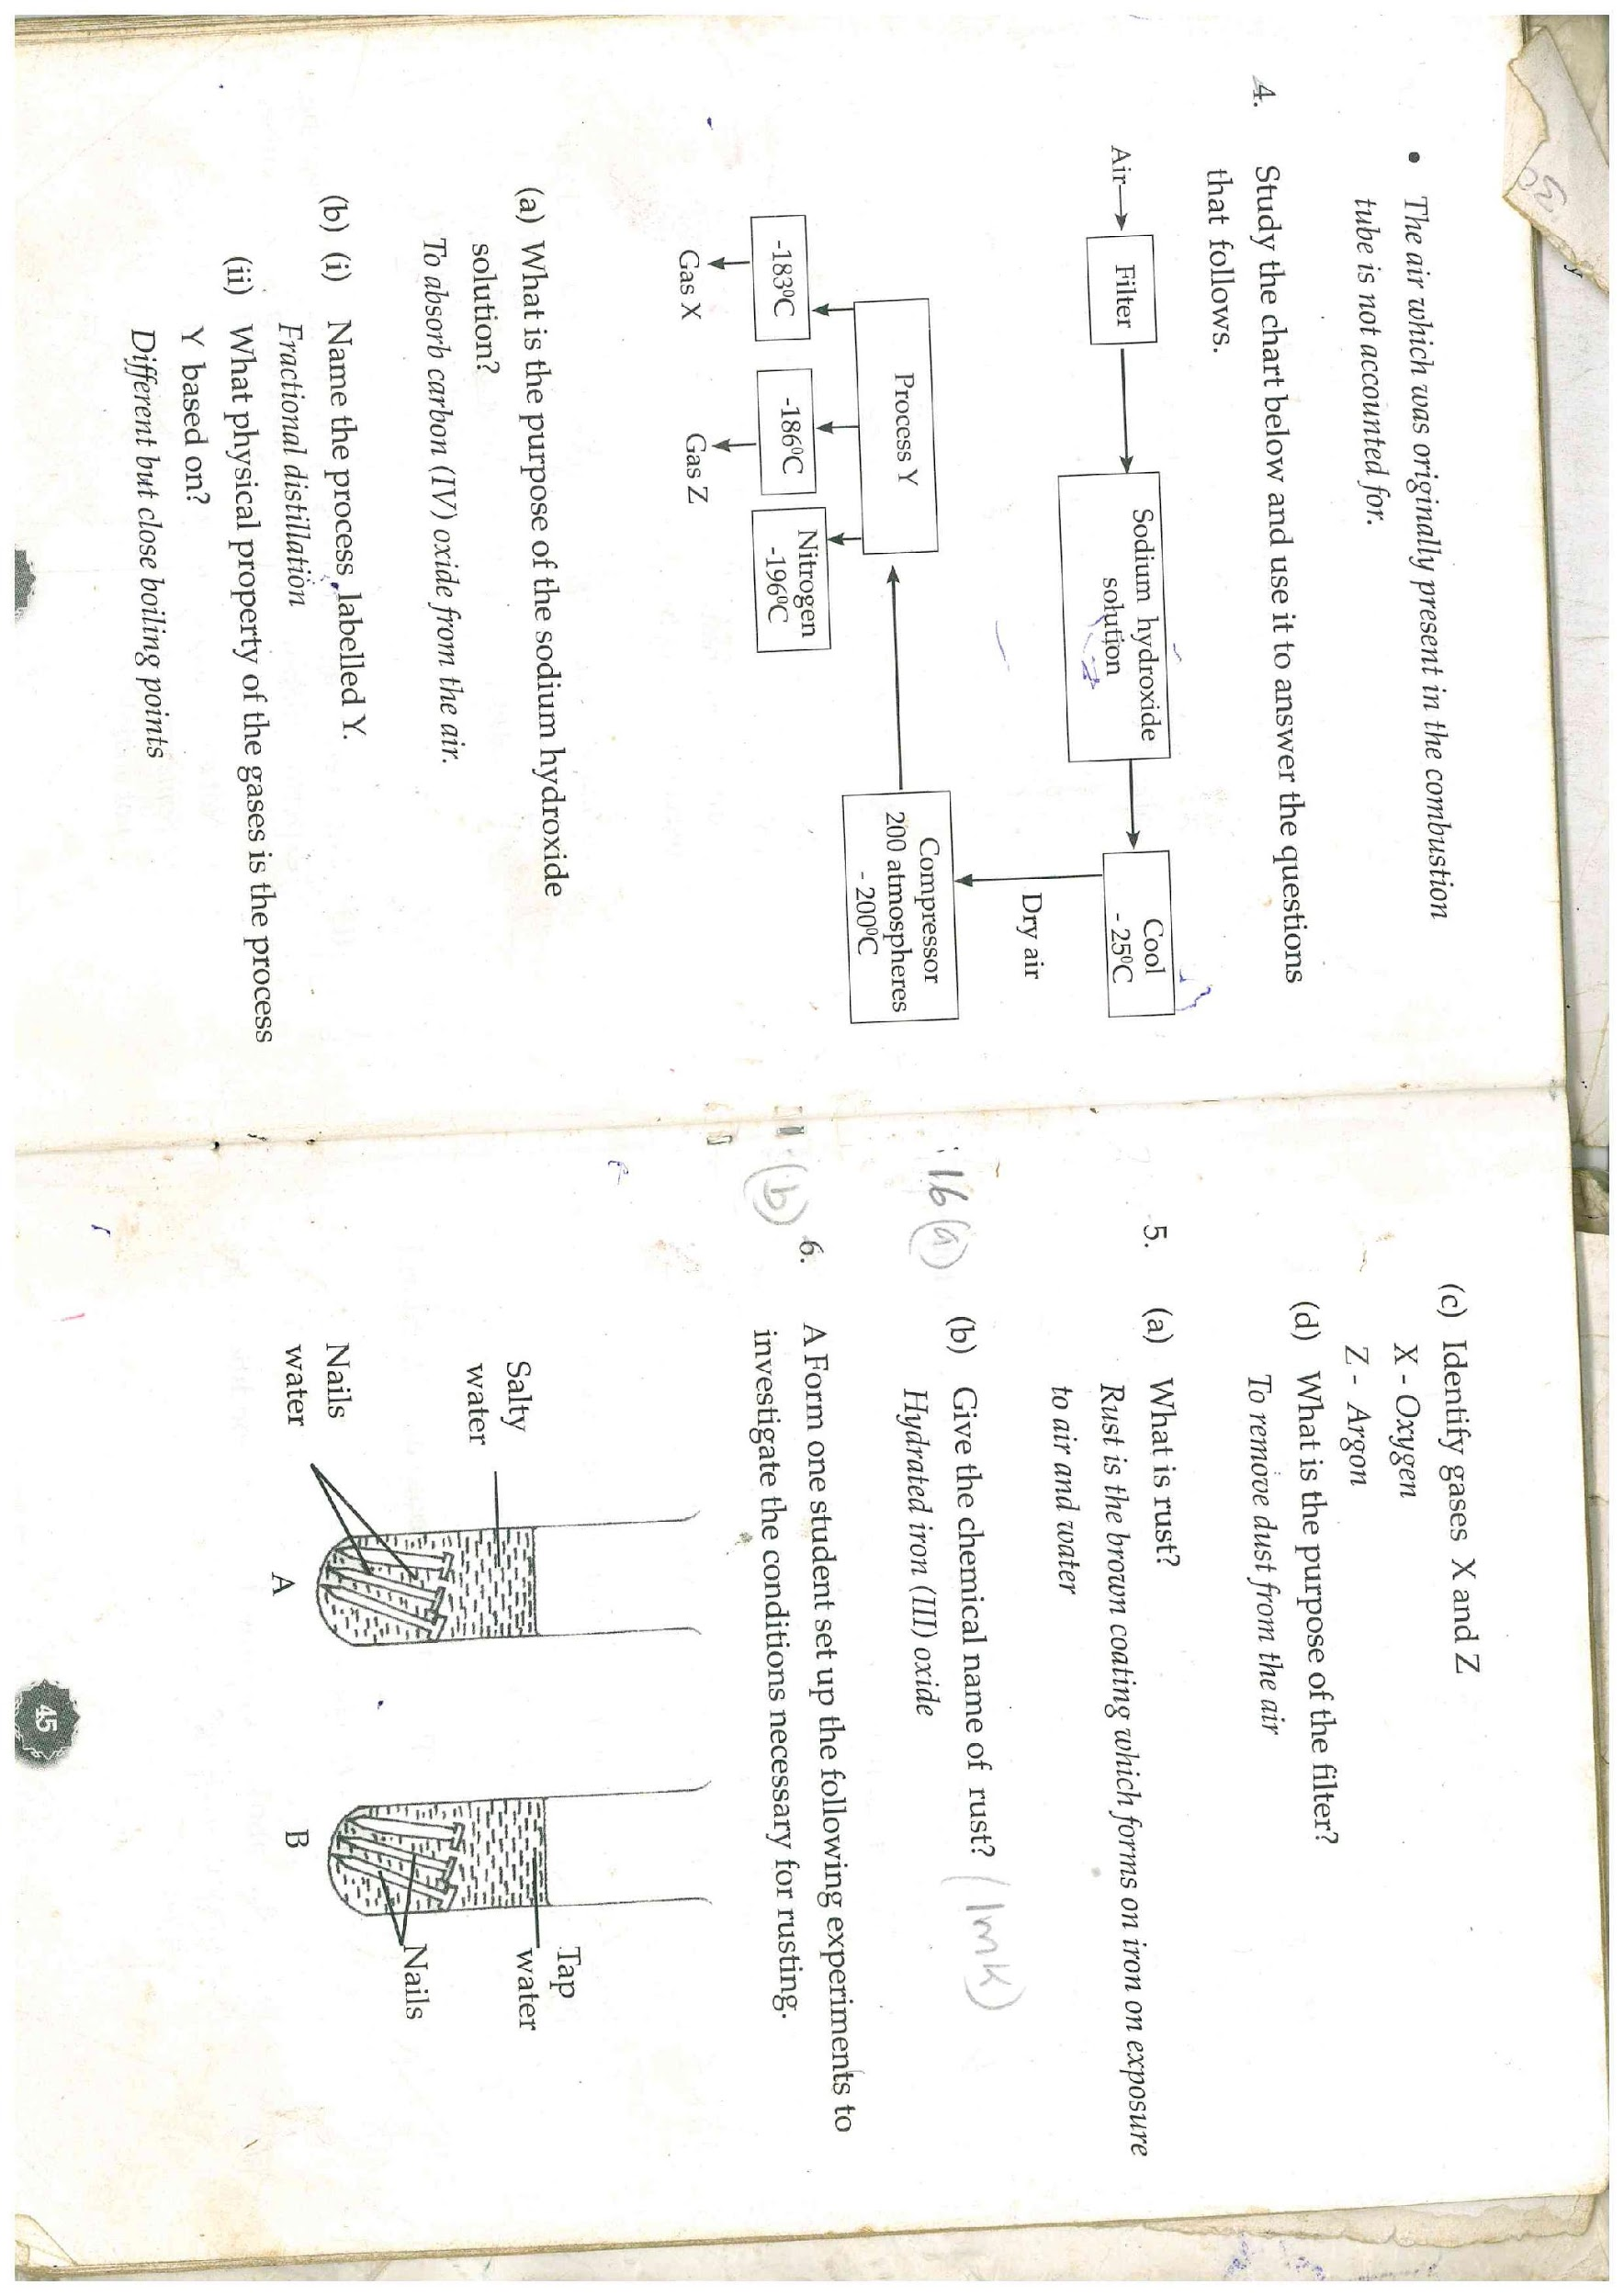

b) A form one student set up the following experiments to investigate the conditions

necessary for rusting.

1. What observations were made in each of the test tubes after four days. (3mks)

* **Nails in test tubes A and B rusted.**
* **The nails in test tubes C and D did not rust.**
* **The nails in tube A rusted more compared to the nails in B.**

1. Why was the water in test tube C
2. Boiled (1mk)

**To remove the dissolved oxygen from the water.**

1. Covered with oil (1mk)

**To prevent further entry of oxygen.**

1. What was the purpose of anhydrous calcium chloride in test tube D? (1mk)

**To absorb the moisture in the test tube.**

1. From the above experiment, what conditions are necessary for rusting? (2mks)

**Oxygen**

**Water**

1. Name a substance that accelerates rusting. (1mk)

**Salt.acid**

1. State 2 methods used to prevent rusting. (2 mks)

**Galvanising**

**Electroplating**

**Painting**

**Oiling and greasing** 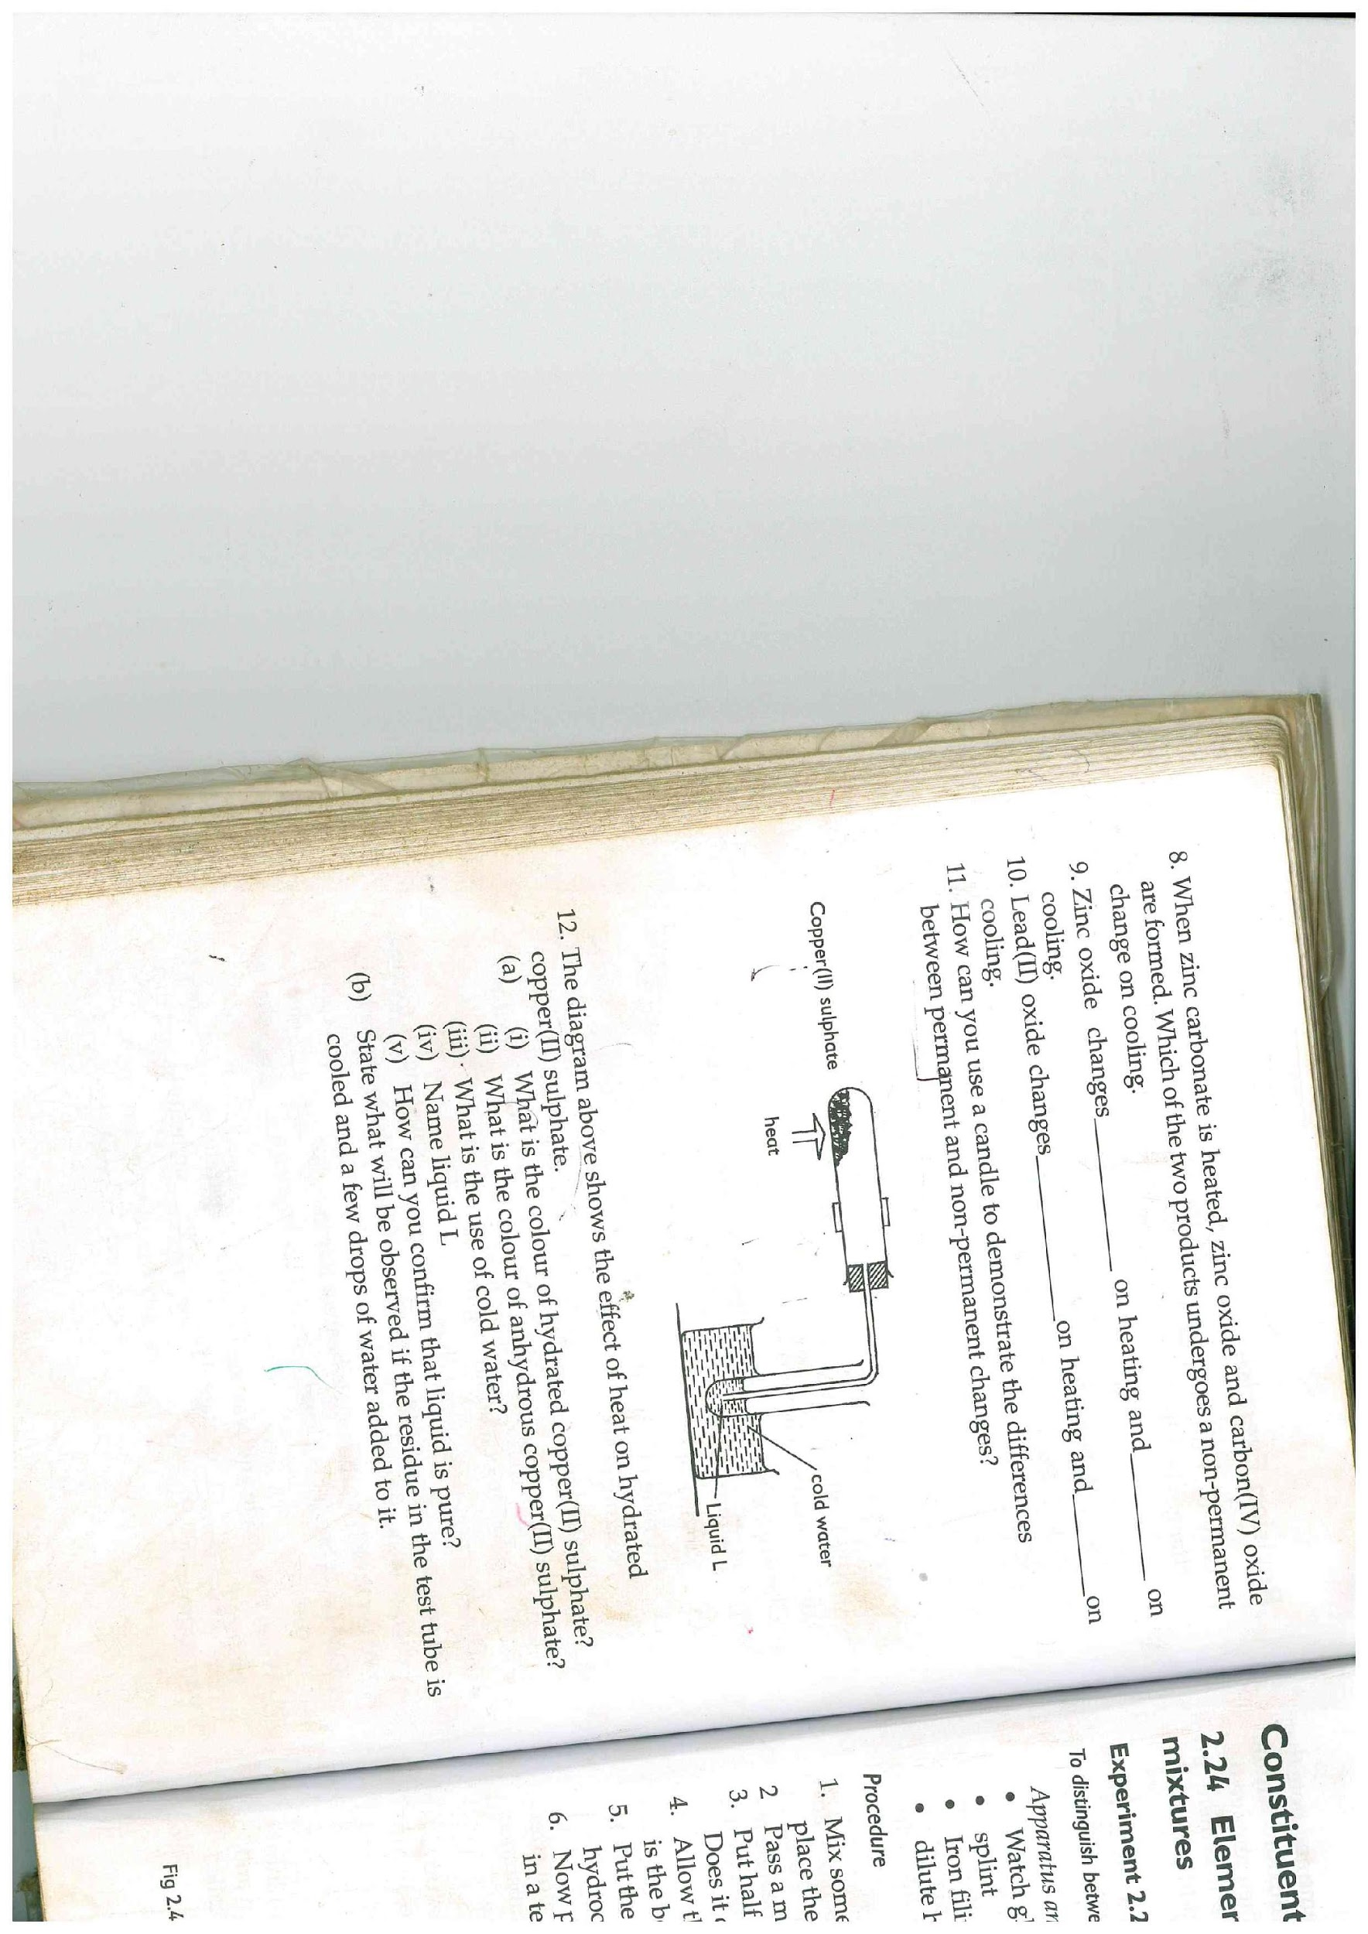

**Sacrificial protection**

**Alloying**

1. Explain why cars in Mombasa rust faster than in Nairobi. (1mk)

**Water in Mombasa is salty and salt accelerates rusting.**

1. The diagram below shows the effect of heat on hydrated Copper (II) Sulphate.
2. (i) What is the colour of hydrated Copper (II) Sulphate? (1mk)

**Blue**

(ii) State one observation made at the end of the experiment. (1mk)

* **A white solid is formed / hydrated copper(II) sulphate turns from blue to red**
* **A Colourless liquid.**

(iii) Name liquid L**.** (1mk)

**Water**

1. Name one test that can confirm the purity of liquid L. (1mk)

**Checking/Testing the boiling point.**

1. Name two apparatus that can be used to measure the volume of a gas. (2mks)

* **Measuring cylinder**
* **Calilbrated (graduated) gas jar.**
* **Syringe (any 2)**

1. The table below shows liquids that are miscible and those that are immscible.

|  |  |  |
| --- | --- | --- |
| Liquid | Y | Z |
| W | Miscible | Miscible |
| X | Miscible | Immiscible |

Use the above information to answer the questions that follow.

1. Name the method that can be used to separate a mixture of W and Y. (1mk)

**Fractional distillation**

1. Describe how a mixture of liquid X and Z can be separated. (2mks)

**Since the two liquids are immiscible, place them in a separating funnel (1mk) turn on the tap the liquid at the bottom is collected in a beaker while the liquid at the top remains in the separating funnel. (1mk)**

1. State one use of each of the following substances.
2. Sulphuric (VI) acid. (1mk)

* **In car batteries**
* **To manufacture sulphate fertilizers**
* **To manufacture detergents, paints, dyes e.t.c**

1. Magnesium hydroxide (1mk)

**As an anti-acid tablet**

1. Nitric (V) acid. (1mk)

**To manufacture nitrate fertilizers.**

1. The diagram below shows preparation of oxygen gas in the laboratory.

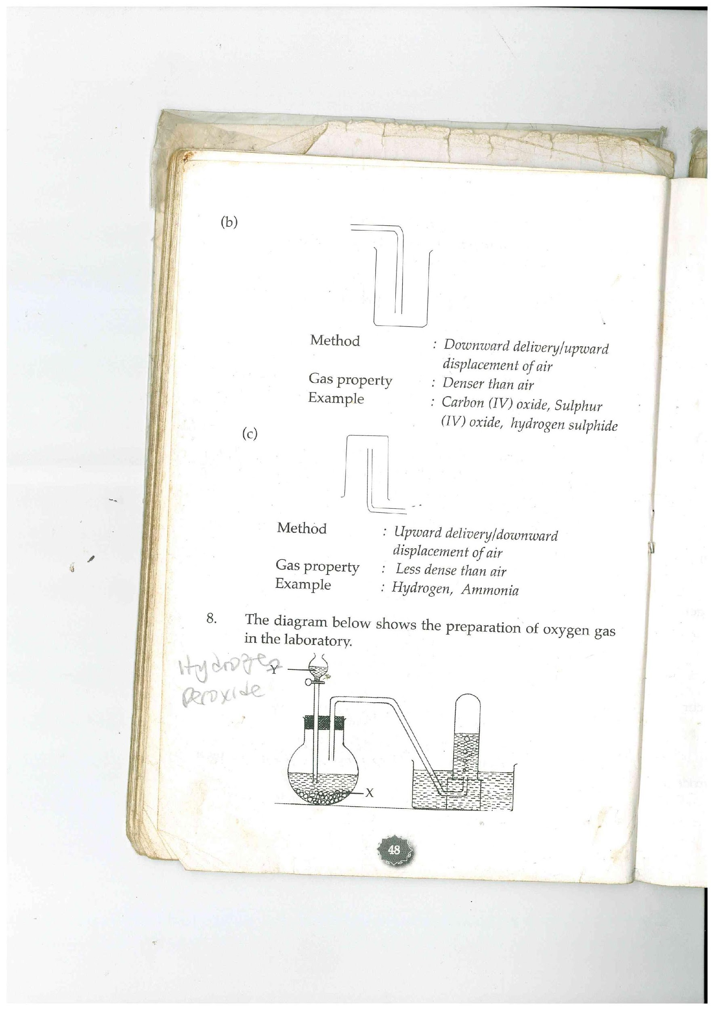

Hydrogen

peroxide

1. i) Name the reagent labeled X. (1mk)

**Manganese (IV) oxide.**

1. Write a word equation for the reaction that occurs in the flask. (1mk)

**Hydrogen peroxide Manganese (IV) Oxygen + Water.**

**Oxide**

1. What is the purpose of solid x in the experiment? (1mk)

**It acts as a catalyst in the decomposition of hydrogen peroxide.**

1. State two physical properties of oxygen. (2mks)

* **Its colourless**
* **Its odourless**
* **It’s slightly soluble in water.**
* **It has almost the same density as air.**
* **It has a low boiling point of -183oC.**

1. State two uses of oxygen. (2mks)

* **In welding and cutting of metals.**
* **In deep sea diving.**
* **In mountain climbing**
* **In hospitals by patients with breathing problems.**
* **To remove iron impurities during manufacture of steel.**