**FORM 3 CHEMISTRY P1 MARKING SCHEME.**

1. (a) Atoms of the same element with same atomic number but different mass

no.s/neutrons

(b) Total sum of protons and neutrons

(c) Compounds with the same molecular formula but different structural formula

1. (a) Both ammonia and water are polar molecules and hydrogen bonds are formed.

(b) Co-ordinate bond/dative bond.

1. In diamond all the bonds are strong covalent bonds while in graphite structure has layers that are held together by weak vander waals forces that are easily broken

4(a) 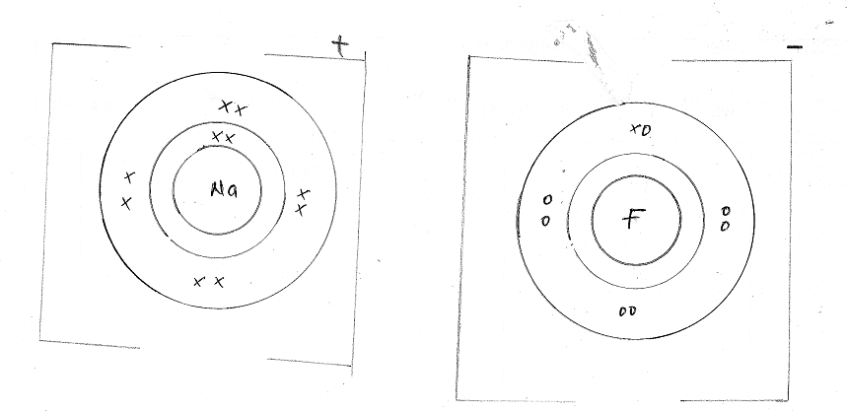

(b)

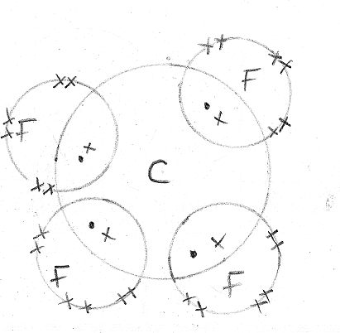

5 (i) Bitumen, last to be collected has the highest boiling point.

(ii) Fractional distillation

(iii) Limited supply of oxygen

6 (a) Conc. Sulphuric(VI) acid reject if concentrated missing

(b) H2SO4 (l) + NaNO3(s) NaHSO4(aq) + HNO3(g)

1. Prevent decomposition of nitric acid by light

7. (a) K and N; same group/same valence electrons/loose two electrons

1. No. Of moles of HCl in 40cm3 of 2M HCl

Moles of HCl in 40cm3 + 2M HCl

= = 0.08 moles

XCO3 : HCl

1 : 2

Moles of XCO3 = = 0.04 moles

0.04 moles 4g

1 mole ?

= 100g

XCO3 = 100

X = 100 - [12 + (16 x 3)] = 40g

9. (i) Artificial ripening of fruits

(ii) Manufacture of polyethene

10 (a) allotropy is the existence of an element in more than one form without change of state

(b) (i) graphite

(ii) – it is a lubricant because layers slide over each other

– a good conductor of both heat and electricity because it has delocalised/mobile electrons

(iii) $\frac{R0_{2}}{RO_{2}}$ = $\sqrt{\frac{MMSO_{2}}{MM0_{2}}}$

Rate of O2 = 12cm3/s

=

= 1.414

= 0.8486

0.8486 = $\frac{80}{t}$

t = $\frac{80}{0.8486}$

= 94.27 sec.

11 (a) – It is the minimum energy required to remove an electron from an atom in gaseous state

(b) Y. It has the lowest ionization energy hence requires the least amount of energy to give out its electron

**12.(a) F** – pale blue zone

**G** – almost colourless zone

**H** – chimney ( ½mk each)

(b) Slip a piece of manila paper /wooden splint into region and quickly remove before it catches fire. The inner part remains unburnt// not charred ( 1½mks)

(c) Hold a match stick on a pin and let the head rest on the chimney when the chimney is lit the head of the match stick in the zone does not light.

13 (a) Prevent water formed to run back to hot part which could crack

(b) Blue solid turns white //crystals form powder //colourless drops of liquid on cooler parts

(c) G is water

14(a) **Q** – 2.8.82 (1mk) **P** – 2. 8.6 (1mk)

(b) oxide of **P** has simple molecular structure (1mk)

15(a) Compare rate of diffusion of gases

(b) Litmus turns blue NH3 diffuses faster since it is lighter ( 2mks)

16. (a) (CH2)n = 42

(12 + 2)n = 42

14n = 42

n = 3 √ ½

Mf = 3(CH2) C3H6 √ ½

(b) CnH2n √ 1

(c) But-2-ene

17. Cpd - 3.22g mass of NaSO4 = 1.42g

Mass of H2O = 3.22 – 1.42 = 1.8g √ ½

Na2SO4 H2O

Mass 1.42 1.8

Moles 1.42 = 0.01 √ ½ 1.8 √ ½ = 0.1

142 18

Mole ratio 0.01√ ½ 0.1

0.01 0.1

1:10

X = 10 √ ½



18. (i) CH3CH2OH CH2CHC1



(ii) CH3CH3 CH3CH2Cl(g) + HCl(g)

19. (a) A – Nitrogen (IV) oxide √ 1/ NO2(g)

B – Oxygen/ O2(g) √ 1

(b) 2Pb(NO3)2(s) 2PbO(s) + 4NO2(g) + O2(g) √ 1

20. (90/100 x 16) + (10/100 x 18) √ 1

= 14.4 + 1.8 = 16.2 √ 1

21. Aluminium reacts with oxygen to from aluminium oxide which coats the surface of he article and prevents further reaction with air and water. √ 1

22.(a) Exp. 1 – No change on the dry cloth because no formation of hypoochlorous acid responsible for bleaching.

Exp. 2- The wet cloth turned white due to bleaching as chlorine dissolves in water in the wet cloth to form hypochlorous

1. Cl2(g) + H2O(l) HCl(aq) + HOCl(aq)
2. Dye + HOCl(aq) {Dye +[O] } + HCl √1

23. (i) O2(g) + 2Mg(s) 2MgO(s) √ (1mk)

(ii)2Mg + CO2(g) 2MgO(s)+ C(S) √ (1mk)

24. - Mix With Cold Water, Sodium Carbonate Dissolves√ (½mk)

* **Filter** off Lead (II) Chloride And Calcium sulphate as residue √ (½mk)
* **Evaporate**  the filtrate to obtain sodium chloride
* **Mix the residue** with hot water to dissolve Lead (II) chloride√ (½mk)
* **Filter** off Calcium sulphate as a residue dry over dessicator
* **Cool the filtrate** to precipitate Lead (II) chloride √ (½mk)

**Filter off residue** as Lead (II chloride and dry √ (½mk)

25. (a) The volume of a given mass of a gas at constant temeprature is inversely proportional to its pressure√ (1mk)

26. Red litmus paper turns blue since ammonium chloride decomposes to form ammonia and hydrogen chloride gas ammonia diffuses faster

27.Anhydrous Calcium Chloride

28. (a) Either

CH4(g) + O2(g) CO2(s) + 2H2O(g)

2C2H6(g) + 7O2(g) 4CO2(g) + 6H2O(l)

C3H8(g) + 5O2(g) 3CO2(g) + 4H2O(l)

2C4H10(g) + 13O2(g) 8CO2(g) + 10H2O(l)

(b) Yellow √(½mk) // sooty

Large, unsteady, √(½mk)

29. (i) But-2-ene✔1

(ii) 3 –ethylhexane✔1

30. (i). H2(g) + CuO(s) Cu(s) + H2O(l)

(ii) lead(ii)oxide Changes colour from orange to grey lead

(iii) to prevent an explosion when it mixes with air. ✔1

31.(a)it is strongly acidic✔1

(b)R✔1

(c)T✔1