**MARKING SCHEME**

1. a. Define statistics (2mks)

**Statistics refer to facts and figures collected and arranged in a systematic manner. 2x1=2mks**

b. Give three uses of statistics (3mks)

**-it is vital for planning at local and national levels**

**-it helps in predicting future trends such as changes in the price level of major crops**

**-it is useful to show changes through time eg imports of machinery over the past five years**

**it is useful in making comparison and identify spatial relationships between geographical phenomena like rainfall amounts and population distribution 1x3=3mks**

1. a) Identify the two types of photographs (2mks)

**-Ground photographs**

**-Aerial photographs**

b) State three advantages of using photographs as a technique of recording data (3mks)

**-Photographs are easy to take**

**-Photographs are less time consuming in that one only needs to focus on the object**

**being photographed**

**-Photographs shows physical features such as the appearance of a landscape or**

**economic activities taking place**

**-Photographs are easily accessible**

1. a) Name two areas where gold is mined in South Africa (2mks)

**-Witwatersrand**

**-Lydenburg**

**-ogendaalrus**

b) State three types of minerals (3mks)

* **Metallic minerals**
* **Non-metallic minerals**
* **Energy minerals**

1. a) State two factors that influence the distribution and types of natural forests. (2mks)

* **Climate**
* **Altitude**
* **Soils**
* **Human activities**

b) State three problems facing the growth of softwood forests in canada.

**- Periodic forest fires destroy large areas**

**- The harsh, cold conditions do not allow trees to mature quickly**

**-The northern parts are inaccessible in winter (3mks)**

1. (a) Differentiate between a reconnaissance and a working schedule? (2mks)

**A reconnaissance is a short visit conducted before the actual day of study while a**

**working schedule is a timetable of activities to be followed on the day of study**

(b). Give three importance’s of a working schedule

* **To ensure proper time managent and reduce the tendency of wasting time.**
* **To ensure that no important area will be inadequately covered or forgotten**
* **It ensures that the one carrying out the study remains on course i.e does not deviate to irrevant areas.**
* **It is a pointer of how much time will be required for the study. (3mks)**

**SECTION B.**

**Answer question 6 and any other two questions in this section**

1. The table below shows the distribution of minerals in a country x in tonnes. Study it carefully and answer the questions that follow.

|  |  |  |
| --- | --- | --- |
| Mineral/Year | 2012 | 2013 |
| Trona | 25 | 40 |
| Gold | 15 | 25 |
| Oil | 10 | 15 |
| Diamond | 9 | 10 |
| Copper | 5 | 10 |
| TOTAL | 64 | 100 |

* Draw proportional divided circles to represent the above data using a scale of 1cm represents 4 tonnes.

**Radius : $\frac{\sqrt{64}}{\sqrt{100}}=\frac{8}{10}$**

**2012**

**Trona = $\frac{25}{64}x 360=140.6^{0}$ ½**

**Gold = $\frac{15}{64}x 360={844}^{0}$ ½**

**Oil = $\frac{10}{64}x 360=56.25^{0}$ ½**

**Diamond = $\frac{9}{64}x 360=50.6^{0}$ ½**

**Copper = $\frac{5}{64}x 360={28.125}^{0}$ ½**

**2013**

$$\frac{40}{100}x 360=144$$

$$\frac{25}{100}x 360={90}^{0}$$

$\frac{15}{100}x 360={54}^{0}$ 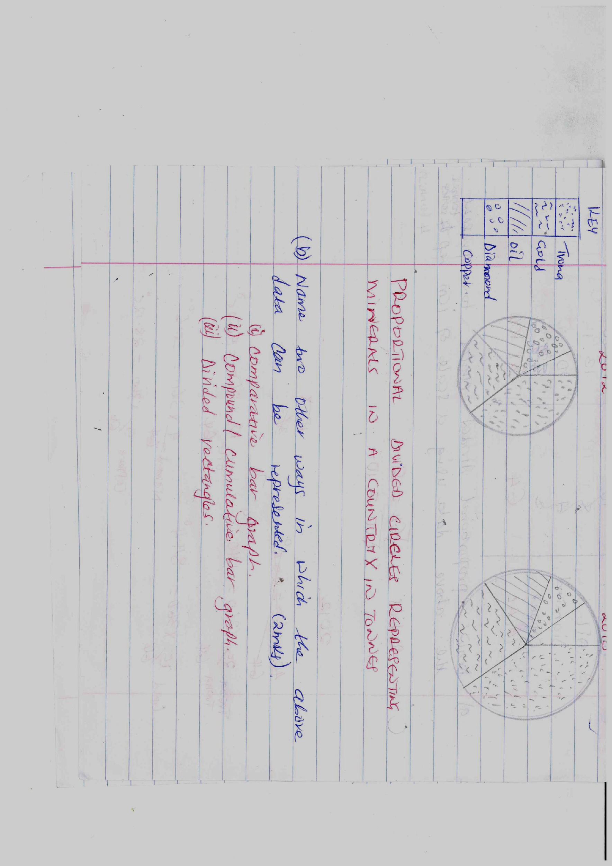

$$\frac{10}{100}x 360={36}^{0}$$

1. PROPORTIONAL DIVIDED CIRCLES REPRESENTING MINERALS IN A COUNTRY X IN TONNES

**2012 2013**

**MARK AWARDING**

**T= 1mk**

**Calculations – 5mks**

**Key – 1mk**

**Correct scale ½ x 2 = 1mk**

**Correct drawn sectors – 2 x 2 = 4mks**

**Total – 12mks**

1. Name two other ways in which the above data can be represented. (2mks)
2. **Comparative bar graph**
3. **Compound/cumulative bar graph**
4. **Divided rectangles.**
5. State two advantages and two disadvantages of using proportional divided circles to represent data.

Advantages

1. **They give clear comparisons of total values of data.**
2. **They give a good visual impression.**
3. **Can be combined with other methods on the same maps home aiding in data analysis.**
4. Identify 3 methods of mining. (3mks)

* **Open cast mining**
* **Underground mining**
* **Alluvial mining/placer method.**

1. State two uses of diamonds. (2mks)

* **Cutting metals**
* **Polishing metals**
* **For making jewellery**
* **For cutting glass.**

1. State four economic benefits of mining to the economy of South Africa. (4mks)

* **It earns the country foreign exchange which is used as a means of paying international debts.**
* **It offers employment to many people raising their standard of living.**
* **It has led to widespread urbanization contributing to the formation of the withwatersland conurbation.**
* **It has led to the development of modern infrastructure e.g. roads, railways and social amenities.**

7 (a) i) Define agro-forestry. (1mk

**-Its land use practice where there is growing of trees and crops on the same of land and at the same time**

(ii) List two species of indigenous hardwood forest trees in Kenya. (2mks

**-The meru oak**

**-Elgon olive**

**-Elgon teak**

**-Camphor**

**-Mvuli**

**Mangroove**

(b) Give the differences in the exploitation of softwood forests in Kenya and Canada under the following sub-headings;

i) Distribution of forests; (1x 2= 2mks)

**- In Kenya, softwood forests are found mainly in the highlands while in**

**Canada they are found both in highland and lowland areas.**

**- In Kenya, softwood forests cover a small percentage of the total land area while in Canada they cover large tracts of land.**

ii) Transportation (1x 2= 2mks)

**- In Kenya, logs are transported by road/trucks while in Canada**

**transport is mainly by water by rivers.**

**- In Kenya, transportation is expensive while in Canada it is cheap.**

(c) Name four reserves found in coastal region of kenya (4mks

1. **Shimba hill**
2. **Sarabuko-sokoke forest reserves**
3. **Boni/dondori forests**
4. **Kaya forests**
5. **Mangrove forests**

(d) (i) what is forest conservation (2mks)

**- it is the protection of forests against over-exploitation and misuse by man**

(ii)State four significance of forestry in Kenya (4mks)

**-provision of wood fuel e.g. charcoal, firewood and sawdust**

**-for building and construction materials such as timber , poles and boards.**

**-trees act as wind breakers**

**-for protection of catchment areas for ecological conservation**

**-production of industrial raw materials e.g. rubber, latex and weaving**

**materials**

(e) Explain four factors that favour the exploitation of softwood forests in Canada. (8mks)

**-Winters are mild and rivers are ice free in British Columbia making it possible to transport logs thought the year**

**-The fast flowing rivers with plenty of waters provide adequate water for the processing of wood.**

**-There is high demand for forests products within Canada and U.S.A**

**-Availability of water from the rivers for processing of timber into pulp and paper**

**-location of industries along the coastline of the pacific ocean thus easing the exportation of the products to U.S.A , Europe and Japan 4 x 2 =8mks**

8. a) list three types of fieldwork (3mks)

**Fieldwork research**

**Field excursion/ Field Trip**

**Field study**

b) Students from your school carried out a field study in a market.

i) list down the normal pattern that the fieldwork procedure takes (5mks)

**-identify the topic of study**

**-statement of objectives**

**-formulation of hypothesis**

**-prepare for the fieldwork**

**-conduct the actual study**

**NB/ THE ORDER MUST BE FOLLOWED**

ii) Give five activities the students will require to do before going for the fieldwork (5mks)

* **Seek permission from authorities**
* **Conduct a reconnaissance**
* **Adjust objectives and hypothesis**
* **Choose suitable methods of data collection**
* **Assemble necessary tools**
* **Prepare a working schedule**
* **Divide the students into groups**

iii) State three objectives of the study (3mks)

**-To find out which types of goods are sold in the market.**

**-To find out sources of the goods sold in the market.**

**-To find out the challenges encountered in marketing of the goods.**

**N/B: Award any relevant correctly stated objective.**

iv) List three problems they are likely to encounter during the study(3mks)

* **Inadequate data.**
* **Advance weather conditions e.g. rainfall**
* **Fatigue**
* **Mechanical breakdown of vehicles.**
* **Sickness team member/researcher.**

v) Prepare a working schedule to be used during the study (4mks)

**5.00A.M- 5.30AM -arrival**

**5.30A.M-8.30AM -travelling**

**8.30AM-9.30AM -breakfast**

**9.3OAM-10.30AM -instructions and dividing into groups**

**10.30AM-12.00PM - field study in the food market.**

**12.00- 1.00PM -interviewing the trader.**

**1.00PM-2.00PM - lunch**

**2:00PM- 4:00PM - travelling back to the school**

**Or any other well organized schedule**

vi) List two follow-up activities that the students could have been involved in (2mks)

**-Discussing and comparing notes in groups**

**-Group secretaries make a presentation in class**

**-Compiling the reports**

**-present the data in tables,graphs e.t.c**

9. a. i. Define the term mining. (2 mks)

**It’s the extraction of valuable minerals from the ground.**

ii. State three ways in which minerals occur. (3 mks)

* **As veins and lodes**
* **Beds and seams**
* **Weathering products**
* **Alluvial/placer deposits**

b. i. State and explain 4 factors that influence the occurrence and exploitation of minerals.

(8 mks)

* **Value of the mineral**
* **Transport costs**
* **Labour availability**
* **Political factors**
* **Capital availability**
* **Size of the mineral deposits**
* **Demand for the mineral/market factors**
* **Quality of the ore**
* **Level of technology**

**Well explained points 4 x 2 = 8mks**

ii. Explain any two methods employed in underground mining.

* **Shaft method – vertical shafts are sunk into the earth’s crust and connected to horizontal**

**tunnels in order to reach the mineral.**

* **Drift/Adit method – horizontal tunnels are dug into the hill or valley sides to reach the mineral.**
* **Solution method – pipes are sunk at great depths to the mineral deposits eg. sulphur. Super heated water is directed through the pipes to dissolve the mineral, which is then pumped to**

**the surface.**

* **Drilling method – wells are dug and oil or gas are extracted. 2 x 2 = 4mks**

c. i. State 4 effects of mining in the environment. (4 mks)

* **Leads to land dereliction.**
* **Collapse of underground mines may lead to heavy casualties/loss of human lives and destruction of property.**
* **Pollution of soil, air and water.**
* **Mining activities interfere with the local water table.**

ii. Highlight 4 problems facing mining in Kenya. (4 mks)

* **Extraction and processing of some minerals pollute the environment.**
* **Inadequate capital for mineral exploitation.**
* **Lack of skilled personnel limits mineral exploration.**
* **Mining activities are mainly in the hands of foreign companies who repatriate the profits to their home countries.**
* **Competition from developed countries.**
* **Shortage of power/energy for mining activities.**

10. a. i. Define the term forest. (2 mks)

**A forest is a collection of trees of one or more species growing naturally or planted by**

**human beings in an area**

ii. Explain five uses of forests and forest products in Kenya.

* **Forests prevent the soil from erosion.**
* **Provision of raw materials for various industries.**
* **Source of fuel.**
* **Source of food – sericulture and apiculture are practiced in forests.**
* **Provide employment opportunities and are a source of revenue. (5x2=10 mks)**

**Award well explained points.**

b. i. Outline any 4 problems facing forestry in Kenya. (4 mks)

* **Over exploitation and illegal logging.**
* **Destruction of forests by drought, fires, pests and diseases.**
* **Massive deforestation due to encroachment into forest lands.**
* **Poor forest management and conservation practices.**

ii. Highlight five forest conservation measures commonly used in Kenya. (5 mks)

* **Creation of forest reserves.**
* **Agro-forestry and silviculture.**
* **Encouraging afforestation and reafforestation practices.**
* **Use of alternative sources of energy and energy saving devices.**
* **Employment of forest warders who protect forests from illegal exploitation.**

**(5x1=5 mks)**

c. State four characteristics of soft wood forests in Canada.

* **Trees are conical in shape**
* **Trees occur in pure strands**
* **Trees grow tall and straight 30 – 40 metres**
* **Trees bare cones**
* **Forest are evergreen**
* **Forest have no undergrowth**
* **Trees have thick barks. 4 x 1 = 4mks**