**2021 MARKING SCHEME**

1. -2(5 + 3) - 9 $÷$ 3 + 5 = - 14 $√√$

-3 x -5 + (-2) x 4 7

= -2 $√$

1. LCM of 9, 15 and 21

32 x 5 x 7 = 315 minutes $√$

Last time ringing together

11.00 2300

5.15 515

5.45 p.m. $√$ 1745hrs $√$

1. let a technician be x and artisan be y

3x + 2y = 9000

4x + 1y = 9500

8x+2y = 19000

3x +2y = 9000

$\frac{5x}{5}$ = $\frac{10000}{5}$ = 2000.......................... $√$

Hiring a technician = 2000 $√$

Hiring artisan

4(2000) + y = 9500

Y= 1500

2(2000) + 5(1500) = 11,500 $√$

1. a) sh 77.24 x 100,000 $√$

= sh 7,724,00 $√$

b) Sh 77.24 x 100 000

= 63172 $√$

122.27 $√$

1. 3x + (x-20) = 1800

4x = 2000

X = 500

(x-20)n=360

30n=360 $√$

n = 12 $√$

1. $\frac{{243}^{- \frac{2}{5}} × {125 }^{\frac{2}{3}}}{9^{- \frac{3}{2}}}$ = $\frac{3^{-2} × 5^{2}}{3^{-3}}√$

= $\frac{27 × 25}{9}√$

= 75 $√$

1. let mother’s year be x and son’s be y now:

X+14=2(y+14) .................................(i)

X+14= 2y+ 28

x-2y = 14...........................................(ii) $√$

(x-4)+(y-4) =30

X+y=38 ............................................(iii) $√$

(iii)-(ii)

X+y=38

-x+2=-14

3y=24

Y=24 x=30 $√$

At son’s birth: mother’s age

30-8=22 $√$

1. Sin (x + 600) = cos 2x

X + 60 + 2x = 900

3x = 30

x = 100

Tan (10 + 60)0 = tan 700

2.748(4.S.F) from tables

1. 2r2 + 2rh = 154

r = h

2r3 + 2r2 = 154

4r2 = 154

r =

= 3.500

diameter = 2r= 3.500 x 2

= 7.00 (s dp) $√$

1. Volume of plate = 1.05 x 100 $√$

8.4

= 125cm3

L = = 25cm



1. From 0700h Monday to 1900h Wednesday

= 24 x 2 + 12 h

=60h $√$

Time lost = 60 x 15 = 900 sec

=15 min $√$

Time shown on clock:

1900 h – 15 min = 1845 h $√$ 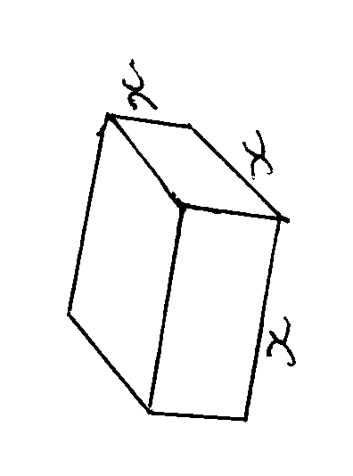

$\sqrt[3]{1728}$ = 12 $√$

?

12

12

$\sqrt{{12}^{2}+{12}^{2}}$

= $\sqrt{288}$ =16.97 cm $√$

1. a) x-5 $≤$ 3x - 8

-2x $≤$-3 $√$

3x - 8 $<$ 2x -3

x $<$ 5

$∴$ 1.5 $≤$ x $<$ 5 $√$

0

1

2

3

4

5

6

b)



$√$

$\left(\frac{3}{-2}\right)-\left(\frac{2}{3}\right)$ $√$

= $\left(\frac{1}{-5}\right)$

Magnitude = $\sqrt{1^{2}+{\left(-5\right)}^{2}}$ $√$

= $\sqrt{26}$ ≈ 5.1 $√$

1. (a) mode

=22 $√$

(b) Median

15,15,16,19,19,20,20,21,22,22,22,26 ,27,28

Median = $\frac{20+21}{2}$ $√$

= 20.5 $√$

1. a) mass after decrease

112 x $\frac{15}{16}$

= 105 kg $√$

Total decrease

(112-105) x 540 $√$

=3780 kg $√$

b) (i) no. of 90kg bags

$\frac{105 x 540}{90}$ $√$

=630

Least number of trips

$\frac{630}{120}√$

= 5.25

6 trips $√$

ii) Expenses

Buying price = 1500 x 630 = 945000 $√$

Transport = 1500 x 630 = 945000

Total 945000 + 15000 $√$

Selling price per bag:

= $\frac{960000 x 1.26}{630}$ = 1920 $√√$

1. a) 10.5x100x6x100=630,000cm3

Area of the tile = 30x30 = 900 cm2

No of tiles = $\frac{area of the floor }{area of one tile}$

= $\frac{630000}{900}$ =700 tiles $√$

b) i) 1 carton = 20 tiles

? = 700 tiles

$\frac{700 x 1}{20}$ =35 cartons. $√$

1 carton = 800 sh.

35 Cartons = $\frac{35 x 800}{1}$ = 28,000sh $√$

1 room =28,000 sh.

15 rooms = $\frac{28000 x 15}{1}$ =420,000sh

= sh. 420,000 $√$

ii) Transport = 2000

subsistence = 600

2000 + 600 = 2600sh $√$

Total cost = 420,000 +2600

=Ksh. 422,600 $√$

$\frac{12.5}{100}$ x 422,600 = 52,825sh

Profit = 52,825sh

Cost price = 422,600sh

Selling price = 422,600sh + 52,825 $√$

=475,425sh

35 cartons = 475,245

1 carton= 475425

1 carton = $\frac{475,425 x 1}{35}$ 13,584sh $√√$

1. a)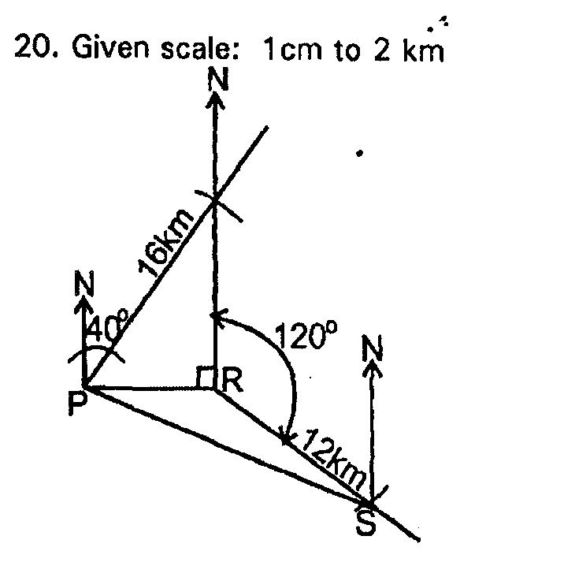

b) i) Distance of P from s =10. 8 + 0.1cm

ii) < PSN = 74 + 10 $√$

earing of P from S = 286 + 10

c) area of PQR = 1/2 x 10.2 x 12.2

= 63.44km2

Area of PRS = 1/2 x 10.2 x 2 sin-600

= 30.6km2

Area of ranch PQRS

= 62.22 + 30.6

= 92.82km2

2. Equation of L

Gradient = $\frac{6-3}{-1--2}$

=3

Equation = $\frac{y-6}{x+1}=3$

= $y-3x=9√$

1. Equation of P $√$

= $\frac{y-6}{x+1}=-\frac{1}{3}$

= 3y + x =17 $√$

1. Equation of Q

= $\frac{y-2}{x-1}=3$

= $y=3x-1√$

$x$ intercept

When $y$ = 0 $⇒ x$ = + $\frac{1}{3}$

$y$ intercept $√$

When $x$ = 0 $⇒ y$ = $-$ 1 $√$

1. Intersection of lines P and Q

$3y+x=17……\left(i\right)$

$y-3x= -1…….\left(ii\right)$

$3y+x=17√$

$3y-9x=-3$

$10x=20 ⇒x=2$

Subset $3y+2=17⇒y=5$

$∴point of intersection (2,5)$ $√$

1. 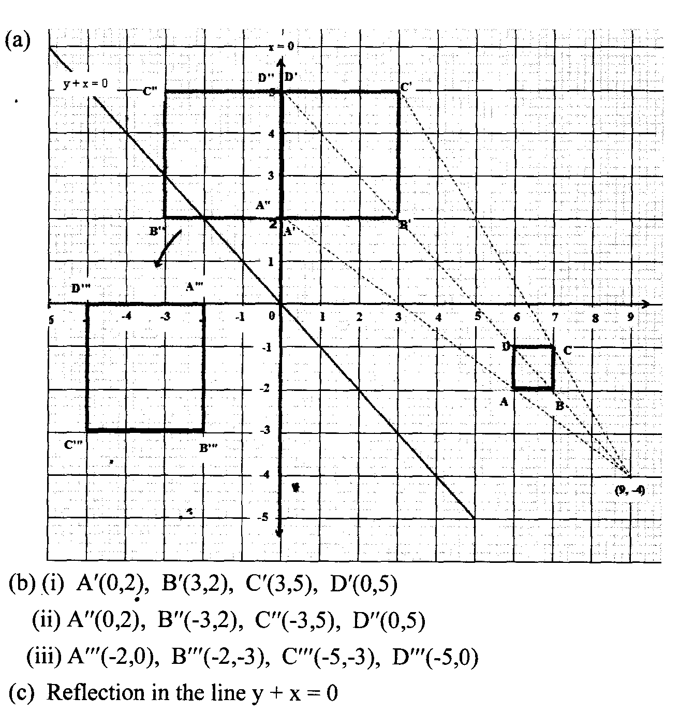
2. a) i) $\frac{r}{9}$ = $\frac{4}{12}$

R = $\frac{9x4}{12}$ = 3 cm

ii) Volume of material drilled out

= $\frac{1}{3}$ $π$ x $3^{2}x$ 4 = 12 $π$

b) Slant height of cone

= $\sqrt{9^{2}+ {12}^{2}}$ = 15 cm

c) Surface area of solid after conical has been drilled

$π$ x 9 x 9 x 15 + $π$ x ($9^{2}- 3^{2}$) + $π$ x 3 x 5

= $π$ (135+72+15)

= 222 $π$

1. 15m/s
2. Maximum speed

1. (i) =

= 1.5m/s2

(ii) = = 1.5m/s2

=

=26.25 m/s

1. (a) total sales = sh 360 x 500

= sh.180,000 $√$

Commission

= sh (180,000 – 100,000) x 2/3

= 13600

(b) (i) New salary

= sh.(12000 + 12000 x 10/100)

= sh. 13200 $√$

Commission paid

= Sh (17,600 -13,200)

= Sh.4400 $√$

Commission is paid on sh.4400 x **100/2**

= 220,000 $√$

Total sales = sh.220,000 + 100,000 $√$

=320,000/= $√$

(ii) No of handbags sold = $\frac{320,000}{500}$ = 640 $√$