Name………………………………………………………………..Adm. No…………………Class…………...

**121/1**

**NOVEMBER 2022 EXAMINATION**

**FORM 3MATHEMATICSPAPER 1**

**YEAR 2021**

**TIME: 2½ HRS.**

**INSTRUCTION TO STUDENTS:**

1. *Write your* ***name****,* ***admission number*** *and* ***class*** *in the spaces provided above.*
2. *Write the* ***date*** *of examination in spaces provided.*
3. *This paper consists of* ***two*** *Sections; Section* ***I*** *and Section* ***II****.*
4. *Answer* ***ALL*** *the questions in Section* ***I*** *and only* ***five*** *questions from Section* ***II****.*
5. *All answers and working must be written on the question paper in the spaces provided below each question.*
6. *Show all the steps in your calculation, giving your answer at each stage in the spaces provided* ***below*** *each question.*
7. *Marks may be given for correct working even if the answer is wrong.*
8. *KNEC Mathematical tables* ***may be*** *used, except where stated otherwise.*
9. *Candidates should check the question paper to ascertain that all the pages are printed as indicated and that no questions are missing.*
10. ***Candidates should answer the questions in English.***

**FOR EXAMINER’S USE ONLY:**

**SECTION I**

|  |  |  |  |  |  |  |  |  |  |  |  |  |  |  |  |  |
| --- | --- | --- | --- | --- | --- | --- | --- | --- | --- | --- | --- | --- | --- | --- | --- | --- |
| 1 | 2 | 3 | 4 | 5 | 6 | 7 | 8 | 9 | 10 | 11 | 12 | 13 | 14 | 15 | 16 | TOTAL |
|  |  |  |  |  |  |  |  |  |  |  |  |  |  |  |  |  |

|  |  |  |  |  |  |  |  |  |
| --- | --- | --- | --- | --- | --- | --- | --- | --- |
| 17 | 18 | 19 | 20 | 21 | 22 | 23 | 24 | TOTAL |
|  |  |  |  |  |  |  |  |  |

**SECTION II**

**GRAND TOTAL**

|  |
| --- |
|  |

***Ensure that all the pages are printed and no question(s) are missing***

**SECTION 1 (50 marks)**

1. Without using a calculator evaluate,

-2(5+3) - 9÷3+5

-3 $×$-5+-2 $×$ 4 (3 marks)

1. Three bells ring at intervals of 9 minutes, 15 minutes and 21 minutes. The bells will next ring together at 11.00 pm. Find the time the bells had last rang together. (3 marks)
2. A construction company employs technicians and artisans. On a certain day 3 technicians and 2 artisans were hired and paid a total of Kshs 9000. On another day the firm hired 4 technicians and 1 artisan and paid a total of Kshs 9500. Calculate the cost of hiring 2 technicians and 5 artisans in a day. (3 Marks)
3. A Kenyan company received US Dollars 100,000.The money was converted into Kenya shillings in a bank which buys and sells foreign currencies as follows:

Buying (in Kenya shillings) Selling(in Kenya shillings)

1 US Dollar 77.24 77.44

1 Sterling Pound 121.93 122.27

1. Calculate the amount of money, in Kenya shillings, the company received. (2 marks)
2. The company exchanged the Kenya shillings calculated in (a) above, into sterling pounds to buy a car from Britain. Calculate the cost of the car to the nearest sterling pound. (2 marks)
3. The size of an interior angle of a regular polygon is 3x0 while its exterior angle is ( x- 20)0. Find the number of sides of the polygon . (3 marks)
4. Simplify $\frac{{243}^{\frac{-2}{5}}×{125}^{\frac{2}{3}}}{9^{\frac{-3}{2}}}$ (3marks)
5. In fourteen years time, a mother will be twice as old as her son. Four years ago, the sum of their ages was 30 years. Find how old the the mother was, when the son was born. (4mks)
6. Given that Sin (x+ 600) = Cos (2x)0, find Tan (x+60)0 (3 marks)
7. A cylindrical solid whose radius and height are equal has a surface area of 154 cm2.Calculate its diameter, correct to 2 decimal places.(Take $π$ =3.142). (3marks)
8. A square brass plate is 2 mm thick and has a mass of 1.05 kg. The density of the brass is 8.4 g/cm3. Calculate the length of the plate in centimeters. (3 marks)
9. Simplify $\frac{a}{2(a+b) }$ + $\frac{b}{2(a- b) }$ (3 Marks)
10. Chelimo’s clock loses 15 seconds every hour. She sets the correct time on the clock at 0700h on a Monday. Determine the time shown on the clock when the correct time was 1900h on Wednesday the same week. (3 mks)
11. The volume of a cube is 1728cm3. Calculate, correct to 2 decimal places, the length of the diagonal of a face of the cube. (3 Marks)

1. Given the inequalities *x* – 5 ≤ 3 *x* – 8 < 2 *x* – 3.
2. Solve the inequalities; (2 marks)
3. Represent the solution on a number line. (1 mk)
4. Given that OA = 2i + 3j and OB = 3i - 2j

Find the magnitude of AB to one decimal place. (3 marks)

1. The production of milk, in litres, of 14 cows on a certain day was recorded as follows

22, 26, 15, 19, 20, 16, 27, 15, 19, 22, 21, 20, 22 and 28.

1. The mode; (1 mk)
2. The median. (2 marks)

**SECTION II(50 marks)**

*CHOOSE ANY FIVE QUESTIONS IN THIS SECTION*

1. A farmer had 540 bags of maize each having a mass of 112kg. After drying the maize, the mass decreased in the ratio 15:16.
2. Calculate the total mass lost after the maize was dried. (3 marks)
3. A trader bought and repacked the dried maize in 90 kg bags. He transported the maize in a lorry which could carry a maximum of 120 bags per trip.
4. Determine the number of trips the lorry made. (3 marks)
5. The buying price of a 90 kg bag of maize was Ksh 1,500. The trader paid Ksh 2,500 per trip to the market. He sold the maize and made a profit of 26 %. Calculate the selling price of each bag of the maize. (4 marks)
6. The floor of a room is in the shape of a rectangle 10.5m long by 6m wide. Square tiles of length 30cm are to be fitted on to the floor.
7. Calculate the number of tiles needed for the floor. (2mks)
8. A dealer wishes to buy enough tiles for fifteen such rooms. The tiles are packed in cartons each containing 20 tiles. The cost of each carton is kshs. 800. Calculate:
9. The total cost of the tiles (3mks)
10. If in addition the dealer spends kshs. 2,000 and Kshs. 600 on transport and subsistence respectively, at what price should he sell each carton in order to make a profit of 12.5% (to the nearest Kshs) (5mks)
11. The boundaries PQ,QR,RS and SP of a ranch are straight lines such that: Q is 16 km ona bearing of 0400 from P;R is directly south of Q and east of P and S is 12 km on a bearing of 1200 from R.

a) Using a scale of 1 cm to represent 2 km. Show the above information in a scale drawing. ( 3mks)

b) From the scale drawing determines:

i) The distance in kilometers of P from S. (2Mrks)

ii) The bearing of P from S.(2Mrks)

c) Calculate the area of a ranch PQRS in square kilometers. (3Mrks)

1. A line L passes through (-2, 3) and (-1, 6) and is perpendicular to a line P at (-1, 6).
2. Find the equation of L (2marks)
3. Find the equation of P in the form *ax + by = c,*where a, b and c are constants. (2marks)
4. Given that another line Q is parallel to L and passes through point (1, 2)

find the x and y intercepts of Q (3marks)

1. Find the point of the intersection of lines P and Q (3marks)
2. (a) On the grid provided, draw the square whose verticals are A (6, -2), B (7, -2), C (7, -1) and D (6, -1). (1 mk)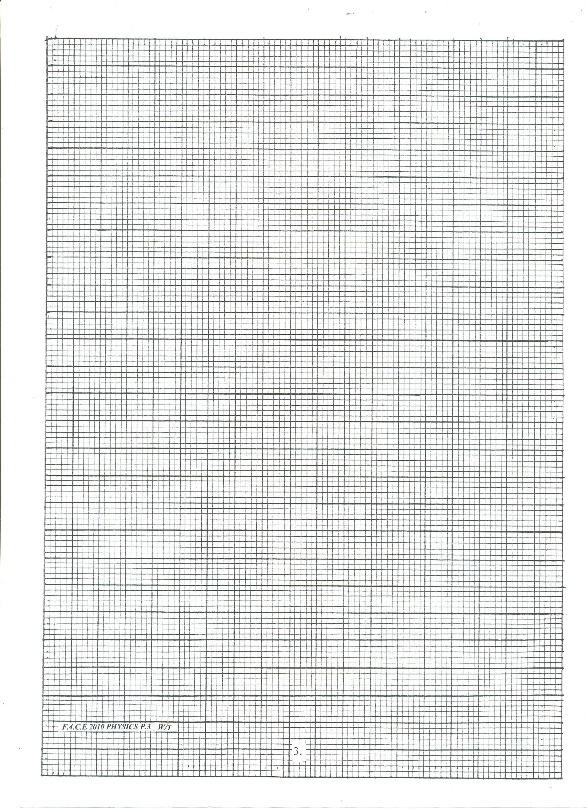

b) On the same grid, draw:

1. AʹBʹCʹDʹ, the image of ABCD, under an enlargement scale factor 3, centre (9, -4); (3 marks)
2. AʹʹBʹʹCʹʹDʹʹ, the image of AʹBʹCʹDʹ, under a reflection in the line *x =* 0; (2 marks)
3. AʹʹʹBʹʹʹCʹʹʹDʹʹʹ, the the image of AʹʹBʹʹCʹʹDʹʹ under a rotation of + 900  about (0,0) (2 marks)

(c) Describe a single transformation that maps AʹBʹCʹDʹ onto AʹʹʹBʹʹʹCʹʹʹDʹʹʹ (2 marks)

1. The figure below represents a cone of height 12 cm and base radius of 9 cm from which a similar smaller cone is removed, leaving a conical hole of height 4 cm.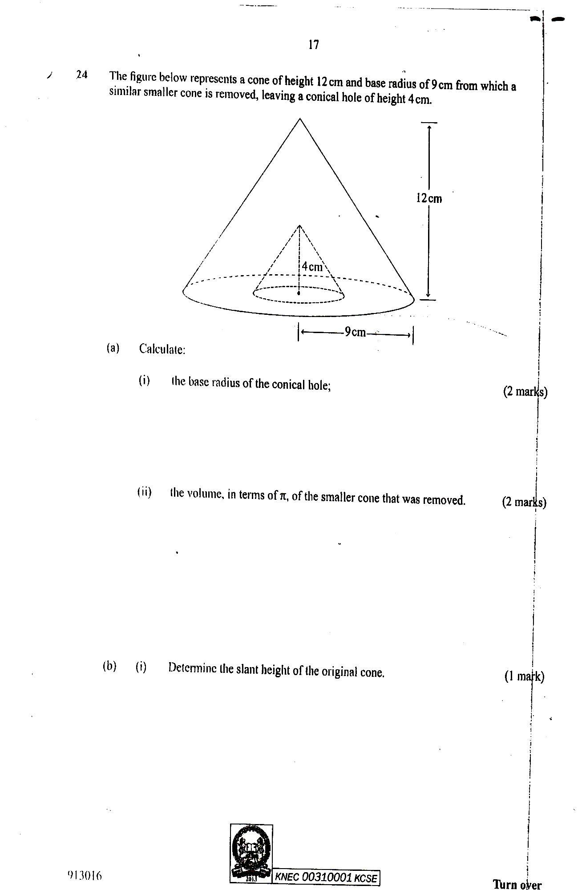
2. Calculate:
3. The base radius of the conical hole; (2 mks
4. The volume, in terms of π, of the smaller cone that was removed. (2 mks)
5. Determine the slant height of the original cone. (1 mk)

c) Calculate, in terms of $π$, the surface area of the remaining solid after the smaller cone is removed. (5mrk)

1. The figure below represents a speed time graph for a cheetah which covered 825min 40 seconds.

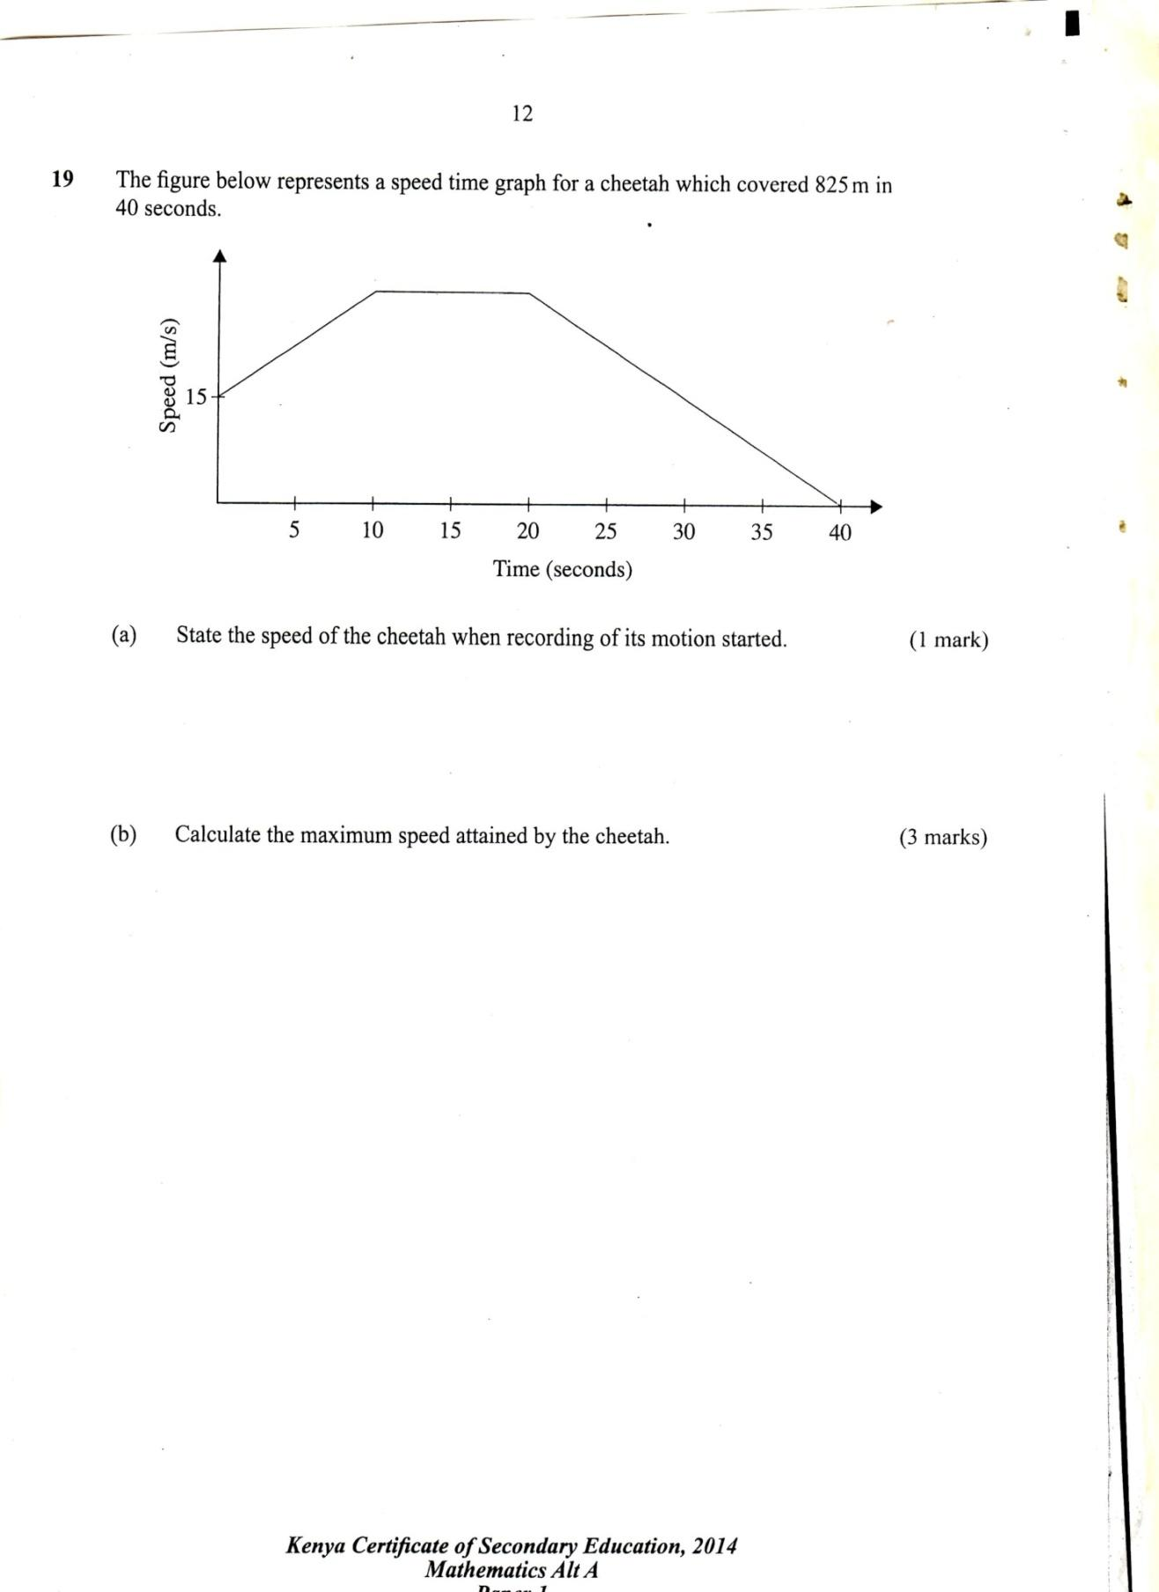

1. State the speed of the cheetah when recording of its motion started (1 mark)
2. Calculate the maximum speed attained by the cheetah (3marks)
3. Calculate the acceleration of the cheetah in:
4. The first 10 seconds (2marks)
5. The last 20 seconds (1mark)
6. Calculate the average speed of the cheetah in first 20 seconds (3marks)
7. A saleswoman is paid a commission of 2% on goods sold worth over Ksh 100,000. She is also paid a monthly salary of Ksh 12,000.In a certain month, she sold 360 handbags at Ksh 500 each.

(a) Calculate the saleswoman’s earnings that month. (3 marks)

(b) The following month, the saleswoman’s monthly salary was increased by 10%.Her total earnings that month were Ksh 17,600.

Calculate:

* 1. The total amount of money received from the sales of handbags that month. ( 5marks)
  2. The number of handbags sold that month. (2 marks)