SECTION A

1. 2x2+ x-3

4x2 -9

2x2 +3x – 2x – 3

X(2x +3) -1(2x +3)

(2x+3) (2x-1)

4x2 – 6x + 6x -9

Thus (4x2-9) can be written as (2x+3) (2x+3)

(x-1) (2x +30

(2x +3) (2x+3)

= x - 1

2x -3

1. Volume = L x w x h

3.2m x 2.5m x 2m

=1600m3

1m3=10001

1600m3=x

M31600 x 1000L = 1,600,000

1m3 250

=6400 MINUTES

1. = 1 since log A + logB =AB

= 1 log A-log B=2a+8=6

9

= 1+ 6a = 2a +8

4a=8

- + a=2

Log 3 2a+8=

9

1. 8.5 x 8.5 x 3.25 = 234.8125 cm3 (Greatest)

7.5 x 7.5 x 3.15 = 177.1875cm3

8x8x3.2=204.8cm3

-234.8125cm 204.8cm3

204.8 -177.1875cm

27.6125cm3

30.01cm3

30.01cm greatest

1. q=2a-3b+2c

a= b= c

2 - 3 +2

6-12 + 0=



X2 x y2

62 + 212



36 + 441

1. 3(2 + 32)

2 - (2 + 6 + 3

10

6 + 3 6 + 3 

12 + 2 - 2 - 2 10 10

1. QU.RU=SU.TU

(11x6)=(x+4)4 m1

66 = 4x +16

50=4x

X= m1

=12.5

SU=12.5 +4 A1

=16.5

1. Hire purchase price .Down payment =200 m1

Installment = 6x250= 1500

1700m1

=1700

1560

140

1. P=a



2 = ( + b2)2 m1

P2y2= x2 + b2 m1

a2

x2=P2y2- b2

a2

m1

x= P2y2 - b2

a

1. Q=-7

d=4

nth term = a +(n-1)d

= -7,-3,1,5,9,13,17 m1

Sum = (2a + (n-1) d )

(2(-7) + (30 -1) 4)

15(-14 +116)

= 15x102

=1530

1. 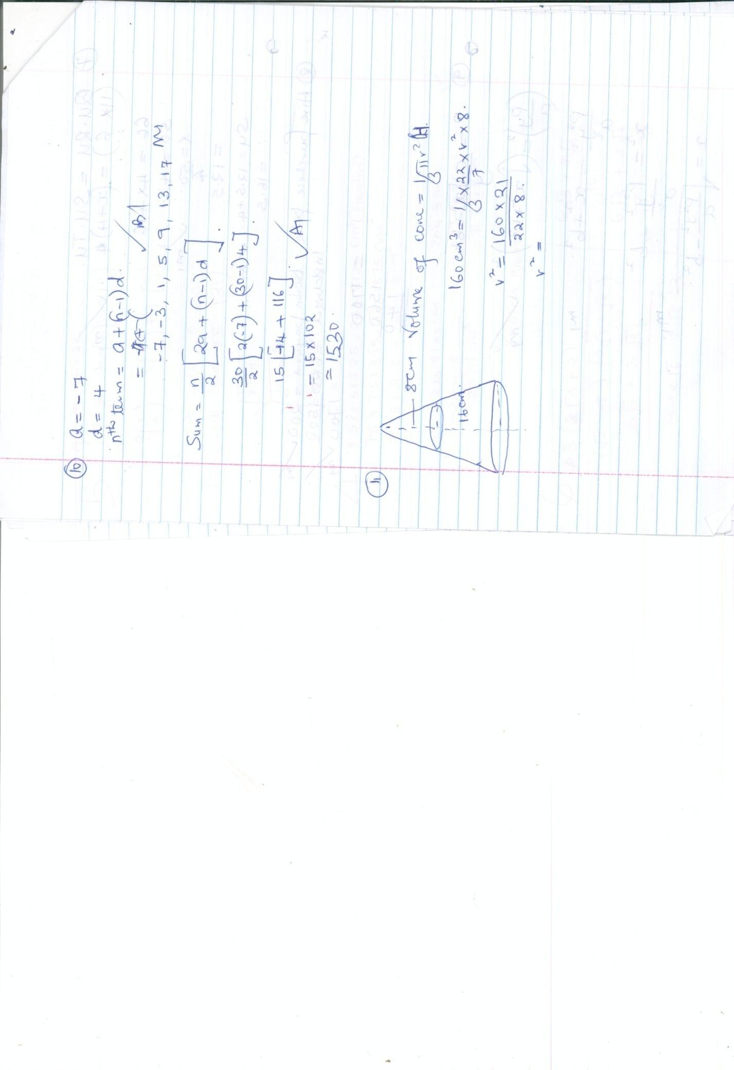

Volume of cone=⅓r2

160cm3 =⅓ x x r2  x 8

r2=

r2=

1. 2x – 3y + 6=0

3y=2x +6

Y=x + 2

Gradient, m =tan (180-) = B1

180- = tan ()

180-=33.70  B1

=180-33.7

0

1. A=P(1+)n

79692.42 = 50,000(1+ )2x4

= (1+ )8 m1

1.593=(1+ )8

= (1+ )

1.06=(1+ ) m1

0.06

R=0.06x 400

=24% A1

1. CBT = BCT= B1

0 B1

BTC =180-(72x2) m1

0 A1

1. + - (26.43 x 10-2)½  20.713

20.571

=(0.1079 x 10 x 2) + (2.749) – (5.1410) M1 0.202

0.1381

1.079 1.158 29

X 22.749 0.1410

1.158 3.907-5.1410 m1

1. Men hours days

5 6 8

3 8 - B1

x x 8 m1

=10 days A1

1. (i) Taxable income = x 15,200)= 1050

= 17480-1050

=16,630 m1

k£ = 9858k£ m1

ii) 3630 x 2=7260 m

3630 x 3=10980

2598 x 4=10392

Total tax per month =

=ksh.2378.50 B1

iii) Ne tax = 2378.50 – 450 m1

=ksh.1928.50 A1

Iv) Net salary = 15,200-1928.50 -1050 m1

=12,221.50 A1

1. (a) Det(4x2)-(3x3)=-1 B1

B1

(b) 20x + 15y =9500 B1

i)30x + 20y = 13,500 B1

Divide by 5

ii)= m1

ii) = m1

c)x 250 = sh.275 m1

90/100 x 200 = sh.180 m1

=

=8200+11,850

Sh.20.050

1. Original price=sh 340,000

No of ratio=x

Cost of each radio=sh.340,000

X

New no of radios = x-30

New price of radio=340,000

x-30 B1

340,000 + 300 = 340,000

X x-30 B1

340,000 + 300x = 340,000 m1

x-30 m1

340,000(x-30)+ 300x(x-30) = sh.340,000 m1

3400x – 102,000 + 3x2- 90 x=3400 x

3x2-9x – 102,000 = 0 m1

X2- 30x-34000=0

P=3400

S=-30

X2-200x+170x-34000=0 m1

X(x-200) + 170(x-200)=0 B1

(x+170) (x-200)=0 A1

X=200

New price of radio=340,000 A1

170

= sh.2000 m1

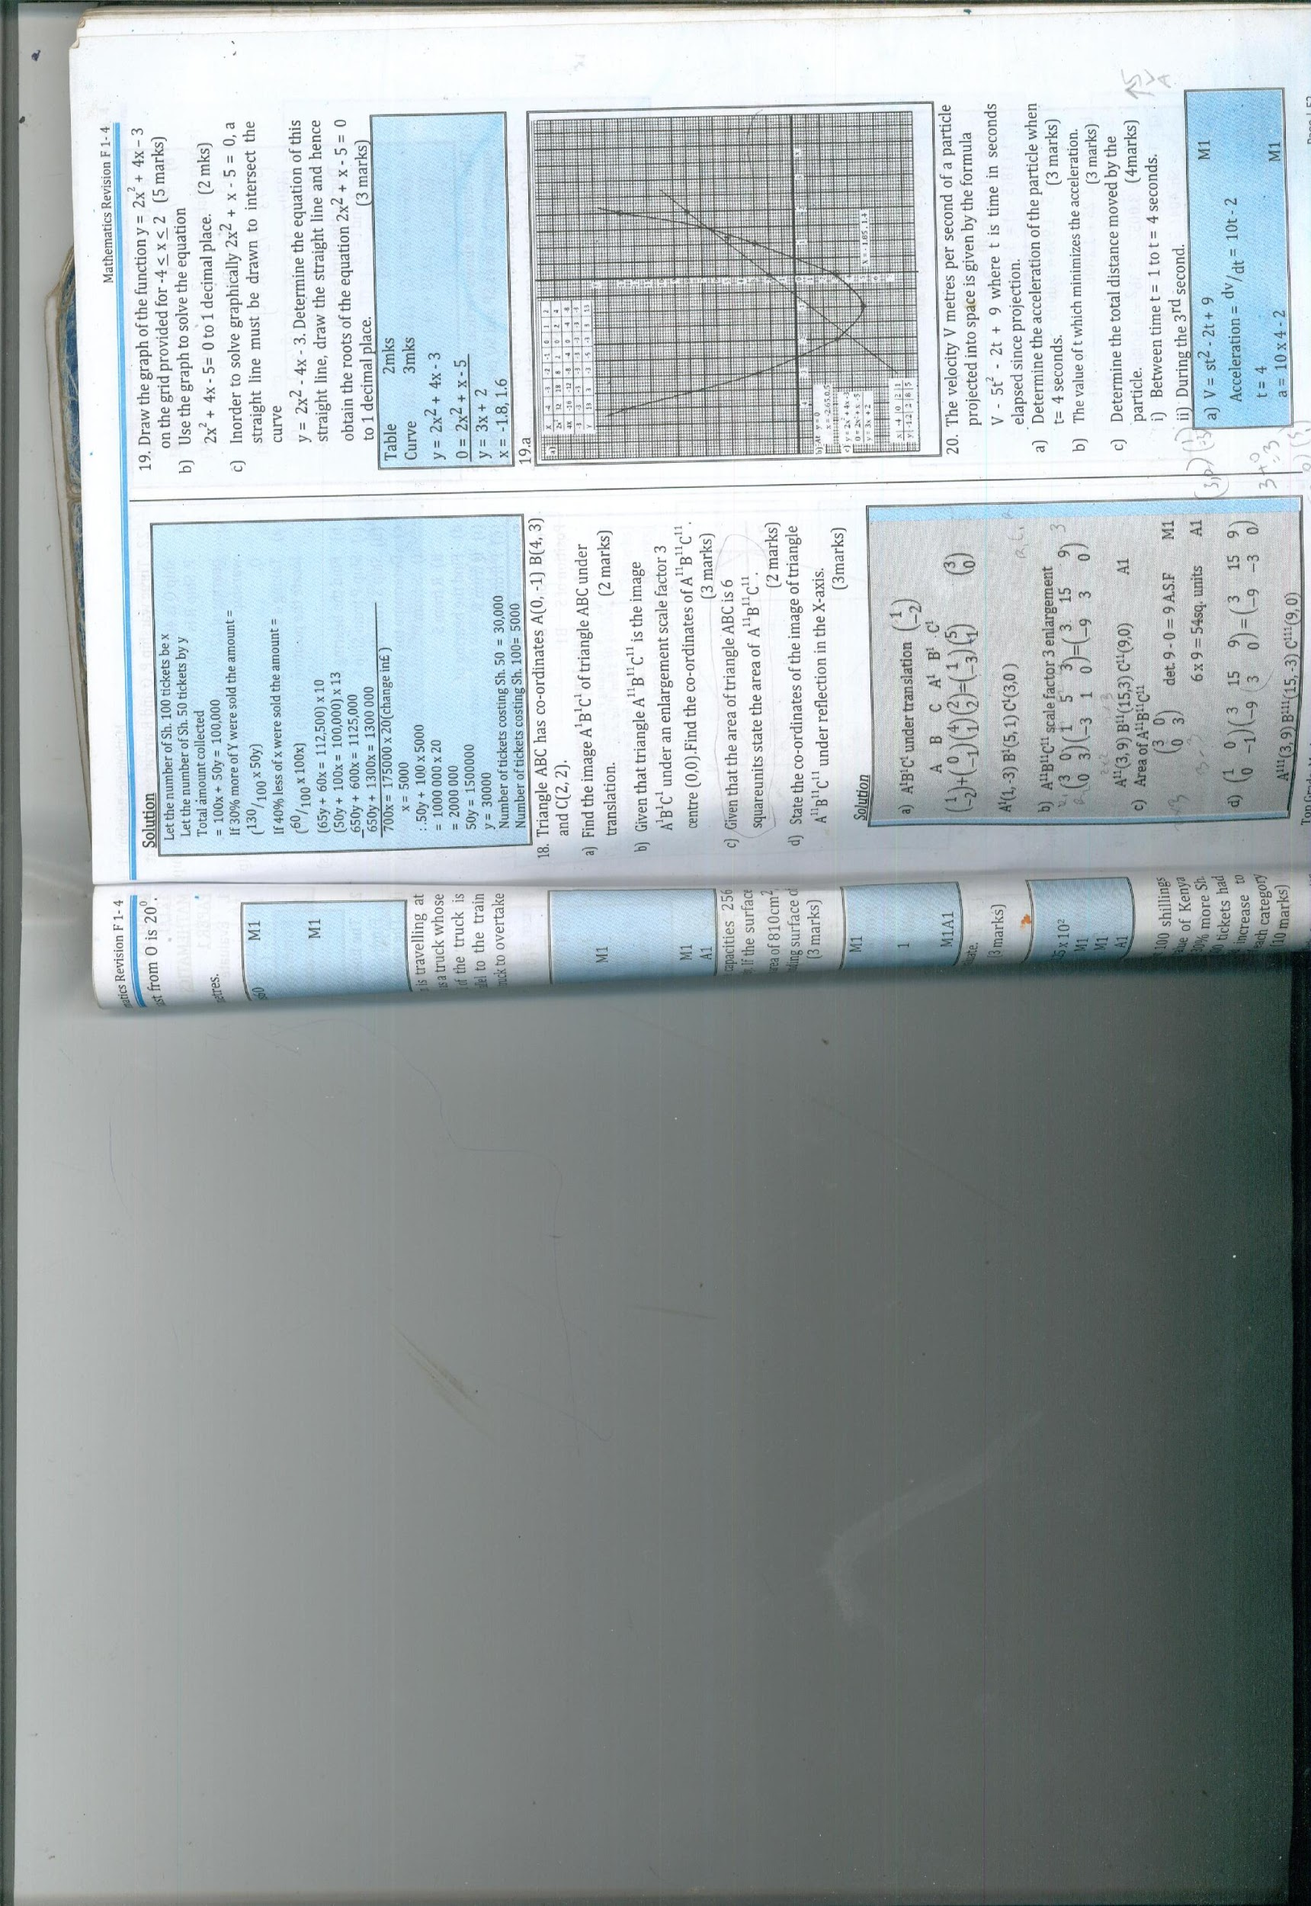

=1200 opposite angles of a cycle quadrilateral

BAD = 500(Alternate segment theorem)

DCB =180-(1100+500)

=200(internal angles of a triangle add up to 1800)

Area of triangle =½ab sin 1100

=½ x 3 x 5 x sin 1100

= 21.14cm2

1. (a) P= m1

q=

k= m1

=108

P= = A1

P=64.8

b)P=

q= B1

(c)q= m1

= m1

-

0.028 A1

% = 0.028 x 100

=-2.8% or reduction by 2.8%

1. (a) a,a+2d, a +5d

= = r B2

(a+2d)2=a(a+5a)

a2 + 4ad + 4d2 = a2 + 5ad

4d2= 5ad-4ad

=

r= m1

r= m1

r=1.5

(b)(i) Sn =

(2(16) + (20-1) 4) m1

10(32+76) A1

10(108)

=1080

ii) = 106.376.2154 A1

1. (a) = + - 2bc cos A

Cos A=

= 102+ 82- 72 A1

2x10x8

=44.050

(b) 2R

R= A1

=5.034

c) Area of sector x 3.142 x 5.0342

= 19.49cm A1

= x 5.0342 x sin 88.1 m

=12.66cm2 A1

Shaded area=19.49-12.66 m

= 6.83cm2A1