**NAME……………………………………………………….…ADM.NO……………CLASS:……….**

**NOVEMBER 2022 EXAMINATION**

**TIME: 2 HRS.**

**INSTRUCTION TO CANDIDATES:**

1. *Write your* ***name****,* ***Admission number*** *and* ***class*** *in the spaces provided above.*
2. *This paper consists of* ***TWO*** *Sections; Section* ***A*** *and Section* ***B****.*
3. *Answer* ***ALL*** *the questions in both Section* ***A*** *and* ***B*** *in the spaces provided.*
4. ***ALL*** *working* ***MUST*** *be clearly shown.*
5. *Candidates should check the question paper to ascertain that all the* ***8*** *pages are printed as indicated and that no questions are missing.*
6. *Candidates should answer the questions in English.*

*Where necessary, take:*

*g = 10N/kg*

*Density of water = 1000kg/m3*

**For Examiners Use only**

|  |  |  |
| --- | --- | --- |
| **Section** | **Marks** | **Marks awarded** |
| **A** | 25 Marks |  |
| **B** | 55 Marks |  |
|  | Total (80Marks) |  |

***Section A: 25 marks***

1. The figure below shows the volume of water in a measuring cylinder before and after immersing a stone. If the mass of the stone is 125g, determine its density. (3mks)

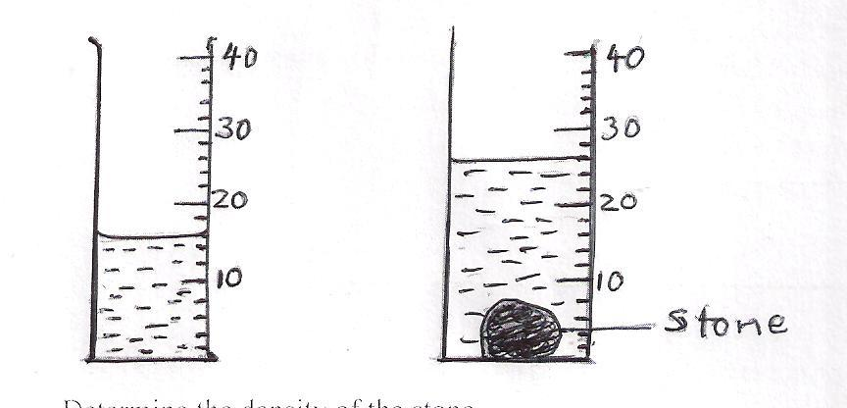

1. A drug manufacturer gives the mass of an active ingredient in a table as 4.0mg. Express this quantity in kilogrammes (1mk)

1. Giving an example, define the termderived quantities. (2mks)
2. A body is acted upon by three forces as shown below.

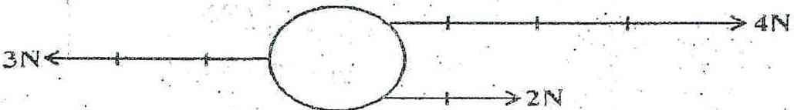

Draw on the body below to show the resultant force acting on it. (2mks)

1. Stateany two the difference between mass and weight (2mks)
2. Explain why water wets the glass while mercury does not.(2mks)
3. Name the instruments you would use to measure each of the following:
4. The length of a football field. (1mk)
5. The height of a 20 litrejerrican (1mk)
6. The circumference of your waist. (1mk)
7. The water level in a burette is 30cm3. If 55 drops of water fall from the burette and the average volume of one drop is 0.12cm3, what is the final water level in the burette? (2mks)
8. A man has a mass of 70kg. Determine
9. His weight on earth, where the gravitational field strength is 10N/kg. (2mks)
10. The gravitational field strength on the moon if his weight on the moon is 119N (2mks)
11. With the aid of a diagram show that pressure increases with depth (2mk)
12. Describe an experiment to show that matter is made up of small particles (2mk)

***Section B: 55 marks***

1. (a) Define pressure and state its SI unit (2mks)

(b) The figure below shows the measurements of a solid of mass 50kg.

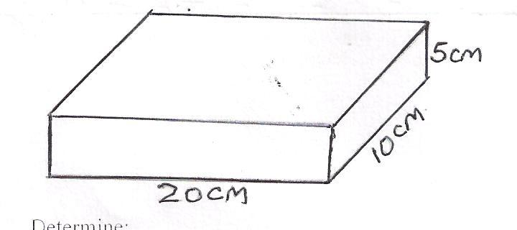

Determine:

1. The weight of the solid (1mk)
2. The minimum pressure the solid can exert on a flat surface (3mks)
3. The maximum pressure the solid can exert on a flat surface (3mks)
4. A sea diver is 35m below the surface of sea water. If the density of the sea water is 1.03gcm-3, the atmospheric pressure 103 000Nm-2 and g is 10N/kg; determine the total pressure on him. (3mks)

1. The diagram below shows a simple hydraulic lift

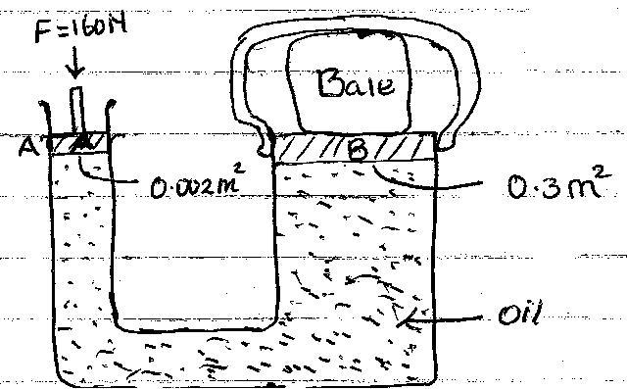

If aforce of 160N is applied on the small piston. Determine:

1. The pressure at the side of small piston A. (2mks)

1. Pressure experienced by the oil (1mk)
2. Force produced on Large pistonB to compress the bale (3mks)
3. State **two** factors that affect pressure other than depth. (2mk)
4. a)Define the term diffusion (1mk)

b) Distinguish between solid and liquid states of matter in terms of intermolecular forces. (2mks)

c) Hydrochloric gas diffuses faster than ammonia gas. Suggest a reason for this observation(2mks)

b) Brown motion of smoke particles can be studied by using the apparatus shown below. To observe the motion, some smoke is enclosed in the smoke cell and then observed through the microscope.

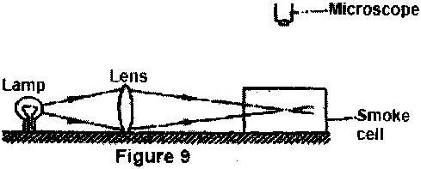

(a) Explain the role of the lamp, lens and microscope in the experiment (3mks)

(b) State and explain the nature of the observed motion of the smoke particles(2 marks)

(c) State what will be observed about the motion of the smoke particles if the temperature surrounding the smoke cell is slightly raised. (1 mark)

1. The figure below shows a beaker filled with water. Some potassium permanganate was gently introduced at the bottom of the beaker at the position shown.Figure (ii) shows uniform purple colour of potassium permanganate solution after about 10 minutes

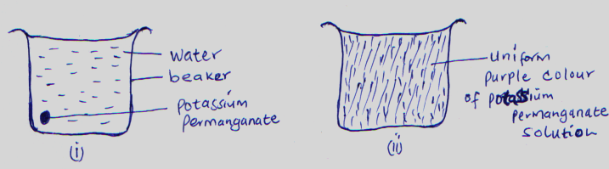

Explain how the appearance in figure(ii) was caused. (2mks)

1. a)Define the term temperature and state its SI units (2mks)

b)The figure is of a below represent mercury in a clinical thermometer.

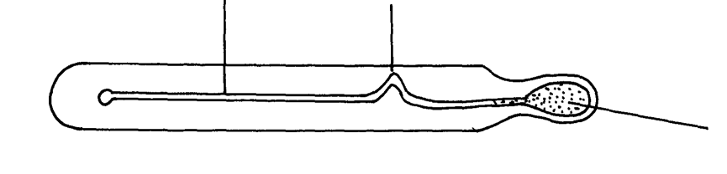

Tube

Bulb

Constriction

Explain why;

1. There is a constriction on the tube (1mk)

1. The bulb is thin (1mk)
2. Mercury is the mostly preferred thermometric liquid in clinical thermometer than alcohol (2mks)

1. A clinical thermometer is likely to break if sterilized using boiling water (1mk)
2. Convert
3. Temperatures of -173oc to Kelvin (2mks)
4. Temperatures of 376K to oc. (2mks)
5. a) Giving an example in each, state the difference between scalar and vector quantity.(4marks)

b) A concrete slab of mass 20g is held by a steel cable of a crane as shown below. Name and show the forces acting on the slab (2mks)

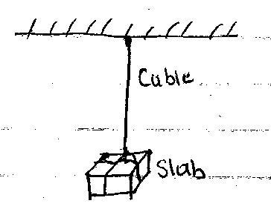

c)State any **two** examples of contact forces. (2mks)

d) State any **three**effects of a force on a body (3mks)