**PHYSICS FORM 3 PP1 MARKING SCHEME**

**SECTION A: 25MKS**

1. A micrometer screw gauge has a zero error of 0.12mm.Sketch the reading of the micrometer screw gauge when used to measure the size of a ball of diameter 3.44mm. (1 mark)

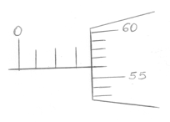

2.  **Figure 1 (a) and 1(b)** shows capillary tubes inserted in water and mercury respectively.

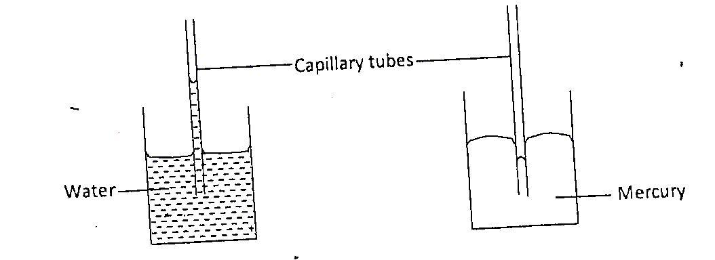

**Figure 1(a) Figure 1(b)**

It is observed that in water the meniscus in the capillary tube is higher than the meniscus in the beaker, while in mercury the meniscus in the capillary tube is lower than the meniscus in the beaker. Explain these observations. (2 marks)

**In (a) adhesive force√ is greater than cohesive force hence molecules of water rises to be in contact with glass molecules.**

**In (b) cohesive force is greater√ than adhesive force hence molecules of mercury remains together forming the shape.**

3. A block of mass 500g and measuring 30cm by 25cm by 15cm rests on a flat floor. Determine maximum pressure exerted on the floor. (3 marks)

**M = 0.5kg = $\frac{0.5 x 10}{0.25 x 0.15}$ (1mk)**

**D (0.3 x 0.25 x 0.15)m**

**Pmax = ? = 133.33 pas 1mk**

**Pmax =**

4. In **figure 2** ammonia gas and an acid gas diffuse and react to form a white deposit on the walls of the glass tube. Explain why the white deposit forms nearer end B than A. (1mark)

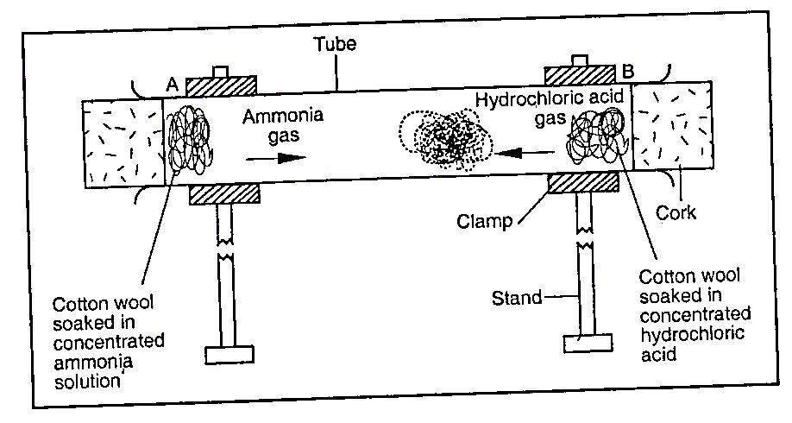

**Figure 2**

**Ammonia diffuses faster√ than hydrochloric acid which is denser.**

5. A man wants to fit a brass ring tightly onto a steel rod of equal diameter to the inner diameter of the ring. Explain how this can be achieved. (2 marks)

**Heat the brass rod and fit the steel rod while its cold.**

6. State how conduction and radiation is minimized in a thermos flask. (2 marks)

* **Conduction – Minimised by a vacuum and glass stopper which is a poor conductor of heat.**
* **Radiation – minimized by double silvered wall.**

7. A body moving around a circle is accelerating and yet the speed is constant. Explain. (1 mark)

* **The body keeps on changing direction and since velocity is a vector quantity, the body is said to be accelerating.**

8. **Figure 3** shows a uniform bar of mass 0.8kg supported by a spring balance at its Centre and the bar is at equilibrium.

//////////////////////









Determine the:

(a) Value of X (3 marks)

**At balance**

**Clockwise mmt = Anticlockwise mmt**

**24 x 0.6 = x 0.8 (1mk)**

**X = $\frac{24 x 0.6}{0.8}$ (1mk)**

**= 18N (1mk)**

(b) Reading of the spring balance (1mark)

**Also at balance**

**Upward forces = downward forces spring reads 18+24**

**= 42 N 1mk**

9. **Figure 4** shows a load-extension graph for various loads hung from a single spring.

1mk



**Figure 4**

On the same axes, sketch a graph for a spring double the diameter of the first one (1mark)

10. An aeroplane is moving horizontally through still air at uniform speed. State with reason what is observed when the speed of the plane is increased. (2marks)

**- Plane lifts up**

**- When speed of the plane increases pressure there decreases causing a dynamic lift.**

11. A crane lifts a load of 2000kg through a vertical distance of 4.0 m in 5 seconds. Determine the power developed by the crane. (3 marks)

**L=20,000N**

**h = 4M**

**t =5s**

**P = $\frac{work done}{time}$ 1mk**

**= $\frac{20000 x 4}{5}$ 1mk**

**= 16000W1mk**

12. Sketch a displacement time graph for a freely falling body and describe the motion. (2marks)





**Displacement is decreasing uniformly since its accelerated uniformly by gravity till it lands.**

13. State Newton’s first law of motion. (1mark)

**A body in its state of rest or uniform motion continues to do so in a straight line unless acted by some external force.**

**SECTION B (55 marks)**

***Answer ALL the questions in this section in the spaces provided.***

14. **Figure 5** shows a crate of mass 70kg being pushed by a man with a force of 150 N along the plane AB.

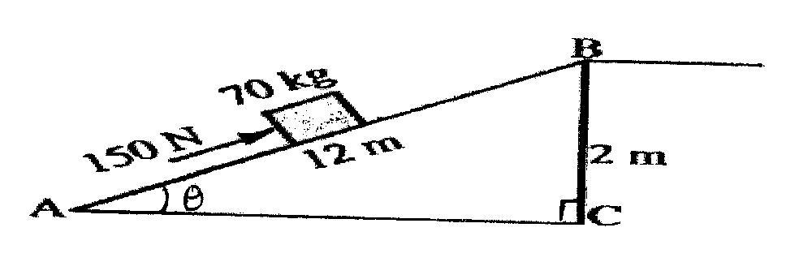

**Figure 5**

(a) Show that V.R of the inclined plane is given by $\frac{1}{Sinϴ}$ (3 marks)

**From definationV.R = $\frac{distance moved by effort}{distance moved by load}$ 1mk**

$\frac{V.R}{1}=\frac{d}{h}$…..i

Sin Ɵ = $\frac{op}{hyp}$**1mk**

$\frac{h}{d}$……. ii

Comparing equation i & ii

V.R. = $\frac{1}{SinƟ}$

(b) Determine the work done:

(i) By the force of the man. (2marks)

**Work = force x distance 1mk**

**= 150 x 12**

**= 1800J 1mk**

(ii) On the mass. (2marks)

**Work = force x distance**

**= 70 x 10 x 2 1mk**

**= 1400J 1mk**

(iii) To overcome friction. (1mark)

**Work to overcome friction = work input – work output**

**= 1800 – 1400**

**= 400 J 1mk**

(c) Determine the efficiency of the inclined plane. (2marks)

ɲ = $\frac{work output}{work input} x 100$ **1mk**

= $\frac{1400}{1800} x 100$

**= 77.78% 1mk**

(d) Suggest one method of improving the efficiency of an inclined plane. (1mark)

* **Decreasing the angle Ɵ**
* **Making the plane smooth.**

**Any 1mk**

15. a) A bullet of mass 2.0g is fired horizontally into a block of wood of mass 600g. the block is suspended from a string so that it is free to move in a vertical plane. The bullet and block rise together through a vertical distance of 8.6cm as in figure 9 below. 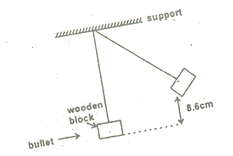

Calculate the speed of the bullet before the impact with the block. (5mks)

**Assuming all KE of mass + bullet is converted to PE.**

**Then ½ mv2 = mgh or 1mk**

**V2 = 2gh**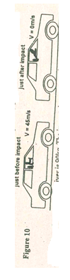

**V =**

**=**

**= 1.311ms -1**

**Momentum before collision = momentum after collision.**

**0.002 V1 + 0.6 x 10 = 0.602 x 1.311**

**V1 = $\frac{0.602 x 1.311}{0.002}$**

**= 394.76 ms -1**

1. Figure below 10 shows a car with a dummy driver before and after collision test.

The mass of the dummy driver is 90kg. The impact time reduces the dummy’s speed from 45m/s to 0m/s in 1.2 seconds.

1. State the energy transformation during the collision. (1mk)

**KE heat + sound** 

1. Calculate the average force on the dummy during impact. (3mks)

**a =**

**=**

**= 37.5m/s2**

**F = Ma**

**= 90 x 37.5**

**= 3375N**

1. Calculate how much of the dummy’s energy is transformed during the collision. 2mks)

**Transformed Energy = KE**

**= $\frac{1}{2}X 90 X {45}^{2}$**

**= 91,125J**

16. a) i)State two conditions necessary for equilibrium of a body acted upon by a number of forces. (2 marks)

* **Algebraic sum of V forces is zero or upward forces equal to downward forces.**
* **At balance sum of clockwise movement is equal to sum of anticlockwise moment.**

ii) Figure below shows beaker containing a block of ice.

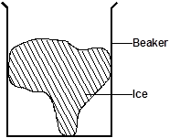

State and explain the change in stability when the ice melts. (3 marks)

* **Stability increases.**
* **When the ice melts cog lowers making the stability to be enhanced.**

b) Figure below shows a drop of fatty acid on a wire of diameter 1.4mm

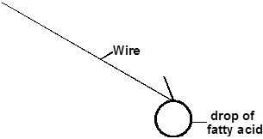

When the drop of the fatty acid was placed on clean water surface it formed a circular patch of diameter 91cm.

i) Estimate the length of the molecule of the fatty acid. (3 marks)

**patch d – 91cm**

**drop d – 0.14cm**

**vol. of the drops = vol of the patch**

**πR2t = 4/3 π r3**

ii) State the assumption made in part (i) above. (1 mark)

* **The drops is spherical in shape.**
* **Drop spread to one molecule thick /monolayer**
* **No evaporation during the spread.**

17 (a) State the principle of conservation of linear momentum. (1 mark)

* **For a system of colliding bodies, the total momentum before collision equals to the total momentum after collision.**

(b) Distinguish between elastic and inelastic collision. (1 mark)

|  |  |
| --- | --- |
| **Elastic** | **Inelastic** |
| **KE & momentum conserved**  **Bodies move apart** | **Only momentum is conserved**  **Bodies stick together and moves as one** |

(c) A striker kicks a ball of mass 200g initially at rest with a force of 78N.Given that the foot

was in contact with the ball for 0.30s; determine the takeoff velocity of the ball. (3 marks)

**M = 0.2kg**

**M = 0ms-1**

**F = 78N**

**t = 0.3S**

**Ft = M (v – u)**

**7 8 x 0.3 = 0.2 (v – 0)**

**V =**

**= 117ms-1**

(d) A high jumper usually lands on thick soft mattress. Explain how the mattress helps in

reducing the force of impact. (2 marks)

* **It increases the time of impact thereby reducing the impulsive force.**

(e) A ball is thrown horizontally from the top of a vertical tower of height 75m and strikes the ground at a point 80m from the bottom of the tower. Determine the:

(i) Time taken by the ball to hit the ground. (*Acceleration due to gravity=10m/s2)* (3 marks)

**h = 75m**

**R = 80m**

**t = ?**

**h = $\frac{1}{2}gt^{2}$**

**75 = $\frac{1}{2}x 10 x t^{2}$**

**5 $t^{2}$ = 75**

$t^{2}=15$

**t = 3.873s**

(ii) Initial horizontal velocity of the ball. (2 marks)

**R = Ux X t**

**80 = Ux X 3.873**

**Ux = $\frac{80}{3.873}$**

**= 20.66 ms-1**

1. a) State Hooke’s law. (1mk)

**For a herical spring or any other elastic material, the extension produced is directly proportional to the stretching force provided elastic limit is not exceeded**

b) Three springs which are identical and have negligible mass are arranged as shown in the diagram below.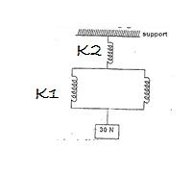

The spring constant of each spring is 2N/cm. calculate the total extension due to the 30N weight. (4mks)

**K2 = 2N/cm√ ½**

**F = Ke √ e1 = $\frac{30}{2}=15cm√$**

**K1 = 4N/cm √ ½ e2 = $\frac{30}{4}$ = 7.5cm√**

**Total extension = (15 + 7.5) = 22.5cm√**

1. A student was provided with a wire, assortment of masses, a test-tube a mounted retort

stand a metre rule. Describe how she could use the provided materials to verify Hook’s law for a spring. (5mks)

**Procedure**

* **Make close windings of the wire round the test tube to make a spring.√**
* **Suspend the spring onto the stand and note the initial reading of pointer.√Hang different masses onto the spring.√**
* **For each load, measure corresponding extension.√**
* **Make a table of extension and corresponding applied force/ load.**
* **plot a graph of force against extension.√**
* **A graph of extension against force/ load is a straight line every force divided by corresponding extension is a constant√ hence Hookes law is obeyed.**