**NOVEMBER 2021 EXAMINATION**

**FORM 3 PHYSICS Paper 2 Marking Scheme**

1. New object distance = 5 – 2 = 3cm

Distance between tip and its image = 3 + 3 ✔

= 6cm✔

1. a)Like poles repel, unlike poles attract. ✔

b) Pole X is South pole ✔

1. Convex mirror gives a **wider field of view of**✔the rear (behind) compared to plane mirror.
2. a) Period, T = 8.0 x 10-4S✔

Frequency = 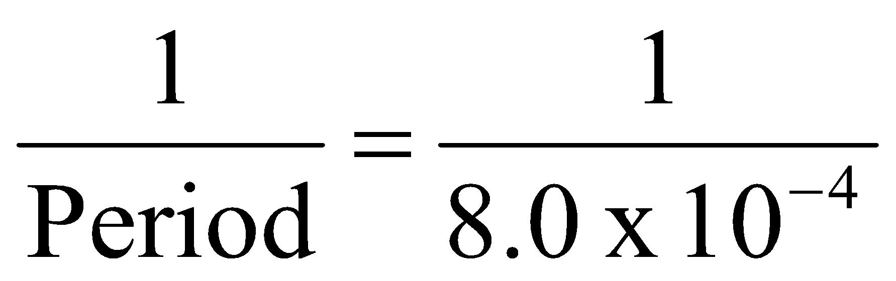

= 1250

= 1.25 x 103 Hz

b)

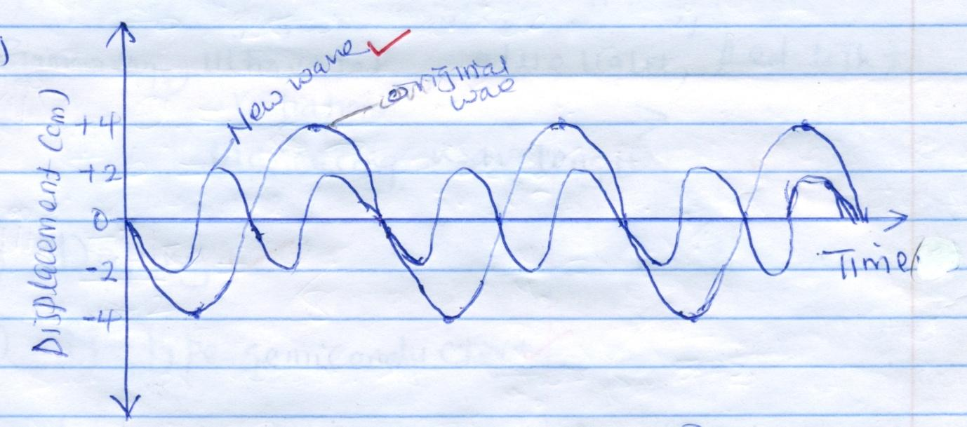

1. a) Primary cells cannot be recharged after use while secondary cells can be recharged after use.✔

b) Polarization is reduced by adding a depolarizer

or

Adding Manganese (VI) oxide✔

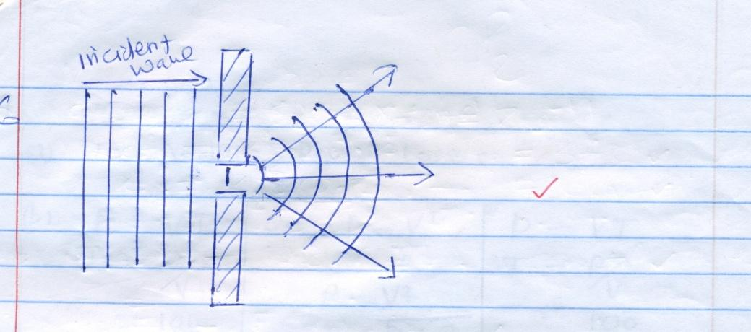

1. 2 Distance = Speed x time✔ (2d = vt)

2x = 320 x 0.8 ✔

x = 320 x 0.8

2

x = 128m ✔

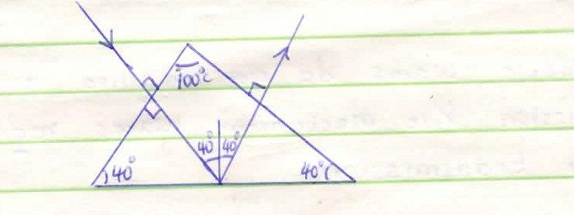

1. Hydrogen gas bubbles at the cathode.

- White deposit forms at the plates.

- Relative density of the electrolyte drops.

1. a)

N

S

N

S

Conductor

Force

b) Reduce the amount of current. ✔

or

Reduce magnetic field strength.

1. Transverse waves forms crests and troughs as they propagate while longitudinal waves forms part of compression and rarefaction. ✓¹

* Transverse waves moves perpendicular to the direction of wave motion

while longitudinal waves moves parallel to the direction of wave motion. ✓¹

1. a)The current flowing through a conductor is directly proportional to the potential difference across the conductor provided Temperature and other physical conditions are kept constant.✔

b) Effective Resistance = $\frac{3 x 6}{3+6}$

= $\frac{18}{9}$

= 2✔

V = IR I = $\frac{V}{R}$ ✔ = $\frac{5}{2}$ = 2.5A ✔

**SECTION 2**

1. (a) (i) Dispersion of light.

(ii) X – Red

Y – Violet

- Red has the lowest frequency/longest wavelength hence least

deviated while violet has the highest frequency/shortest

wavelength hence most deviated.

(iii) Act as point source of light.

(b) (i) 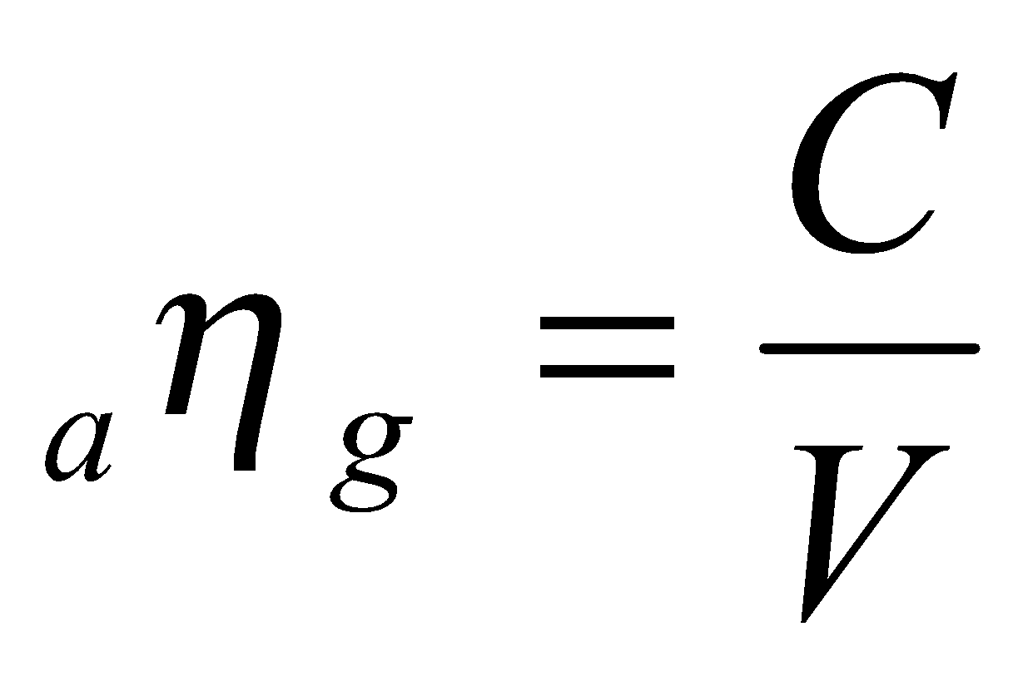✓¹

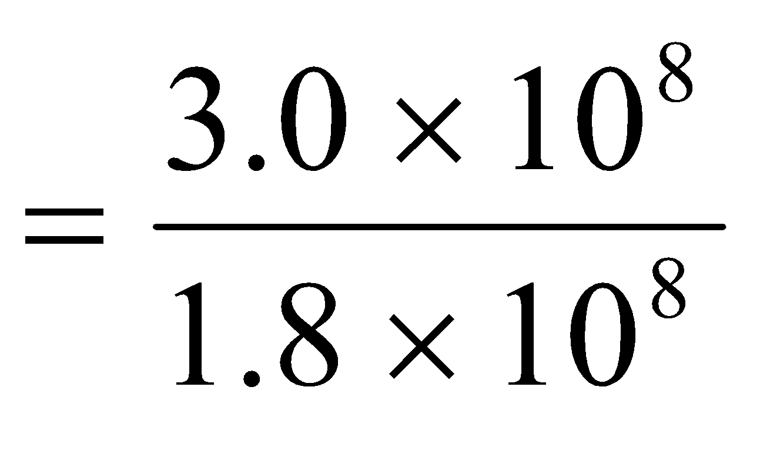✓¹

= 1.6667 ✓¹

1. C on the diagram. ✓¹

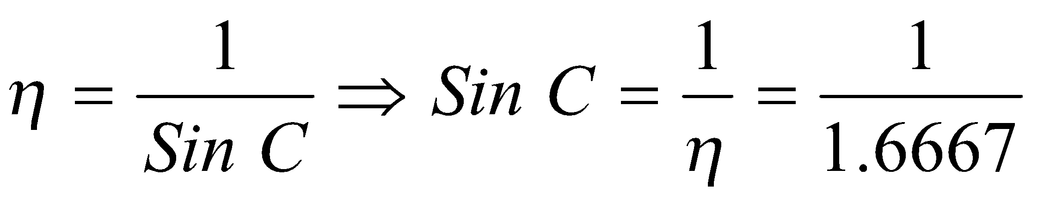✓¹

Sin C = 0.5999

C = 36.86° ✓¹

(iii) 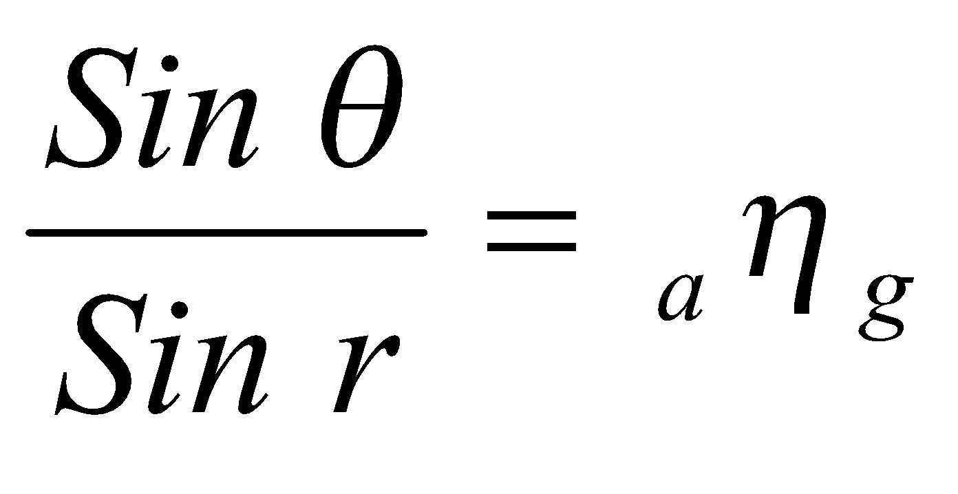✓¹

Sin ➔ = 1.6667 x 31.2 ✓¹

= 0.8634

➔ = 59.7° ✓¹

a) 3 + 1 = 4Ω

4 + 2 = 6Ω

R = 6 x 4

6 + 4 ✔

= 2.4Ω

RE = 2.4Ω + 5.6Ω ✔

= 8Ω ✔

ii) V = IR ✔

I = 6 ✔

8

= 0.75A ✔

iii) V5.6Ω = 0.75 x 5.6

= 4.2V

6V - 4.2V✔ = 1.8V✔

Alt

RXY = 2.4Ω

V = 2.4 x 0.75 ✔

= 1.8V ✔

* + 1. Frequency not affected
    2. Speed reduces
    3. Wavelength reduces
 $f=\frac{v}{ƛ}=\frac{0.12}{0.08}=1.5Hz$

 1. Stationary wave Progressive wave
* No energy is transferred from source - energy is transferred from source
* Wave form does not appear to move - wave form moves away continuously
  1. (i) Time taken to make one complete oscillation

10 x 10-2 seconds

(ii) F = I

T

I

10 x 10-2 = 10Hz

(iii) V = λf

X = v

f

= 200 = 20m

10

* 1. Mechanical waves require material medium for transmission but electromagnetic waves do not

Mechanical waves are longitudinal or transverse but electromagnetic waves are only transverse in nature. 2mks

1. Amount of current

Number of coils / turns

Shape of the core

b)i)The metre rule tilt anticlockwise ✔when switch is closed current flows in coil magnetising bar ✔. End of coil facing magnet become south pole ✔hence attract magnet to which ruler is attached ✔

ii) Metre rule tilt clockwise or weight comes down while magnet moves upwards ✔. Reversing terminals reverses direction of current hence polarity of electro magnet.✔ End facing magnet become north pole hence repulsion

iii) Move jockey J from B toward A / right to left of R. ✔

iv)It reduces resistance and increase current hence stronger electromagnet