**Name……………………………………………………….ADM No……………Class…………**

232/2

**PHYSICS**

Paper 2

**Time: 2 Hours**

**NOVEMBER 2022 EXAMINATION**

**PHYSICS 232/2 FORM 3**

**Time: 2 Hours**

**INSTRUCTIONS TO CANDIDATES**

a) Write your name and Index No. in the spaces provided above.

b) Sign and write the date of the examination in the space provided above

c) This paper consists of Two sections; A and B

d) Answer ALL the questions in Section A and B in the spaces provided.

e) All working MUST be Clearly shown

f) Non-programmable silent electronic calculators and KNEC Mathematical tables

may be used for calculations

**FOR EXAMINER’S USE ONLY**

|  |  |  |  |
| --- | --- | --- | --- |
| **Section** | **Question** | **Maximum score** | **Candidates score** |
| A | 1-12 | 25 |  |
| B | 13 | 13 |  |
| 14 | 11 |  |
| 15 | 12 |  |
| 16  17 | 11  8 |  |
|
|  | **TOTAL** | **80** |  |

***This paper consists of 13 printed pages.Candidates should check the question paper to ascertain that all pages are Printed as indicated and that no question is missing***

**SECTION A (25 MKS)**

1. Figure 1 shows a pencil lying in front of a plane mirror. The pencil is moved 2cm towards the mirror in the same orientation.

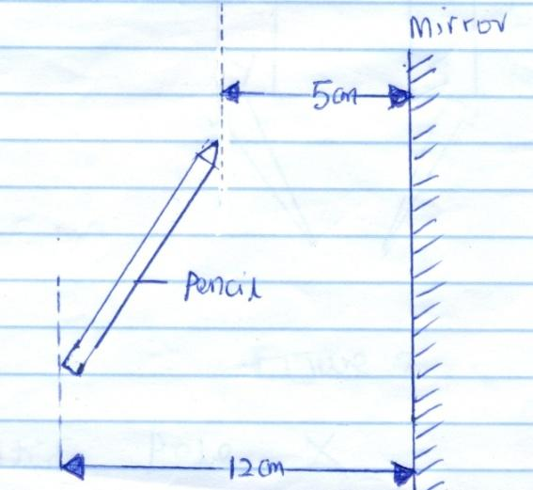

**Figure 1**

Determine the distance between the new position of the tip of the pencil and its image. (2mks)

………………………………………………………………………………………………………………………………………………………………………………………………

1. (a) State the basic law of magnetism. (1mks)

………………………………………………………………………………………………………………………………………………………………………………………………

b) Figure 2 shows two bar magnets, one whose poles are labelled and a second one whose poles are labelled X and Y. Iron nails are attracted to the lower ends of the magnets as shown.

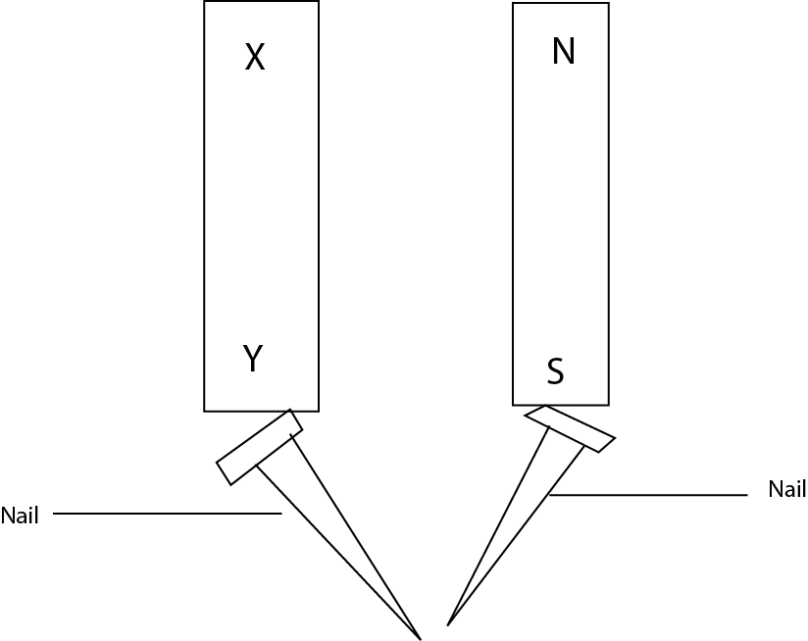

**(1mk)**

**Figure 2**

Identify pole **X** ……………………………………………….……………………………………

1. State the reason why convex mirror is preferred over a plane mirror for use as a driving mirrors in cars. (1mk)

……………………………………………………………………………………………………………………………………………………………………………………………………………………………………………………………………………………………………………..

1. Figure 3 shows the displacement-time graph for a certain wave.

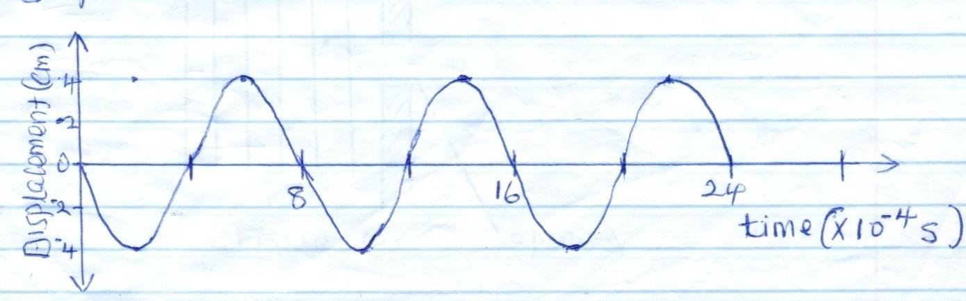

**Figure 3**

a) Determine the frequency of the wave. (2mks)

………………………………………………………………………………………………………………………………………………………………………………………………………………………………………………………………………………………………………………

b) On the same diagram, draw a wave with half the amplitude and twice the frequency of the one shown. (1mk)

1. (a)State the main difference between primary chemical cells and secondary chemical cells. (1mk)

…………………………………………………………………………………………………………………………………………………………………………………………………………

b) State how the design of a dry Lechlanche cell reduces polarization. (1mk)

……………………………………………………………………………………………………………………………………………………………………………………………………

1. Figure 4 shows a wave incident on a narrow opening.

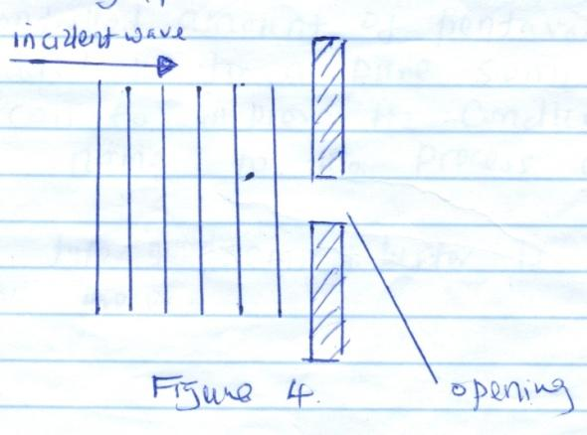

**Figure 4**

Draw the appearance of the wave after passing through the opening. (1mk)

1. A student stands between two classroom walls and claps. After 0.6 seconds, she hears the first echo and hears the second echo after 0.8 seconds. Determine the distance from the student to the further wall. Take speed of sound in air = 320m/s. (3mks)

…………………………………………………………………………………………………………………………………………………………………………………………………………………………………………………………………………………………………………………………………………………………………………………………………………………………………………………………………………………………………………………………

1. In the fig. 4 shown below (not drawn on scale) sketch the path of a ray till it emerges from the prism.

(1mk)

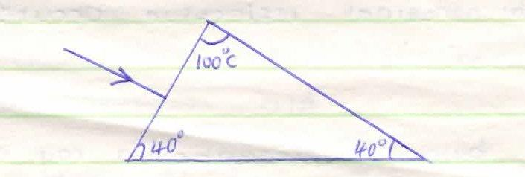

1. Describe the changes that can be observed during discharging process of lead-acid accumulator. (2mks)
2. Figure 5 shows the cross-section of two bar magnets and a current carrying conductor held between them. The direction of current is into the paper.

N

S

Conductor

N

S

**Figure 5**

a) indicate with an arrow the direction of force experienced by the conductor. (1mk)

b) State one way in which the force on the conductor above can be reduced. (1mk)

……………………………………………………………………………………………………………………………………………………………………………………………………….

1. Distinguish between transverse and longitudinal waves. (2mks)

…………………………………………………………………………………

…………………………………………………………………………………

……………………………………………………………………………………

1. a) State Ohm’s law. (1mk)

……………………………………………………………………………………………………………………………………………………………………………………………………………………………………………………………………………………………………………

b) Figure 6 shows an electrical circuit.

3

A

6

Switch

5V

**Figure 6**

Determine the Ammeter reading in a closed circuit. (3mks)

……………………………………………………………………………………………………………………………………………………………………………………………………………………………………………………………………………………………………………

**SECTION B (55 MARKS)**

1. Figure 7 below shows a narrow beam of white light onto a glass prism.

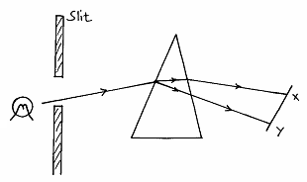

Figure 8

(i) What is the name of the phenomenon represented in the diagram? (1mk)

…………………………………………………………………………………….

(ii) Name the colour at **X** and **Y**. Give a reason. (3mks)

…………………………………………………………………………………….

…………………………………………………………………………………….

(iii) What is the purpose of the slit? (1mk)

…………………………………………………………………………………….

…………………………………………………………………………………….

1. Figure 8 below shows the path of ray of yellow light through a glass prism.

The speed of yellow light in the prism is 1.8 x 108m/s.

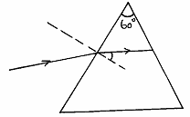

r

Figure 8

1. Determine the refractive index of the prism material (speed of light

in vacuum C = 3.0 x 108m/s). (3mks)

………………………………………………………………………………

………………………………………………………………………………

………………………………………………………………………………

1. Show on the same diagram, the critical angle, c, and hence determine its value. (3mks)

………………………………………………………………………………

………………………………………………………………………………

………………………………………………………………………………

………………………………………………………………………………

(iii) Given that r = 31.2°, determine the angle ➔. (3mks)

………………………………………………………………………………

………………………………………………………………………………

………………………………………………………………………………

………………………………………………………………………………

1. (a) The figure below shows resistors in a circuit. The internal resistance of the battery is negligible.

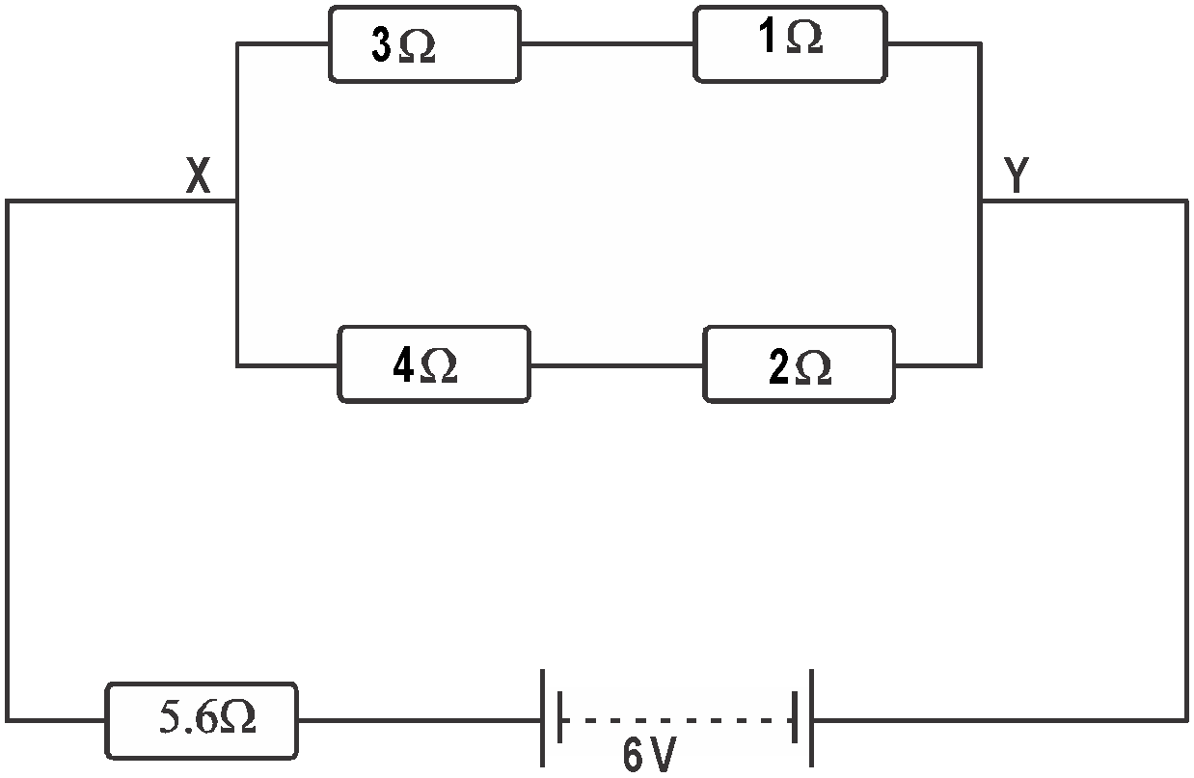

i) Calculate the effective resistance of the circuit. (3 marks)

...................................................................................................................................................................

...................................................................................................................................................................

...................................................................................................................................................................

...................................................................................................................................................................

ii) Find the total current in the circuit. (3 marks)

...................................................................................................................................................................

...................................................................................................................................................................

...................................................................................................................................................................

...................................................................................................................................................................

iii) P.d between X and Y (2 marks)

...................................................................................................................................................................

...................................................................................................................................................................

...................................................................................................................................................................

...................................................................................................................................................................

 (b)Define the term “e.m.f” of a cell. (I mark)

………………………………………………………………………………………………

……………………………………………………………………………………………….……………………………………………………………………………………………….

(c )Why is repulsion the surest way for polarity of a magnet. (1 mk)

1. Some plain water waves were produced in a ripple tank. They pass from a region of deep water into aregion of shallow water. The figure shows what the waves look like from above

Boundary

Waves

Move

This way

Deep Water Shallow water

1. State what happens at the boundary to:
   * 1. The frequency of the waves (1 mark)
     2. The speed of the waves (1 mark)
     3. The wave length of the waves (1 mark)
2. The waves have a speed of 0.12m/s [in the deep water. Wave crests are 0.08m apart to the deep water. Calculate the frequency of the sources producing the waves. (3 marks)
3. State two differences between a stationary wave and a progressive wave. (2 marks)
4. The wave shown in the figure below has a velocity of 200ms-1

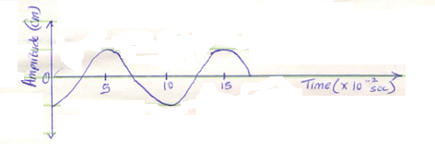

Determine:

1. The period T of the wave. (2mks)
2. The frequency of the wave. (2mks)
3. The wavelength of the wave. (2mks)
4. State two difference between electromagnetic waves and mechanical waves. (2 mks)
5. **a)**State two factors that affect the strength of an electromagnet. (2 mks)

. ....................................................................................................................................................

...................................................................................................................................................................

b)Figure below shows suspended metre rule in equilibrium balanced by the magnet and weight shown. The iron core is fixed to the bench.

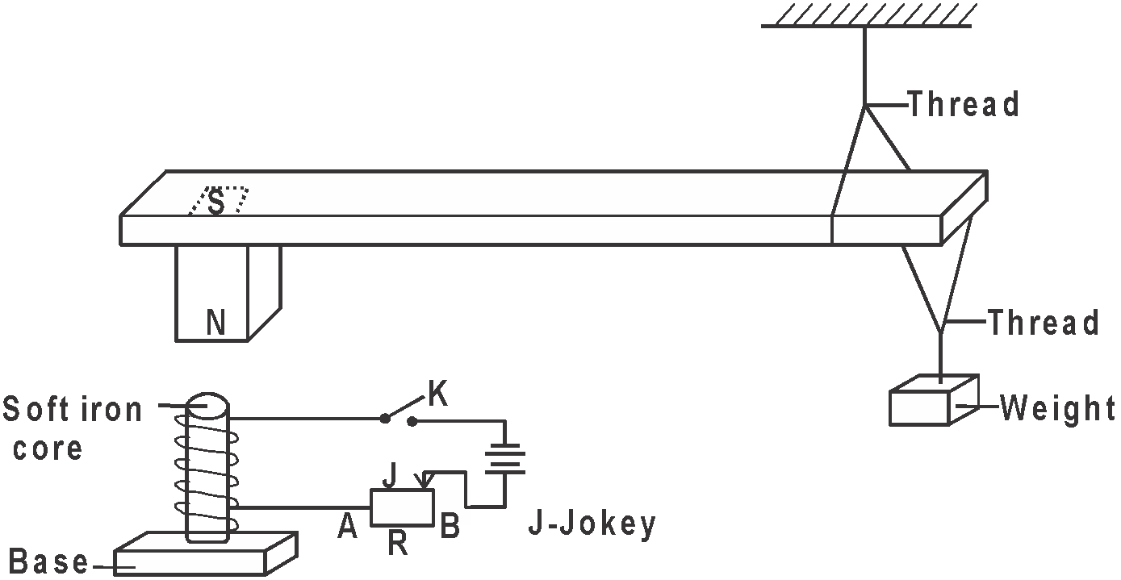

i) State and explain the effect on the metre rule when the switch S is closed. (3 marks)

...................................................................................................................................................................

...................................................................................................................................................................

...................................................................................................................................................................

...................................................................................................................................................................

ii) State and explain the effect on the metre rule when the terminals of battery are reversed. (2 marks)

...................................................................................................................................................................

...................................................................................................................................................................

...................................................................................................................................................................

...................................................................................................................................................................

iii) Suggest how J on the set up can be varied to have metre rule tilt anticlockwise faster. (1 mark)

...................................................................................................................................................................

...................................................................................................................................................................

iv) Explain your suggestion in b(iii) above. (3 marks)

...................................................................................................................................................................

...................................................................................................................................................................

...................................................................................................................................................................

...................................................................................................................................................................