**PANGANI GIRLS’ HIGH SCHOOL**

**POST MOCK 2022**

***Kenya Certificate of Secondary Education (KCSE)***

***Feb 2022***

**232/2**

**PHYSICS**

**MARKING SCHEME**

**PAPER 2**

**( SECTION A 25 Marks)**

1. Light travels in a straight light🗸1 / Rectilinear propagation of light.

2.

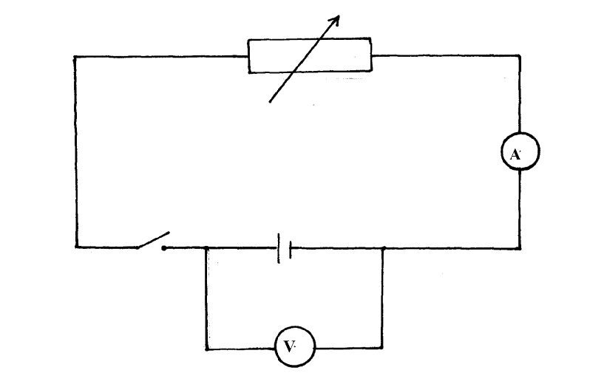

3. - When hammered the dipoles Vibrate/🗸1 excited.

- Then they align along the Earth’s Magnetic field🗸1

4. 1. Magnified

2. Upright / erect any 2 x 1 = 2mks

3. Virtual

5. The gold leaf becomes more positive as a result of attraction of the negative charge towards the metal cap🗸2 ( 2mks tied)

6. V = f🗸1

V is constant🗸1

2 is 31 OR 2 = 31 1🗸­1

7.

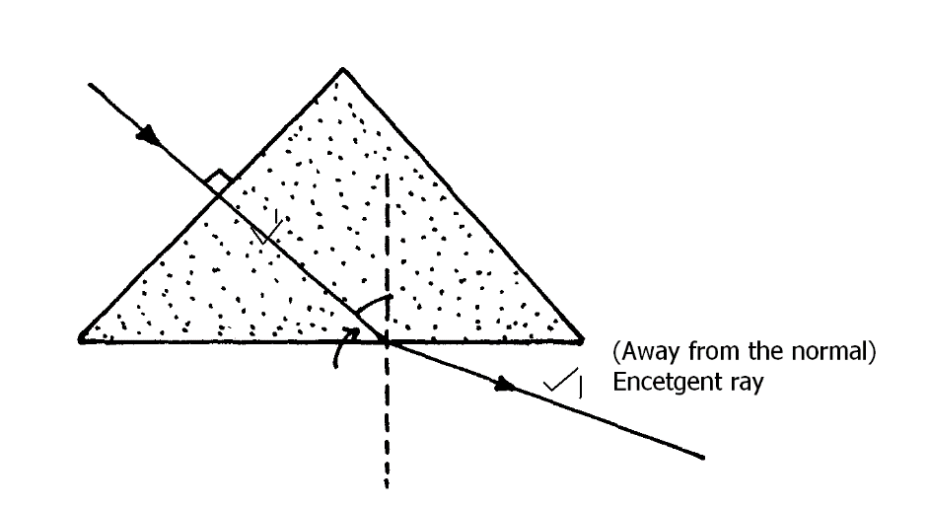

8. P = VI🗸1

= 220 x 🗸1

= 91.67 W🗸1

9.

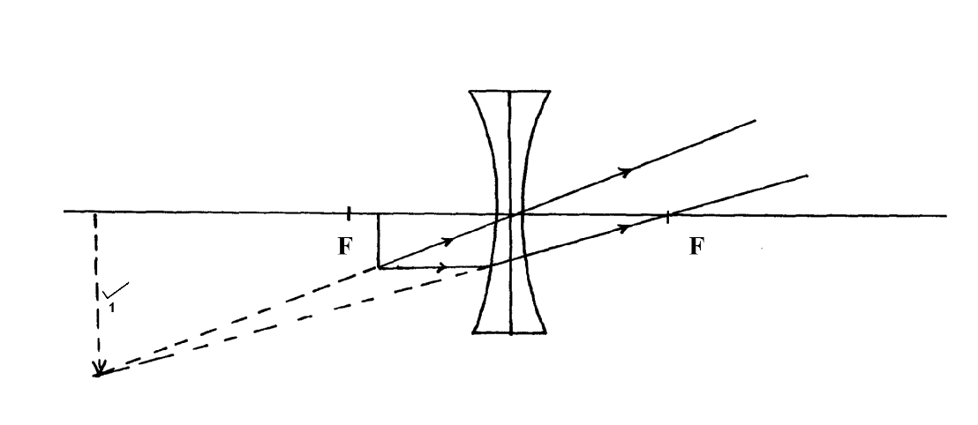

10. X – rays : Produced when cathode rays / fast moving electrons are suddenly stopped in an x – ray tube.

Gamma rays: Produced when nucleons in on unstablenundidrearrange to form a stable nudide.

11. E. Energy = 🗸1

= 2.160 kwh🗸1

12. The spot moves up and down the screen.🗸1

13. f0 = 4 x 1014 Hz 🗸1 ( 3.5 – 4.5) x 1014 Hz

14.

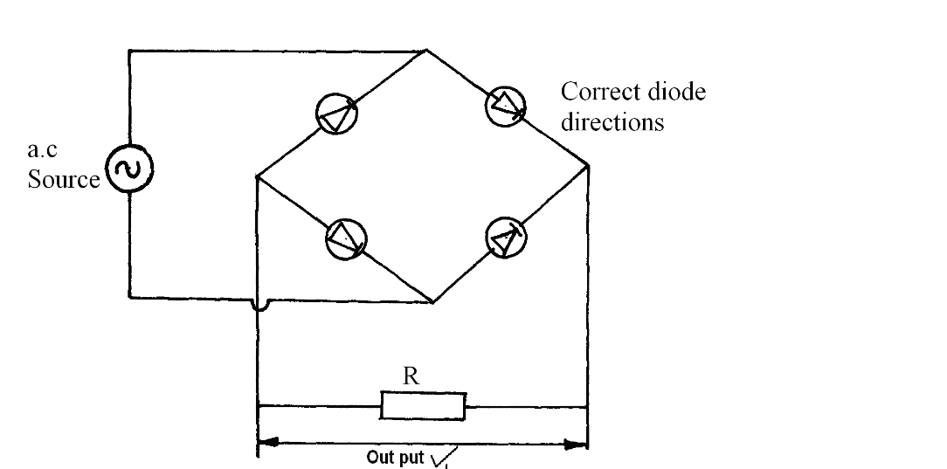

***SECTION B (55 MARKS)***

15. a) i) Suspend the iron bar and the bar magnet separately using the string🗸1.

- Displace Both slightly horizontall1.

- Displace Both slightly horizontally.

ii) The bar magnet nettles pointing🗸1 in the North – South direction.

- The iron bar nettles pointing in any direction🗸1.

b) P requires less current🗸1 for all the dispoles🗸1 to be aligned in one direction/ to reach magnetic saturation while Q requires more current for all the dipoles to be aligned in one direction / to reach magnetic saturation.

- P is soft magnetic material while Q is hard magnetic material🗸1

c) i) It turns anti clockwise🗸1

ii) It turns clockwise🗸1

iii) 1) Attach a pointer with scale on the left side of the metre rule.🗸1

2. Vary the current by adjusting 🗸1 the rheostat.

3. Calibrate or mark the scale for low and high current.🗸1

16. a) i) In transverse wave, the vibration of particles is perpendicular to the direction of travel of the wave but in longitudinal the vibration is parallel to the direction of the wave travel🗸1

ii) Sound wave requires medium for transgression but e.m waves does not require medium.🗸1

* Sound wave is longitudinal and e.m wave is transverse.🗸1

b) i) V = 🗸1 = 🗸1

= 320 /s🗸1

ii) 320 = 2 🗸1

1280 = 2x- 800

2080 = 2x

1040 = x

x = 1040🗸1m

c) i) Produce coherent sources of light🗸1

ii) Alternating dark and bright fringes🗸1 are observed on the screen on both sides of the central brighter fringe🗸1

iii) i) Dark and bright fringes get closer🗸1

ii) A full spectrum is observed🗸1

17. a) i) Dispersion of white light🗸1

ii) X - Red🗸1

Y - Violet🗸1

iii) Red has the lowest frequency/ longest wavelength hence it is least deviated while violet has the highest frequency / shortest wavelength hence it is most deviated.🗸1

iv) Acts as a point source of light🗸1

b) i) ang =🗸1

= 🗸1

= 1.6667🗸1

ii) c on the diagram🗸1

 =🗸1

Sin c = 0.5999 C = 36.860

iii) 🗸1

Sin = 1.6667 x Sin 31.2🗸1

Sin = 0.8634

 = 59.70 🗸1

18. a) i) Hard x - rays🗸1

ii) Have high penetrating power🗸1

b) i) A = Cathod rays🗸 / fast moving electrons

B = Anode🗸1

ii) Change in heating current🗸1 changes the number of electrons produced🗸1

iii) Kinetic energy🗸1 of cathode rays is converted to heat🗸1 energy.

iv) Has high density 🗸1

c) eV = hf🗸1

1.6x 10-19 x 12000 = 6.62 x 10-34 x f 🗸1

f = 

f = 2.900 10 18 Hz🗸1