**PANGANI GIRLS’ HIGH SCHOOL**

**POST MOCK 2022**

***Kenya Certificate of Secondary Education (KCSE)***

**233/1 CHEMISTRY (THEORY)**

**PAPER 1**

**MARKING SCHEME**

**---------------------------------------------------------------------------------------------------------------------**

1) A thistle funnel does not have a tap while a dropping funnel has.√1// A dropping funnel delivers controlled amounts of liquid substances while a thistle funnel does not.

2) a) A substance that dissociates in water to give hydrogen ions as the only positively charged ions..√1

b) Sodium hydroxide solution causes a greater deflection on the ammeter than ammonia solution. .√1Sodium hydroxide completely ionizes.√ ½ to form sodium and hydroxide ions while ammonia solution partially ionizes.√ ½ to form ammonium and hydroxide ions.

3)a) fermentation.√1

b)Ethanol forms hydrogen bonds .√ ½ with water while ethane does not//.√ ½ remains molecular/has only weak vanderwaals forces( intermolecular force)//.Ethane is non polar while ethanol is polar.

4) a) 234U → 230Th + 4He.√1

(b) Gamma rays will penetrate through the walls of the container and cause damage.

5)a) I..√1

II More Oxygen is used to form CO2.√1

b) (i) CH4  + 2O2 🡪 CO2 + 2H2O

IV 2V 1V 2V.√ ½

80 cm3  150 cm3  75 cm3  150 cm3

Volume of carbon (IV) oxide = 75 x 1 = 75cm3 .√ ½

(ii) Volume of water = 2 x 75 = 150cm3

Residual air = 5cm3 + 75cm3 + 150cm3.√ ½ = 230cm3 .√ ½

6)a) X. .√ ½ It is stable; it neither loses nor gains electrons.√ ½

b) W and Y.√ 1

c) YW.√ ½1

7) . a) Thermometer should not be dipped in the mixture, .√ 1 it should be at the outlet point to the condenser.

The direction of water flow is wrong/ condenser wrongly fixed.√ any 1

No water bath is used

(b)Boiling point/ Freezing point/Density / refractive index

8).a) 2Pb(NO3)2(s)--------->2PbO+4NO2(g) +O2(g).√ 1

b) Moles of NO2 gas=.√ ½

moles of Pb(NO3)2=.√ ½

mass of Pb(NO3)2=0.006x331.√ ½ =1.986g.√ ½

9) a) Neutralization.√ 1

b) (i)Calcium hydrogen carbonate.√ 1

(ii) Drying agent. .√ 1 Extraction of sodium from Downs’s process..√ ½

10.Kerosene floats on water therefore it continues to burn

carbon (iv) oxide blanket covers the flame.√ 1// cuts off the supply of oxygen therefore burning stops .√ ½

11) a) ∆H1 – Bond breaking.√ ½ / activation Energy

∆ H3 – Energy evolved during reaction

(b) ∆H3 = ∆H1 + ∆ H2.√ 1

12.Add excess zinc oxide.√ ½ to dilute HCl(aq).√ ½

/ HNO3(aq) / H2SO4(aq).Filter. .√ ½

To the filtrate add aqueous K2CO3(aq) / Na2CO3(aq) / (NH4)2 CO3(aq) to precipitate ZnCO3(S).

√ ½

Filter.√ ½ to obtain ZnCO3(S) as the residue. .√ ½

Q13. i) T = (32 x60) + 10 = 1930s .√ ½

I = 0.5

Q = It = 0.5 x 1930 = 765 C .√ ½

0.44g deposited by 765C

88g ?

.√ ½

.√ ½

Charge of X = 2

ii) X(OH)2.√ 1

Q14. Butane.√ 1

H H H H

I I I I

H - C - C - C - C - H

I I I I

H H H H

Q15(a)Barium Sulphate (BaSO3).√ 1

(b)BaSO3(s) + 2HCI (aq) →BaCI2(aq) + SO2(aq).√ 1

(c)Changes from orange to green.√ 1

Q16

|  |  |  |  |
| --- | --- | --- | --- |
| Element | C | H | O |
| % Composition | 57.15 | 4.76 | 38.09  √ 1 |
| R.A.M | 12 | 1 | 16 |
|  | 4.7625 | 4.76 | 2.380625√ 1 |
| Moles ratio | =2.004 =2 | =2.00 | =1  √ ½ |

Empirical formula= C2H2O√ ½

n = = 3 √ ½

Molecular formula = (C2H2O)3 = C6H6O3√ ½

Q17 a) Ammonia gas√ 1

b) Filtration/precipitation/Crystallization√ 1

c) 2NaHCO3 (s) 🡪 Na2CO3(s) + CO2 (g) + H2O (g)√ 1

Q18. -Iron wool turns or rusts√ ½ due to formation of hydrated iron (III) oxide√ ½

-Level of water inside the tube rises√ ½ to occupy the space left by oxygen√ ½

// Level of water in the beaker will fall

Q19.a) The water contained impurities √ 1 (1mk) //presence of impurities elevate the Boiling point. // water contained dissolved ions//Hard.

b) (i) Copper(II) sulphate;√ 1 at 400C ONLY 28gm is soluble leaving the rest undissolved. √ 1

At 400C, all lead nitrate dissolves.

(ii) 35-28=7g√ ½

Q20. Equilibrium shift to the right (1mark)

- Shift to the right √ ½

- Shifts to the left ( equivalent to increase in pressure) (1mark)

Q21.a)

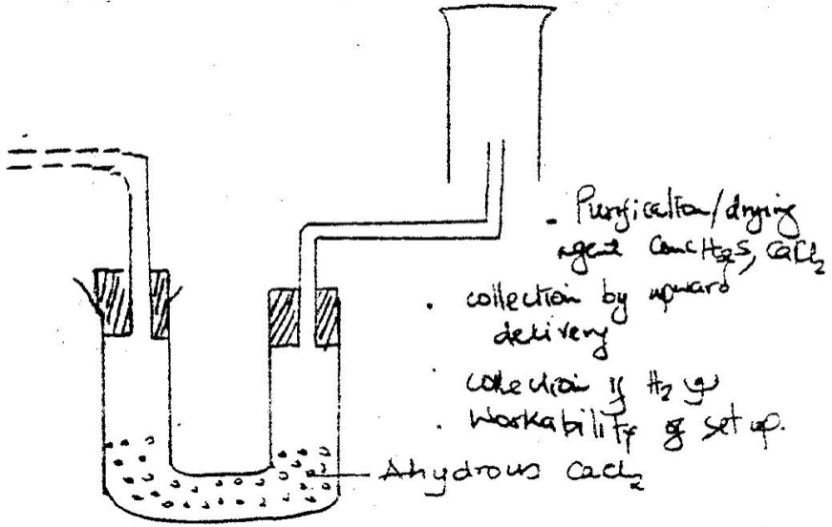

√1

√1/2

√1/2

√1

b) 2H2(g) + O2(g) 2H2O(g)√ 1

Q22. a) 1000cm3 = 0.1mol

25 cm3 ?

√ 1

b) H2X (aq) + 2 NaOH (aq) → Na2X(aq) + H2 O(l)

Mole ratio 1 : 2√ 1

Moles of acid = 0.0025x2= 0.00125mol.√ ½

Molarity = = 0.0668M√ ½

√Q23. NH4NO3(s) 🡪N2O(g) + 2H2O(g)

b) Over warm water.√ ½ Downward displacement of warm water because it is fairly soluble in cold water.√ ½

c) Both red and blue litmus will not change colour√ 1

Q24. a) At room temperature √ 1cold and dilute sodium hydroxide

b)Used in sterilizing of water / treatment of water / killing germs

Used as a bleaching agent√ 1 any

Antiseptic for mouth wash

Fungicide

Q25. Q22. a) 2cr + -2 x 7 = -2 √ ½

*2cr - 14 = -2*

*2cr = +12*

*Cr = +6*√ ½

(b) Oxidation - Fe2+√ 1 (Iron (II) ions) to Fe3+(increase of oxidation number/ loss of electron)

Reduction – Chlorine to Cl-1( decrease in oxidation number/ gain of electron)√ 1

Q26. a)Bromine

At room temp (25°c) Bromine is liquid since its M.P is -7°c

and B.P 59°c/58.8°c.Room temp is between its M.P and B.P√ 1

b) Atomic mass / molecular mass / molecule of iodine is higher than that of Cl2.

Van der waals forces are stronger in I2 than Cl2 hence iodinesb.p is highest than that of Cl2

Q27. a) N √1

b) Eø =0.80 +0.76√ ½

= 1.56 volts √ ½

Q28. a) Polystyrene or polyphenylethene√ ½

b)√ 1

c) non biodegradable√ 1

Q29. P1+ P2

Volume is constant

760 = P2 P2 = 760 x 373√ 1 = 1038 mmHg√ 1

273 373 273